Electric vehicles are the future. Texas lawmakers must act.
By Tom “Smitty” Smith
Electric vehicles are about to become the new way we get around. Why? Because they are cheaper to own, cooler to drive and better for the environment.
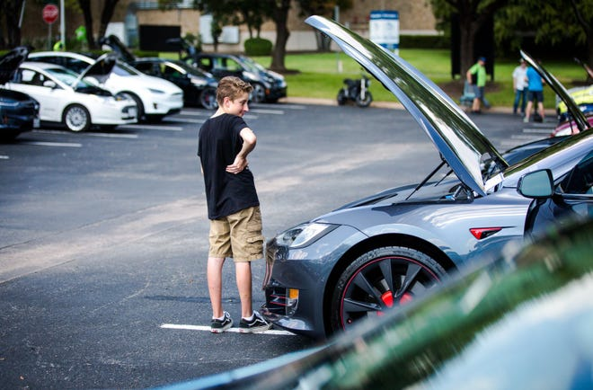
By 2022, there will be over 200 EV models available in the U.S., including 10 pickup trucks, and prices will soon drop below fossil-fueled cousins. They are changing the transportation industry just like cellphones transformed the telephone industry, and the change is coming just as fast. EVs are predicted to be 15% of the cars on the road, and 41% of all new vehicles sold in Texas by 2030.
With this change comes questions the Texas Legislature will have to answer such as: What is a fair fee for an electric vehicle owner to pay to build and maintain roads and bridges? What consumer protections should be put in place? How can we ensure that electric vehicle batteries are reused or recycled? How do we guarantee that a border-to-border charging network is built along our major highways?
A proposed Electric Transportation Act has been drafted to answer these questions by the Texas Electric Transportation Resources Alliance (TxETRA), We expect the bill to be filed soon.
In cities across the world and in Texas, the air has become unhealthy due to air pollution from cars, trucks and motorcycles. In fact, they now produce more climate pollution than any other source in most countries, across the nation as well as right here in Texas. As a result, 32 countries and states have set targets to phase out the sale of fossil-fueled vehicles between 2030 and 2050.
In addition to improving the environment, India and China and several European countries see zero emission electric vehicle manufacturing as their opportunity to become the vehicle manufacturers of the future and build the new industries that will energize their countries’ economies by developing adequate charging networks and funding incentives. Texas needs to act now to pass legislation to encourage more manufacturing to locate here or we’ll be left behind in this emerging market.
Tesla’s decision to build a new billion-dollar manufacturing plant near Austin certainly caught global attention, but Tesla is not the only electric transportation manufacturer in Texas. Peterbilt builds electric heavy-duty trucks in Denton; Navistar will soon begin manufacturing electric trucks and school buses in San Antonio; Helion produces electrified powertrains in Cedar Park; Lone Star Specialty Vehicles makes electric terminal tractors in Texarkana; Toshiba Heavy Industries builds motors and transmissions for Ford plug-in hybrid electric vehicles in Houston; Aero manufactures small electric delivery trucks and Volcon makes electric motorcycles and off-road vehicles in Round Rock.
The Texas Advanced Energy Business Alliance (TAEBA) released a report last month that revealed there are over 7,000 people involved in the Electric Transportation Supply Chain in Texas and that number is expected to grow dramatically.
Companies like HEB, PepsiCo, Amazon and dozens of others have already begun to electrify their fleets; it makes good business sense. For a heavy-duty truck driving 200 miles, the fossil-fuel cost is about $100 compared to just $23 for EV charging.
Average drivers in a personal EV save one-half to two-thirds in fuel costs. It cost me about $1 a day in electricity to drive to work in downtown, but about $3 to cover the same distance in my pickup.
Forty-five other states have acted on these issues and now Texas needs to act.
The Electric Transportation Act has been drafted by a policy group assembled by Texas Electric Transportation Resources Alliance (TxETRA), representing manufacturers, utilities, charging companies, consumers and environmental advocates, to address these issues.
You can help pave the way to a cheaper, cooler, and cleaner future, by asking your legislators to pass the Electric Transportation Act this legislative session.
Smith is the executive director of the Texas Electric Transportation Resources Alliance (TxETRA).

