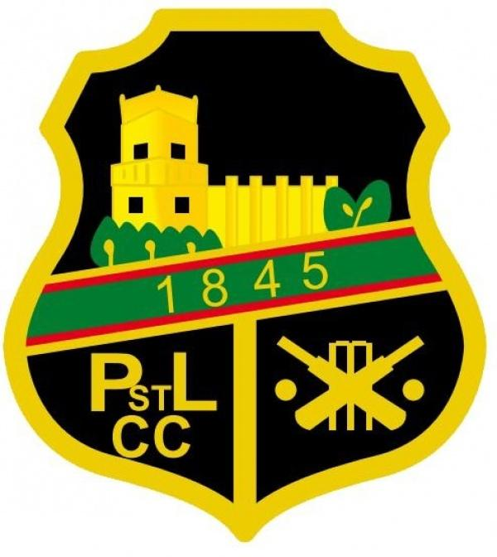
Pudsey St Lawrence Cricket Club
Junior code of conduct.

PSLCC is fully committed to safeguarding and promoting the wellbeing of all its members.

PSLCC believes that it is important that members, coaches, administrators and parents, carers or guardians associated with the club should, at all times, show respect and understanding for the safety and welfare of others. Therefore, members are encouraged to be open at all times and to share any concerns or complaints that they may have about any aspect of the club with any member of the club’s management team.
As a member of PSLCC you are expected to abide by the following junior code of conduct:

All members must play within the rules and respect officials, coaches, and other helping adults and their decisions.
- All members must respect the rights, dignity and worth of all participants regardless of age, gender, ability & disability, colour or cultural background, religion and social background.
- All members have a right to feel safe and welcome at training and matches. Encourage your team mates even if they don’t get it quite right. You are all here to learn and deserve respect.
- Members should keep to agreed timings for training and competitions or inform their coach or team manager if they are going to be late.
- Members must wear suitable kit including helmets, suitable protective equipment for training and match sessions, as agreed with the coach/team manager.
- Members must pay any fees for training or events promptly.
- Junior members are not allowed to smoke on club premises or whilst representing the club at competitions.
- Junior members are not allowed to consume alcohol or drugs of any kind on the club premises or whilst representing the club
- The wellbeing of all our junior players at PSLCC is very important. If at anytime you feel bullied, discriminated or harassed or witness it happening to someone else please report it to an adult you trust, parent or coach so that we can stop it from happening again.

