Directions to Robin Lane Medical Centre

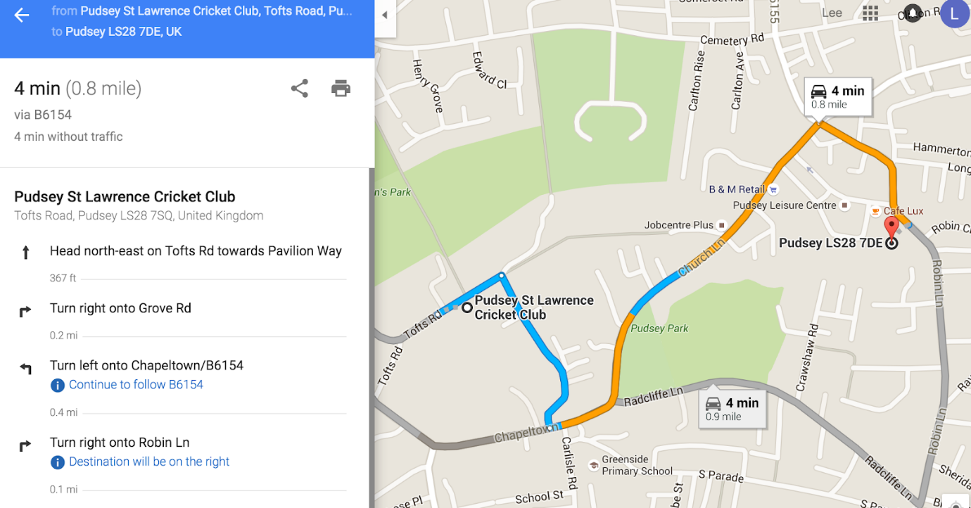

Address: | Robin Lane Health and Wellbeing Centre  Robin Lane  Pudsey  Leeds  LS28 7DE
Telephone: | 0113 257 6787 (Can also be used out of Hours)
Surgery Hours: | 8am to 8pm Mon - Fri, 8am to 4pm Saturday

