Code of Conduct for Cricket Club Members and Guests*

Pudsey St Lawrence

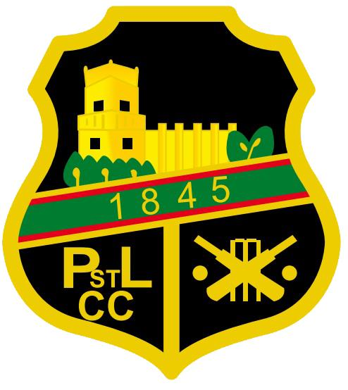
- Members and Guests of PSLCC Cricket Club are required to abide by the provisions of this Code of Conduct and any subsequent updates as may be in force from time to time, and by their presence on club premises or at club events or activities are deemed to have accepted and to abide by the provisions of this Code and any other relevant Codes of Conduct, Rules or Regulations the Club has adopted.

All Members and Guests of PSLCC will:

- Respect the rights, dignity and worth of every person within the context of Cricket

- Treat everyone equally and not discriminate on the grounds of age, gender, disability, race, ethnic origin, nationality, colour, parental or marital status, religious belief, class or social background, sexual preference or political belief

- Not condone, or allow to go unchallenged, any form of discrimination if witnessed

- Display high standards of behaviour

- Promote the positive aspects of Cricket e.g. fair play

- Encourage all participants to learn the Laws and rules and play within them, respecting the decisions of match officials

- Actively discourage unfair play, rule violations and arguing with match officials

- Recognise good performance not just match results

- Place the well-being and safety of children above the development of performance

- Ensure that activities are appropriate for the age, maturity, experience and ability of the individual

- Respect children’s opinions when making decisions about their participation in Cricket

- Not smoke, drink or use banned substances whilst actively working with children in the Club.

- Not provide children with alcohol when they are under the care of the Club

- Follow ECB guidelines set out in the ‘Safe Hands – Cricket’s Policy for Safeguarding Children’ and any other relevant guidelines issued

- Report any concerns in relation to a child, following reporting procedures laid down by the ECB

- In addition to the above, all Club Officers and Appointed Volunteers will:

Have been appropriately vetted, if required, before taking on their role
  - Hold relevant qualifications and be covered by appropriate insurance

  - Always work in an open environment (i.e. avoid private or unobserved situations and encourage an open environment)

  - Inform Players and Parents of the requirements of Cricket

  - Know and understand the ECB’s ‘Safe Hands – Cricket’s Policy for Safeguarding Children’

  - Develop an appropriate working relationship with young players, based on mutual trust and respect

  - Ensure that physical contact is appropriate and necessary and is carried out within recommended guidelines with the young player’s full consent and approval

  - Not engage in any form of sexually related contact with a young player. This is strictly forbidden as is sexual innuendo, flirting or inappropriate gestures and terms. The ECB adopts the Home Office guidelines which recommend the principle -“People in positions of trust and authority do not have sexual relationships with 16-17 year olds in their care”

  - Attend appropriate training to keep up to date with their role, especially that relating to the Safeguarding of children

    - If a breach of the provisions or principles of this Code occurs or is reasonably suspected to have occurred the Club reserves the right to take such action as it deems appropriate, including but not limited to asking the person responsible for the breach to leave the Club premises. Any disciplinary or complaint hearings in connection with a breach of these rules shall be dealt with in accordance with the disciplinary procedure as set out in the Club constitution or Cricket Section Regulations as may be amended from time to time.

Date Adopted: 2015

