
Visit our website:
USACARDGRADING.COM
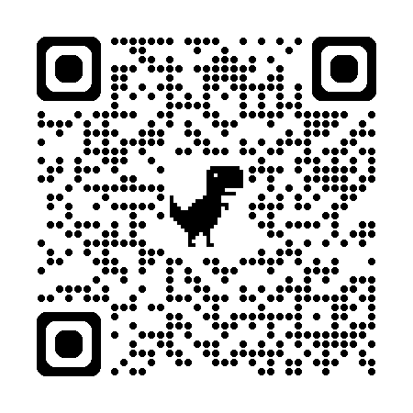

GRADED CARD SUBMISSION FORM
MAIL SUBMISSIONS TO: USA 300 S. MAIN ST. UNIT K SALISBURY, NC 28144
$10/CARD 10 DAY SERVICE* $10 SHIPPING*
 | QTY | YEAR | CARD CO. | TYPE | # | PLAYER | RC / REF. / #'D / ETC
EX. | 1 | 2025 | TOPPS | FINEST | 154 | ELLY DE LA CRUZ | BLUE REFRACTOR /150
1
2
3
4
5
6
7
8
9
10

RUSH RUSH RUSH MY ORDER $10_____

QTY | $10 / CARD | SHIP | TOTAL
 |  |  | $

YOUR E-MAIL:______________________________________

NAME |  |  |  |  | ADDRESS
C.C.# |  |  |  |  | CITY |  |  | STATE
EXP |  |  |  |  | ZIP
CVV
SIGNATURE |  |  |  |  | PHONE #

PH: (919) 244-5010 EMAIL: 10@USACARDGRADING.COM
AUTH. CODE

 | QTY | YEAR | CARD CO. | TYPE | # | PLAYER | RC / REF. / #'D / ETC
EX. | 1 | 2025 | TOPPS | FINEST | 154 | ELLY DE LA CRUZ | BLUE REFRACTOR /150
11
12
13
14
15
16
17
18
19
20

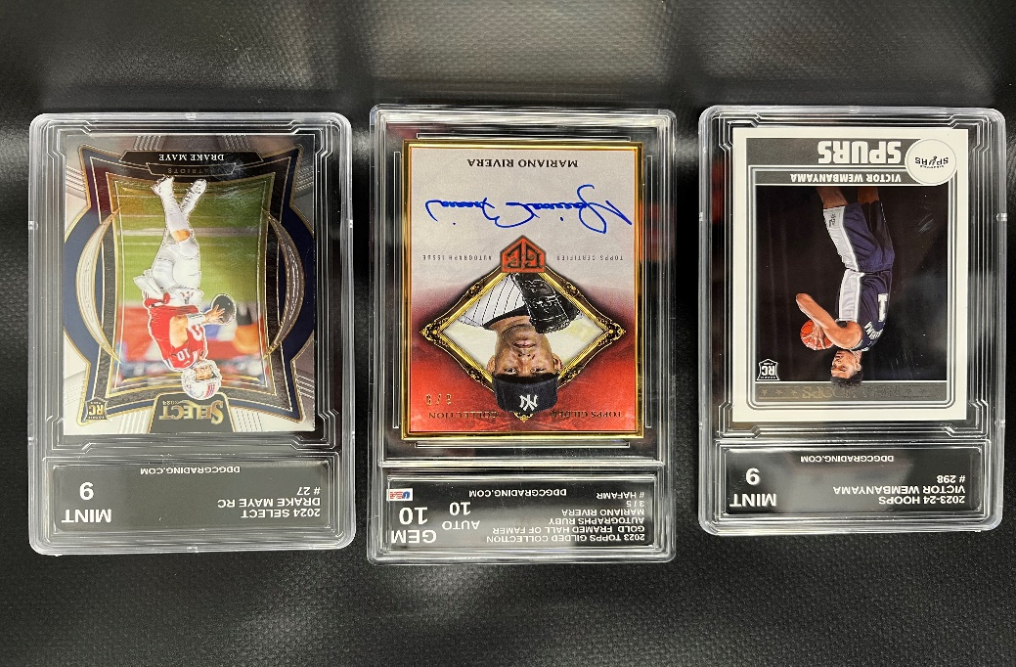

- EVERY CARD IS CAREFULLY AUTHENTICATED TO THE EXACT STANDARDS USED FOR GRADING DETERMINATION.
- STANDARD RETURN INSURANCE INCLUDED
- $10 / EA. 10 CARD MINIMUM
- $10 SHIPPING ON 1ST 10 CARDS / $0.25 EA. ADD. CARD
- 10 DAY SERVICE BASED ON BUSINESS DAYS FROM DATE RECEIVED TO DATE SHIPPED
EMAIL US: 10@USACARDGRADING.COM
PH: (919) 244-5010

