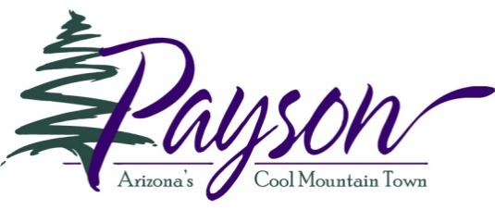 **EXHIBIT A____**

**Fire Department**

**400 W Main Street**

**Payson AZ 85541**

**(928) 474 5242 Ext. 9**

Fire Adaptive Community Fuel Mitigation Standard

Address Numbers must be present and visible from the roadway if a structure is on the property.

Fire Access Driveways must be clear to 10’ 6” (height) and must be mitigated to zone 3 standards 10 feet on both sides of the driveway. Fire Access Driveways are generally 150 feet or more in length.

Roof must be clear of leaves/pine needles.

Tree limbs, leaves and needles must be 10 feet from chimneys.

Tree limbs and other vegetation should not be touching the structure, under the eaves or near openings. Irrigated, fire resistive plants, may be approved on a case-by-case basis.

Structure to 5’ – Zone 1

Clear of combustibles.

No dead dried or combustible material allowed.

Irrigated, fire resistive plants, may be approved on a case-by-case basis.

5’ to 30’ From the Structure – Zone 2

No dead vegetation.

Dead grasses and light fuels mowed to 4” or less.

Native shrubbery/vegetation trimmed off the ground, no crown grouping more than 5’X5’.

Crown areas of shrubs separated by 1-1/2 times the height of the vegetation.

Trees trimmed 1/3 height of the tree or to 6’ maximum if the tree is over 18’ tall (some non-native irrigated species may be exempt).

No small trees growing in to the canopy of large trees. Weak or diseased trees must be removed. Leave trees should be the healthiest specimens. Drip line (canopy) of trees should be approximately 20 feet apart.*

No ladder fuels

30’ to 100’ From the Structure – Zone 3

No dead vegetation

Dead grasses and light fuels mowed to 4” or less.

Native shrubbery/vegetation trimmed off the ground, no crown grouping more than 10’X10’.

Crown areas of shrubs separated by 1-1/2 times the height of the vegetation.

Trees trimmed 1/3 height of the tree or to 6’ maximum if the tree is over 18’ tall (some non-native irrigated species may be exempt).

No small trees growing in to the canopy of large trees. Weak or diseased trees must be removed. Leave trees should be the healthiest specimens.

Drip line (canopy) of trees should be approximately 10 feet apart.*

No ladder fuels.

Vacant parcels should meet Zone 3 or have a mitigation plan approved by the Fire Chief

No more than approximately 40 to 60 trees per acre. Weak or diseased trees must be removed.

Slash, cuttings and dead vegetation must be removed from the property. Up to 40% of the slash, cuttings and dead vegetation may be mulched or chipped to a depth of no more than 4”.

Some 1000 hour (or larger) dead and down fuels may be left to decay and to provide run-off protection.

* *Tree canopy spacing may be evaluated between groupings instead of individual trees.*

*\** *Removal of native trees 6” or more in diameter at 4’ above grade require a permit per the Payson Tree Preservation Ordinance.*

# STANDARD DEFINITIONS:

**1000 HOUR FUEL** – Vegetation greater than 3 inches in diameter.

**ACRE** - 43,560 square feet, 66 feet by 660 feet.

**CANOPY** – Extent of the outer layer of leaves of an individual tree or group of trees or bushes.

**CROWN –** Bulk area of the top of a bush or tree including the leaves.

**DRIP LINE -** The outer edge of the canopy of a tree where rain would drip from the outermost leaves or needles to the ground.

**LADDER FUELS** - Combustible materials which would allow a ground level fire to spread vertically to taller, larger fuels (spread from grass to brush to tree canopies for example).

**SLASH –** Cuttings and material removed for hazardous fuels treatment.

**LEAVE TREES** – Trees, which are not to be cut.

**CUT TREES**– Trees, which are to be cut.