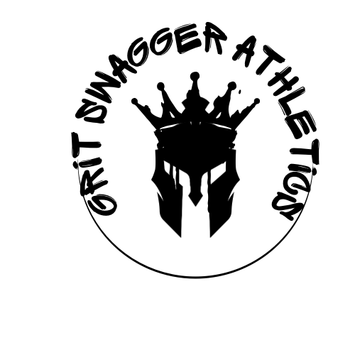

**Parent/Guardian Permission & Media Release Waiver**

**Child’s Full Name: _________________________________  
 Parent/Guardian Name: ____________________________  
 Phone Number: _________________________________  
 Email: ________________________________________**

**I, the undersigned parent or legal guardian of the minor named above, hereby grant permission to Grit Swagger Athletics LLC to capture and use photographs, video recordings, or other media of my child for promotional and marketing purposes, including but not limited to social media platforms, websites, printed materials, and other media outlets.**

**I understand and agree to the following:**

1. **The images or recordings may be used without further notification or compensation to me or my child.**
2. **The images or recordings may be edited, copied, and distributed for lawful promotional purposes.**
3. **I waive the right to inspect or approve the final product in which my child’s likeness appears.**
4. **Grit Swagger Athletics LLC will not include personal identifying information (such as full name, address, or contact details) in connection with any media content.**
5. **I release and hold harmless Grit Swagger Athletics LLC and its representatives from any claims, demands, or liabilities arising from the use of these images/videos.**

**I understand that I may revoke this permission at any time by providing written notice to [Organization Name], though prior use will not be affected.**

**☐ I GIVE PERMISSION for my child’s image/video to be used as described above.  
 ☐ I DO NOT GIVE PERMISSION for my child’s image/video to be used.**

**Signature of Parent/Guardian: ________________________  
 Date: ________________________**