Fentanyl Fathers Assembly Analysis
1/24/24 – 3/6/24
There were an estimated 14,510 students in attendance across 25 assembly presentations conducted at 22 Miami-Dade County, Florida high schools, three Oakland County, Michigan high schools. Each assembly presentation was slotted for 45-minutes to an hour and included viewing a 14-minute edited version of an award-winning video documentary called Dead on Arrival, testimony from a bereaved parent, naloxone training, and a slide deck outlining the prevalence, threat, and consequences of illicit fentanyl and counterfeit pills. Pre and posttest surveys were collected from students in attendance who used their cell phones to scan a QR code linked to a survey. The surveys elicited about an 11% response rate from attendees (1,559 respondents) across 25 assembly presentations, and no incentives for survey participation were provided. Survey participation was voluntary, and all responses were recorded anonymously. The demographic breakdown of survey participants from assembly presentations is presented in Table 1.
Respondent ages ranged from 11 or younger to 18 years or older, and there was a total of 1,559 respondents included in this analysis. The mean age of respondents was 16.5 years of age, and the largest proportion of respondents were 17 years of age (32.0%), 18 years of age or older (23.0%), 16 years of age (20.8), and 15 years of age (16.9%) subsequently. There were more females (53.2%) than males (43.2%), but there was a nearly even distribution of Hispanic or Latino (48.7%) and non-Hispanic respondents (51.3%). Most respondents were White or Caucasian (58.8%), followed by Black or African American (17.1%), and Some other race or multiracial (13.7). There were more 12th grade respondents (46.4%) than any other grade represented in the analysis followed by 11th grade (21.8%), 10th grade (17.8%), and 9th grade (13.5%) students. Most students reported never using alcohol, marijuana, diverted prescription pharmaceuticals, or illicit drugs within 30-days of the assembly presentations (93.0%), however 3.5% of students reported 1–2-time monthly use, and 2.2% reported daily use of at least one of these substances.
Table 1. Demographic breakdown and PreMisuse Behaviors of survey respondents overall
Variable | Response option | N=1,559  n (%)
State | Michigan  Florida  Alaska  Ohio  Texas | 619 (39.7)  934 (59.9)  3 (0.2)  2 (0.1)  1 (0.1)
Age | 11 or younger  12  13  14  15  16  17  18 or older | 3 (0.2)  1 (0.1)  1 (0.1)  110 (7.4)  263 (16.9)  324 (20.8)  499 (32.0)  358 (23.0)
Gender | Female | 830 (53.2)
 | Male  Other  Prefer not to say | 674 (43.2)  23 (1.5)  32 (2.1)
Ethnicity | Hispanic or Latino  Not Hispanic or Latino | 760 (48.7)  799 (51.3)
Race | Black or African American | 267 (17.1)
 | White or Caucasian | 916 (58.8)
 | American Indian or Alaska Native | 18 (1.2)
 | Asian  Native Hawaiian or Pacific Islander  Some other race or Multiracial | 141 (9.0)  4 (0.3)  213 (13.7)
Grade | 6th  7th  8th  9th  10th  11th  12th | 7 (0.4)  0 (0.0)  1 (0.1)  210 (13.5)  278 (17.8)  340 (21.8)  723 (46.4)
PreMisuse Behavior | Never  1-2 times a month  Weekly  2-3 times a week  Daily | 1,450 (93.0)  55 (3.5)  11 (0.7)  9 (0.6)  34 (2.2)

Attitude changes were measured across constructs informed by the Health Belief Model of Behavioral Theory which hypothesizes that if the perceived severity, susceptibility, self-efficacy, benefit, and barriers of engaging in a health promoting behavior, and participants are given a cue to action to participate in the health promoting behavior(s), then they will be more likely to engage in the health behavior(s) being promoted by the program (i.e. decreasing drug misuse behaviors, calling 9-1-1 and administering naloxone to reverse a witnessed overdose event, etc.). Respondents’ pretest responses were compared with posttest responses answered at the end of assembly presentations. Each question was phrased the same in pretest and posttest surveys and used 10-point Likert scale score survey options. There were statistically significant (p<0.05) attitude changes across every construct measured, with the largest magnitudes of change noted in the program’s effectiveness to increase respondents’ self-efficacy to recognize (15%) and respond (19%) to an opioid overdose and increase respondents’ perceived knowledge about fentanyl and counterfeit pills (14%). The largest magnitude of change was observed in the program’s effectiveness at reducing respondents’ perceived barriers to accessing and administering naloxone (-24%). The perceived benefit of drug abstinence and perceived severity of fentanyl and counterfeit pill use had high baseline mean scores at pretest and had lower percent magnitude changes as a result, 4% and 4% respectively. Perceived susceptibility of experiencing or witnessing an opioid overdose after assemblies increased by 8% after assembly presentations which could be an expected outcome since program implementation targeted a majority population with no history of drug or alcohol misuse (93%).
Table 2. Mean attitude differences among pre and posttest scale score items overall
Variable | Description | Pretest Mean (SD)  (N=1,559) | Posttest Mean (SD)  (N=1,559) | Mean Difference (p-value)
PSevere | Perceived severity of fentanyl and counterfeit pill use | 9.0 (2.0) | 9.4 (1.7) | 0.4 (<0.001)
SERecognize | Self-efficacy to recognize the signs of an opioid overdose | 6.5 (2.6) | 8.0 (2.2) | 1.5 (<0.001)
SERespond | Self-efficacy to respond to an opioid overdose | 5.8 (2.8) | 7.7 (2.4) | 1.9 (<0.001)
Pbenefit | Perceived benefit of drug abstinence | 8.5 (2.6) | 8.9 (2.4) | 0.4 (<0.001)
Psusceptible | Perceived susceptibility to witnessing or experiencing an overdose | 4.3 (3.1) | 5.1 (3.2) | 0.8 (<0.001)
Pbarriers | Perceived barriers to accessing and administering naloxone | 7.3 (3.3) | 4.9 (3.6) | -2.4 (<0.001)
PKNOW | Perceived knowledge about fentanyl and counterfeit pills | 6.6 (2.8) | 7.9 (1.3) | 1.4 (<0.001)

Intention to reduce or abstain from drug misuse as a result of what students had learned from the presentation averaged 8.3 points on a 10-point Likert scale with a standard deviation of 2.9, while the intention to share information that they had learned with friends and family averaged 4.3 points on a 5-point scale with a standard deviation of 1.0.

Comparative Assembly Analysis
During this evaluation period, the program was implemented with two collaborating organizations, each serving different demographic-majority groups. One population was majority white, non-Hispanic with 33% racial minority students represented in Oakland County, Michigan. The other was a majority white, Hispanic population with over 46.5% racial minority populations represented in Miami-Dade County, Florida public schools. The population served in Florida during this evaluation period was 1.5 times the number of those served in Michigan; therefore, the strength of evidence for Florida would be slightly greater, but evaluators wanted to see if pre-post attitude changes differed between the two implementation areas significantly and thus conducted separate analysis for the two focus areas (Michigan and Florida) by filtering results and analyses for each group of respondents.
Michigan
There were an estimated 4,855 students in attendance across three high school assembly presentation events conducted in Rochester school district with an 13% survey response rate. The demographic breakdown of these assemblies is presented below in Table 3.
Respondent ages ranged from 14 to 18 years or older (with one outlier 12 year old respondent), and there were a total of 619 respondents included in this analysis. The mean age of respondents was 15.9, and the largest proportion of respondents were 16 years of age (27.9%). There were more females (55.1%) than males (41.5%), and the majority were non-Hispanic (89.3%) and White or Caucasian (67.0%). There were more 10th grade respondents (28.4%) than any other grade represented in the analysis followed by 11th grade (27.1%), 12th grade (25.8%), and 9th grade (17.6%) students. The majority of students reported never using alcohol, marijuana, diverted prescription pharmaceuticals, or illicit drugs within 30-days of the assembly presentations (95.6%), however 2.7% of students reported 1–2-time use, and seven students reported daily use of one of these substances prior to assemblies (1.1%).
Table 3. Demographic breakdown and PreMisuse Behaviors of survey respondents in Michigan
Variable | Response option | N=619  n (%)
Age | 12  14  15  16  17  18 or older | 1 (0.2)  71 (11.5)  160 (25.8)  173 (27.9)  165 (26.7)  49 (7.9)
Gender | Female | 341 (55.1)
 | Male  Other  Prefer not to say | 257 (41.5)  11 (1.8)  10 (1.6)
Ethnicity | Hispanic or Latino  Not Hispanic or Latino | 66 (10.7)  553 (89.3)
Race | Black or African American | 21 (3.4)
 | White or Caucasian | 415 (67.0 )
 | American Indian or Alaska Native | 10 (1.6)
 | Asian  Native Hawaiian or Pacific Islander  Some other race or Multiracial | 123 (19.9)  2 (0.3)  48 (7.8)
Grade | 6th  7th  9th  10th  11th  12th | 5 (0.8)  1 (0.2)  109 (17.6)  176 (28.4)  168 (27.1)  160 (25.8)
PreMisuse Behavior | Never  1-2 times a month  Weekly  2-3 times a week  Daily | 592 (95.6)  17 (2.7)  3 (0.5)  0 (0.0)  7 (1.1)

Respondents’ pretest responses were compared with posttest responses answered at the end of assembly presentations. Each question was phrased the same in pretest and posttest surveys and used 10-point Likert scale score survey options.
Like the overall analysis, there were statistically significant (p<0.05) attitude changes across every construct measured, with the largest magnitudes of change noted in the program’s effectiveness to increase respondents’ self-efficacy to recognize (16%) and respond (23%) to an opioid overdose and increase respondents’ perceived knowledge about fentanyl and counterfeit pills (17%). The largest magnitude of change was observed in the program’s effectiveness at reducing respondents’ perceived barriers to accessing and administering naloxone (32%). This is notably the largest percentage change seen across any construct, in any area, since this program’s inception which may be credited to the wide-net naloxone resources offered to students during the Michigan presentations (100 low-barrier naloxone distribution sites located in Oakland County). Perceived benefit of drug abstinence and perceived severity of fentanyl and counterfeit pill use had high baseline mean scores at pretest and had lower percent magnitude changes as a result, 3% and 8% respectively. Perceived susceptibility of experiencing or witnessing an opioid overdose after assemblies only increased by 10% after assembly presentations which could be an expected outcome since program implementation targeted a majority population with no history of drug or alcohol misuse (95.6%).
Table 4. Mean attitude differences among pre and posttest scale score items in Michigan
Variable | Description | Pretest Mean (SD)  (N=619) | Posttest Mean (SD)  (N=619) | Mean Difference (p-value)
Psevere | Perceived severity of fentanyl and counterfeit pill use | 8.9 (1.8) | 9.7 (1.2) | 0.8 (<0.001)
SERecognize | Self-efficacy to recognize the signs of an opioid overdose | 6.4 (2.5) | 8.0 (1.9) | 1.6 (<0.001)
SERespond | Self-efficacy to respond to an opioid overdose | 5.7 (2.6) | 8.0 (2.0) | 2.3 (<0.001)
Pbenefit | Perceived benefit of drug abstinence | 8.8 (2.3) | 9.1 (2.1) | 0.3 (0.001)
Psusceptible | Perceived susceptibility to witnessing or experiencing an overdose | 4.4 (2.9) | 5.4 (3.1) | 1.0 (<0.001)
Pbarriers | Perceived barriers to accessing naloxone | 7.5 (3.1) | 4.3 (3.4) | -3.2 (<0.001)
PKNOW | Perceived knowledge about fentanyl and counterfeit pills | 6.4 (2.7) | 8.1 (1.9) | 1.7 (<0.001)

Intention to reduce drug misuse as a result of what students had learned from the presentation averaged 8.7 points on a 10-point Likert scale with a standard deviation of 2.6, while the intention to share information they had learned with friends and family averaged 4.3 points on a 5-point scale with a standard deviation of 1.0.
Florida
There were an estimated 7,855 students in attendance across 21 assembly presentations conducted at Miami-Dade County public high schools. The demographic breakdown of respondents from these assemblies is presented in Table 5.
Respondent ages ranged from 13 to 18 years or older, and there was a total of 934 respondents included in this analysis. The mean age of respondents was 16.8 years of age, but 68.8% of respondents were 17 years of age or older. There were more females (52.4%) than males (44.4%), and the majority were Hispanic or Latino (73.9%) and White or Caucasian (53.5%). There were more 12th grade respondents (60.2%) than any other grade represented in the analysis followed by 11th grade (18.3%), and equal distributions of 10th and 9th graders (10.7% and 10.8% respectively). Most students reported never using alcohol, marijuana, diverted prescription pharmaceuticals, or illicit drugs within 30-days of the assembly presentations (91.4%), however 4.1% of students reported 1–2-time monthly use, 0.9% reported weekly use, 1.0% reported use 2-3 times weekly, and 2.7% reported daily use of at least one of these substances.
Table 5. Demographic breakdown and PreMisuse Behaviors of survey respondents in Florida
Variable | Response option | N=934  n (%)
Age | 13  14  15  16  17  18 or older | 1 (0.1)  39 (4.2)  101 (10.8)  151 (16.2)  334 (35.8)  308 (33.0)
Gender | Female | 489 (52.4)
 | Male  Other  Prefer not to say | 415 (44.4)  10 (1.1)  20 (2.1)
Ethnicity | Hispanic or Latino  Not Hispanic or Latino | 690 (73.9)  244 (26.1)
Race | Black or African American | 244 (26.1)
 | White or Caucasian | 500 (53.5)
 | American Indian or Alaska Native | 8 (0.9)
 | Asian  Native Hawaiian or Pacific Islander  Some other race or Multiracial | 17 (1.8)  2 (0.2)  163 (17.5)
Grade | 9th  10th  11th  12th | 101 (10.8)  100 (10.7)  171 (18.3)  562 (60.2)
PreMisuse Behavior | Never  1-2 times a month  Weekly  2-3 times a week  Daily | 854 (91.4)  38 (4.1)  8 (0.9)  9 (1.0)  25 (2.7)
Similar to Michigan, there were statistically significant (p<0.05) attitude changes across every construct measured, with the largest magnitudes of change noted in the program’s effectiveness to increase respondents’ self-efficacy to recognize (13%) and respond (18%) to an opioid overdose and increase respondents’ perceived knowledge about fentanyl and counterfeit pills (11%). The largest magnitude of change was observed in the program’s effectiveness at reducing respondents’ perceived barriers to accessing and administering naloxone (19%). Perceived benefit of drug abstinence and perceived severity of fentanyl and counterfeit pill use had high baseline mean scores at pretest and had lower percent magnitude changes as a result, 4% and 3% respectively. Perceived susceptibility of experiencing or witnessing an opioid overdose after assemblies only increased by 7% after assembly presentations which could be because the majority of respondents had no history of previous drug or alcohol misuse (91.4%).
Table 6. Mean attitude differences among pre and posttest scale score items in Florida
Variable | Description | Pretest Mean (SD)  (N=934) | Posttest Mean (SD)  (N=934) | Mean Difference (p-value)
Psevere | Perceived severity of fentanyl and counterfeit pill use | 9.0 (2.0) | 9.3 (1.8) | 0.3 (<0.001)
SERecognize | Self-efficacy to recognize the signs of an opioid overdose | 6.7 (2.7) | 8.0 (2.4) | 1.3 (<0.001)
SERespond | Self-efficacy to respond to an opioid overdose | 5.8 (2.9) | 7.6 (2.6) | 1.8 (<0.001)
Pbenefit | Perceived benefit of drug abstinence | 8.3 (2.7) | 8.7 (2.5) | 0.4 (<0.001)
Psusceptible | Perceived susceptibility to witnessing or experiencing an overdose | 4.3 (3.2) | 5.0 (3.3) | 0.7 (<0.001)
Pbarriers | Perceived barriers to accessing naloxone | 7.2 (3.4) | 5.3 (3.8) | -1.9 (<0.001)
PKNOW | Perceived knowledge about fentanyl and counterfeit pills | 6.7 (2.9) | 7.8 (2.7) | 1.1 (<0.001)

When comparing the mean attitude changes between the two populations, there were statistically significant (p<0.05) change differences between the two groups. In Michigan, there was a statistically significant greater change in perceived severity (4%), self-efficacy to recognize (4%) and respond (5%) to an opioid overdose, and perceived knowledge about fentanyl and counterfeit pills (6%). The largest, and most surprising mean difference was the perceived barriers to accessing naloxone, which was a 12% greater difference for the Florida respondents. There were not statistically significant mean differences observed for perceived benefit, or susceptibility during this analysis.
Table 7. Mean attitude differences with side-by-side state comparison percent differences
Variable | Description | Michigan  Mean Diff (SD)  (N=619) | Florida  Mean Diff (SD)  (N=934) | Difference %  (p-value)
Psevere | Perceived severity of fentanyl and counterfeit pill use | 0.7 (1.5) | 0.3 (1.8) | 4% (<0.05)
SERecognize | Self-efficacy to recognize the signs of an opioid overdose | 1.7 (2.4) | 1.3 (2.6) | 4% (<0.05)
SERespond | Self-efficacy to respond to an opioid overdose | 2.2 (2.6) | 1.7 (2.7) | 5% (<0.05)
Pbenefit | Perceived benefit of drug abstinence | 0.4 (2.2) | 0.4 (2.3) | 0% (>0.05)
Psusceptible | Perceived susceptibility to witnessing or experiencing an overdose | 1.0 (2.7) | 0.7 (2.9) | 3% (>0.05)
Pbarriers | Perceived barriers to accessing naloxone | -3.1 (4.4) | -1.9 (4.4) | 12% (>0.05)
PKNOW | Perceived knowledge about fentanyl and counterfeit pills | 1.6 (2.7) | 1.0 (3.0) | 6% (<0.05)

Conclusions
This information can provide focused insights into opportunities for improving curriculum, implementation, or program fidelity across focus areas with differing student populations. Although the magnitude of differences is relatively small across most constructs, the magnitude difference for perceived barriers to accessing naloxone offers the greatest opportunity for improving low barrier resources to naloxone for students in Florida. In Oakland County, Michigan there are 100 low-barrier naloxone distribution sites across the county which are presented as a resource for students to utilize at any time. Perhaps a similar low-barrier naloxone distribution strategy could be either offered or implemented in Miami-Dade County and presented to the students to narrow this gap. There is also a notable greater magnitude difference in perceived knowledge about fentanyl and counterfeit pills for Michigan respondents (16%) compared to Florida (10%). Ensuring program fidelity, providing culturally appropriate content, and striving for diverse and inclusive videos and speakers could help to narrow this gap. Both areas were successful in achieving statistically significant attitude changes across all program outcomes despite demographic and geographic differences.

Graphs & Figures
Figure 1. Graphical depictions of overall survey respondent demographics & baseline misuse.

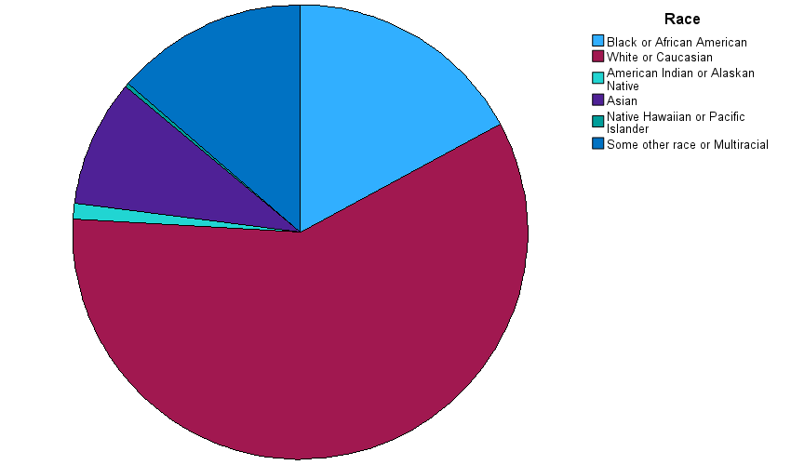
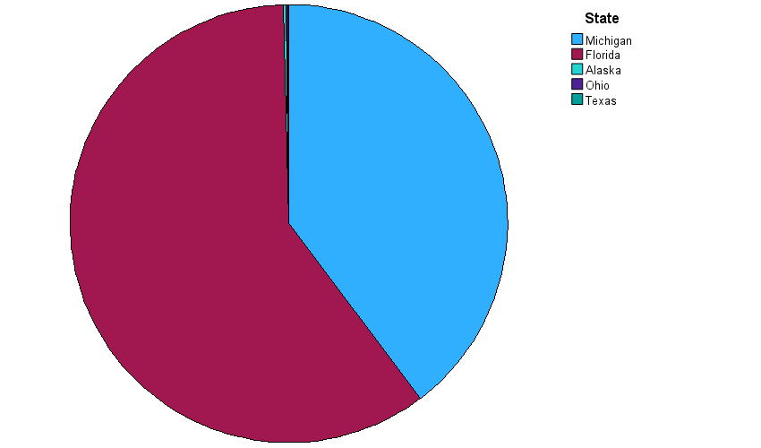

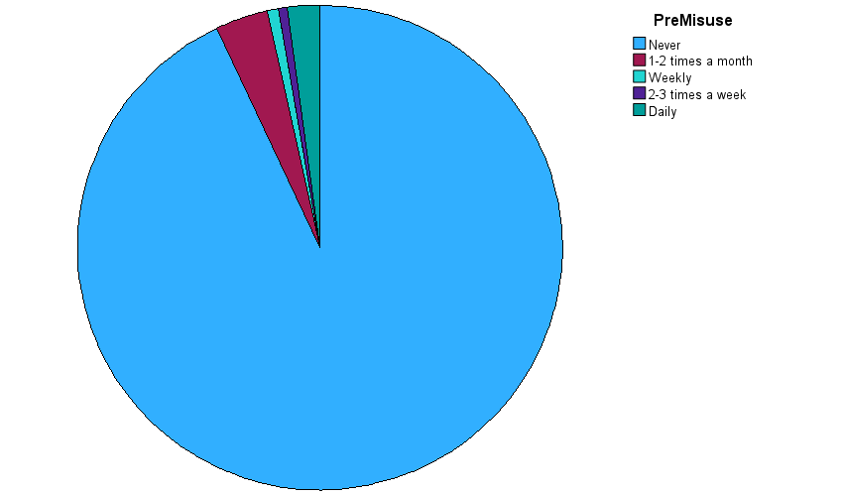
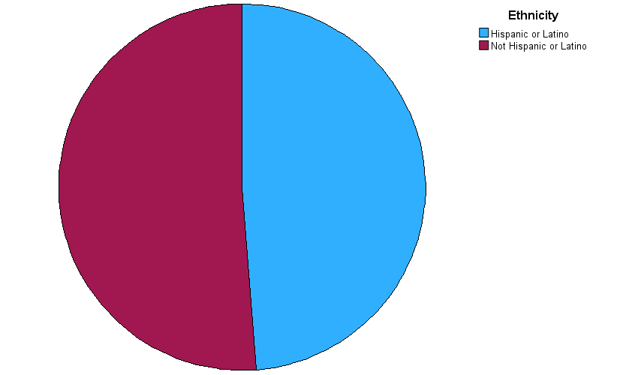

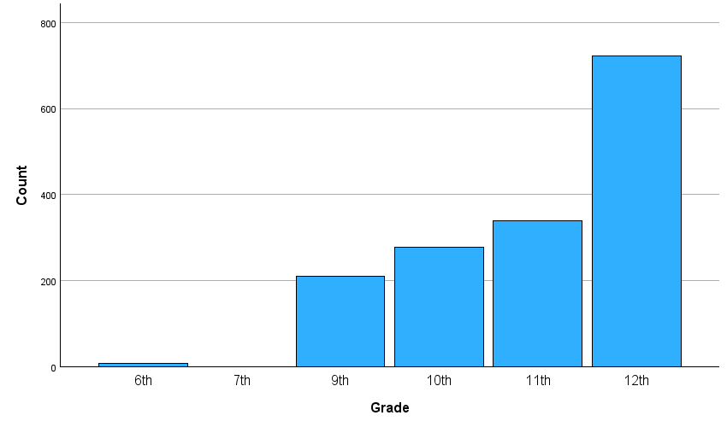
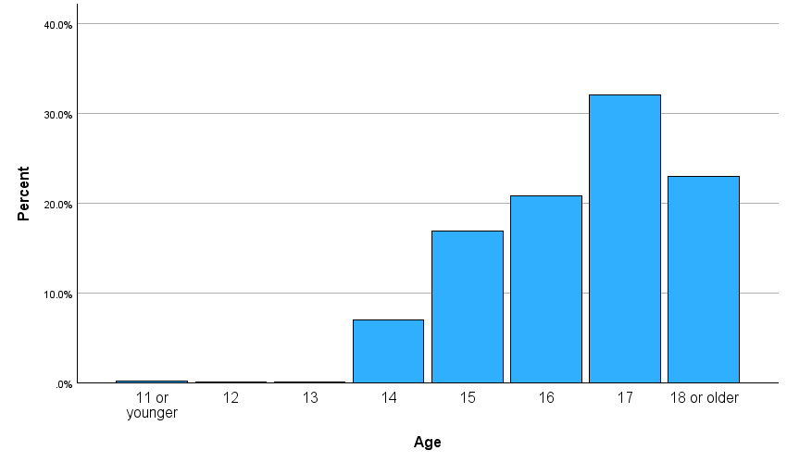

Figure 2. Graphical depictions of program demographics and baseline misuse for Michigan
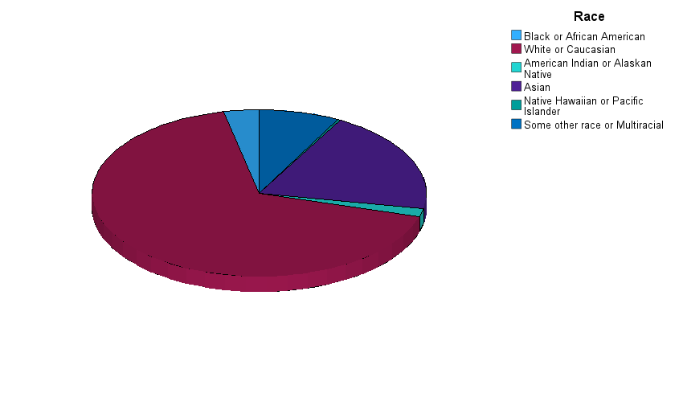

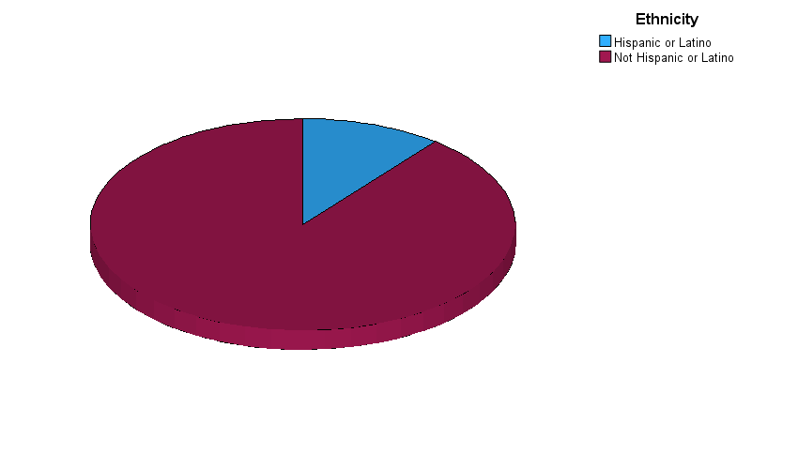

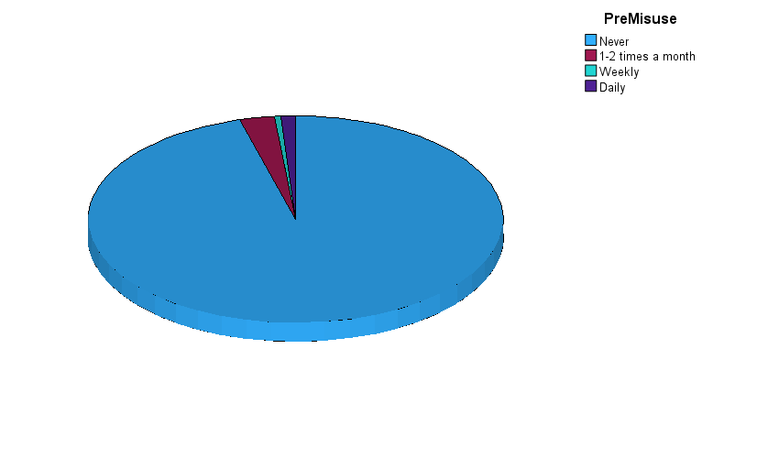

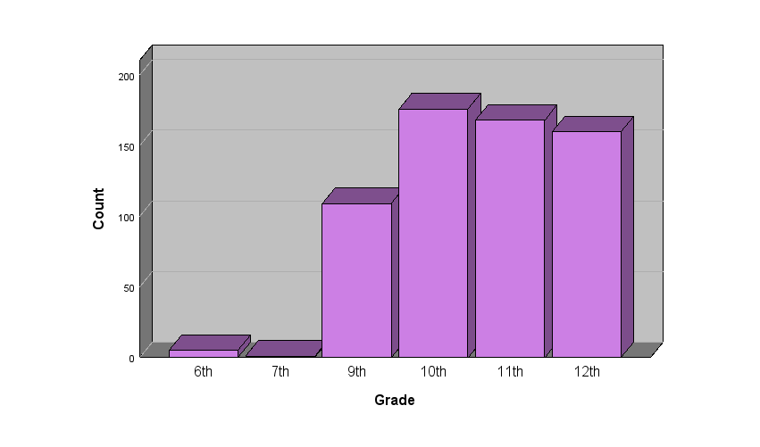
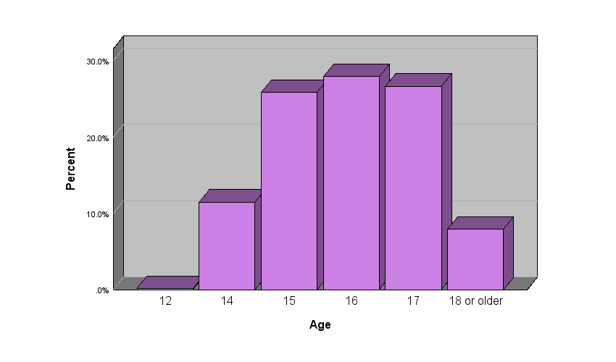

Figure 3. Graphical depictions of program demographics and baseline misuse for Florida

