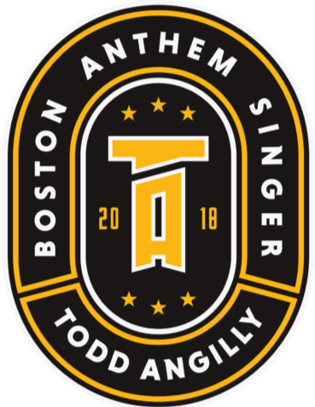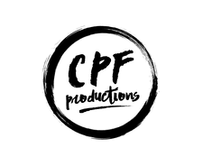

**Todd Angilly & Friends Christmas Music Mixer**

**A Time For Giving Back**

**Sunday December 10, 2023 6:00pm**

**At Lynn Auditorium**

**Hello business friends**

**We are very excited to announce our kickoff to the Todd Angilly & Friends Christmas Music Mixer: A Time for Giving Back on Sunday December 10 at Lynn Auditorium. This is an exciting show for us filled with local talent and celebrities performing alongside Todd to celebrate the holiday season AND to give back to some local groups. This year’s beneficiaries will include My Brother’s Table in Lynn, The Matt Light Foundation, Boston Bruins Foundation, Angilly Opportunity Scholarship and Ray Bourque Foundation. All of these groups do amazing things for people in need and we are excited to be working with them to give a portion of the events proceeds to each group.**

**This event comes with some expenses and we are reaching out to our friends to help us make this a memorable event AND keep this going into an annual holiday show to help different groups every year. We have attached some sponsorship opportunities available to our friends that would like to help out and to be a part of this show. Not only do we want your sponsorship, we also want you at the event and to join us in any and all events attached to this. Please take a look at the tiers below that we’ve made and let us know if any of these fit into your budget and we can discuss further. Of course, anything Todd can do to make your experience even better, he would be happy to do if he can accommodate it.**

**We plan to announce the event on Friday September 1st and pre sale tickets will be on sale Wednesday September 6th, with general public tickets Friday September 8th. So we are working to get our ducks in order now.**

**Thank you for your time and we look forward to hearing back. Please contact Todd Angilly at** [**angillytodd@yahoo.com**](mailto:angillytodd@yahoo.com) **or Chris Flahive from CPFProductions at chris@cpfproductions.com**

**SPONSORSHIP OPPORTUNITIES FOR THIS EVENT:**

**Tier 1: $250 includes your business name in our program, mentioned on social media ads week of show and 2 comp balcony tickets**

**Tier 2: $500 includes your business name in our program, mentions on social media ads throughout our advertisement, logo on banner in lobby, 4 comp balcony tickets**

**Tier 3: $1000 includes your business name in our program, mentions in all social media ads throughout promotions, mentions on radio spots, 6 lower balcony comp tickets and 2 tickets to VIP after party. Plus an appearance at your business with social media video shout out by Todd (LIMITED SPOTS LEFT)**

**Tier 4: $2500 includes all of the above, plus mentions on any live TV spots during Bruins game, company logo on banners on side of stage, 10 floor level comp tickets, 6 passes to VIP after party. Plus an appearance at your business with social media video shout out by Todd**

**Their 5: $5000 is the Title Sponsor. Includes all above plus banner in center stage backdrop, 20 floor level comp tickets, 10 VIP after party tickets and more. Plus an appearance at your business with social media video shout out by Todd**

**For more information on sponsorship, please contact Chris Flahive at** [**chris@cpfproductions.com**](mailto:chris@cpfproductions.com)**. All checks made payable to CPFProductions.**

**Thank you!**