Chapin Greene Condominium Association

Storm Door Specifications

The following storm door styles are approved for Chapin Greene Condominium Association.

You may choose whatever door manufacturer you like. The only requirement is that the model & style you select fits either of the following description.

**Door Style:** Full View – The daylight opening is the full length of the door. This can be a self storing window/screen or full removable window & screen.

**Hardware/Handle:** It is recommended to select the lever style handle which are ADA compliant for easy operation.

**Color:** The door color must be white. The exterior handle mount & lock should either be black or pewter/nickel.

**A “Request for Alteration” application MUST be submitted for approval prior to installation or contractor commitment.**

* EXAMPLE: Full View storm door with removable glass and screen and lever door handle.

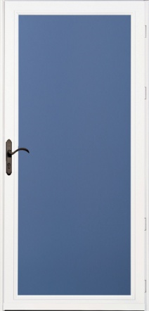

* EXAMPLE: Full View storm door with self storing glass and screen with lever door handle. The only noted difference is the mullion across the center of the door.

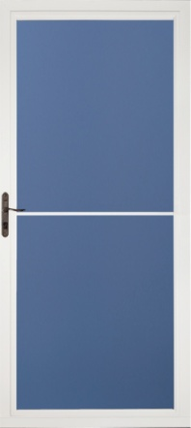 *August 2016*