Privacy Policy- Learning the Baby Dance. 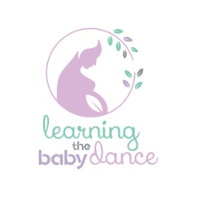

www.learningthebabydance.com.au

Phone 0421642568

Email: jenni@learningthebabydance.com.au
Learning the Baby Dance (LBD) is committed to maintaining your privacy.
Information gathered in the process of care is documented on Cliniko website as it has high level protection and dual confirmation access. It is a place LBD notes can be written, and invoices and payments recorded.

At LBD we are committed to ensuring the confidentiality and security of your personal information (including health and other sensitive information). We are bound by the Privacy Act 1988 and the Australian Privacy Principles (APPs).
We are legally bound to take notes to ensure that best care can be provided.

How we use your information
LBD collects your personal information (including health and other sensitive information) to provide you with Lactation, pregnancy, birth, parenting education products and services. LBD will inform you and seek permission if it would need to disclose information to help in the provision of its services.
We will collect and use information about you during your relationship with us.
It is important that the information we hold about you is up to date. It would be good if you let LBD know when information you have provided has changed.

Collection, use and disclosure of information.
We may use and disclose your personal information (including health and other sensitive information) for the following purposes:
- to assist in providing you with products and services.
- to consider your request for a product or service.
- to tell you about other products or services that may be of interest to you.
- to assist in arrangements with other organisations if requested in relation to the promotion or provision of a product or service.
- as required by relevant laws, regulations, codes of practice and AHPRA
- As a mandatory reporter LBD may have to disclose if you or your baby is a risk of harm to seek further help. LBD always aims to be transparent in this process.

Marketing and Privacy
LBD may use your personal information to send you information about our products and services from time to time.
LBD will also seek feedback to improve services.

