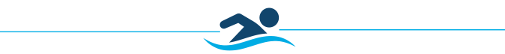
LOGO/IMAGE
 | Members | Members | Non-Members | Non-Members
 | Single Lesson | Package of 5 | Single Lesson | Package of 5
Private Lessons | $45 | $200 | $85 | $400
Semi-Private Lessons  (2-4 participants) | $32.50  Per Person | $147.50  Per Person | $52.50  Per Person | $247.50  Per Person

For more information, please visit us at
Benefits Entail
- One on One Instruction. Your instructor is devoted entirely to your individual needs, this
may be preferred over a group since the instructor would have to share their attention among
several students.
- Focus and Curriculum. There is no required or set curriculum, seeing how it will be based on what the individual wants to learn or improve on.
- Ease of Scheduling. As diverse as XXXXX lesson schedule is, you may not find that your
level isn’t offered at a convenient time for you. Many customers pursue private lessons for the
flexibility of scheduling.
Lesson Rates
- Lessons are 30 minutes in duration.
- Private lessons involves only 1 student in each lesson.
- More than 1 student at a time would be a semi-private lesson, which can hold up to 4 students.
Students must all be at the same skill/ability level.
- The cost of semi-private lessons is higher per lesson, but lower per student.
- Discount rates available when you purchase 5 lessons at a time. All lessons must be paid for before starting the first session.
Private and Semi-Private Lessons

PRIVATE LESSONS

