Homeschooling Rescue & Recreation Program
“Homeschooler R&R Program”
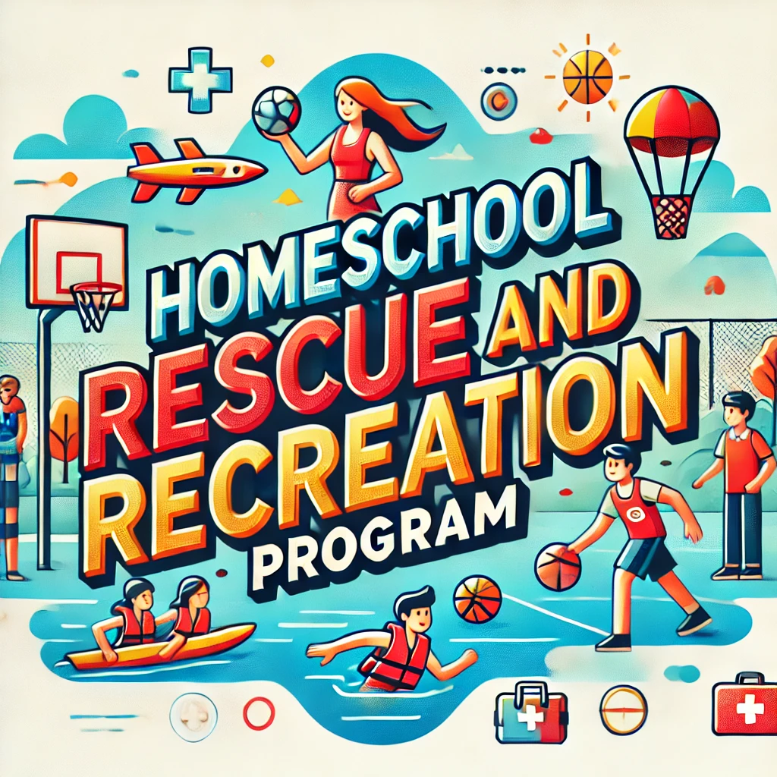

-Courses provide CEU credits-

Week 1: Babysitting Basics & CPRO Introduction
Main Goal: Develop core babysitting skills and introduce advanced CPR concepts for professional rescuers.
- Day 1 (3 hours):
  - Babysitting Basics (3 hours):
    - Responsibilities, communication with parents, safety, and injury prevention.
    - Discuss common emergencies in babysitting and how to manage them.
- Day 2 (2 hours):
  - Babysitting Essentials (2 hours):
    - Infant and toddler care (feeding, diapering, napping).
    - Introduction to behavior management and emergency protocols.
- Day 3 (3 hours):
  - Babysitting Emergency Response (2 hours):
    - Role-playing scenarios for managing injuries and illnesses.
  - CPRO Introduction (1 hour):
    - Overview of CPR for Professional Rescuers, discussing the differences from standard CPR.
- Day 4 (2 hours):
  - CPRO Basics (2 hours):
    - Basic life support (BLS) introduction.
    - Role of a professional rescuer, legal considerations, and team-based response.
- Day 5 (3 hours):
  - CPR for Professional Rescuers (3 hours):
    - Adult and child CPR introduction.
    - Airway management and checking for breathing and pulse.

Week 2: Advanced CPR for the Professional Rescuer
Main Goal: Focus on in-depth CPR skills required for professional rescuers.
- Day 6 (3 hours):
  - CPR for Infants and Children (3 hours):
    - 2-person CPR techniques for infants and children.
    - Using rescue breathing and pulse checks for infants and children.
- Day 7 (2 hours):
  - CPR/AED Integration (2 hours):
    - Using an AED in an emergency for adults and children.
    - Team CPR with AED and oxygen administration.
- Day 8 (3 hours):
  - CPR Scenarios (3 hours):
    - Hands-on practice in simulated emergency scenarios (cardiac arrest, drowning, etc.).
    - Rescue breathing and bag-valve-mask (BVM) techniques.
- Day 9 (2 hours):
  - First Aid Integration (2 hours):
    - Administering advanced first aid in emergencies (bleeding control, fractures, spinal injuries).
    - Connecting first aid with CPR response.
- Day 10 (3 hours):
  - Advanced Airway Management (3 hours):
    - Airway obstruction, conscious choking, and unconscious choking techniques.

Week 3: Emergency Preparedness Focus
Main Goal: Build comprehensive emergency preparedness skills and integrate them with professional rescuer responses.
- Day 11 (3 hours):
  - Introduction to Emergency Preparedness (3 hours):
    - Types of emergencies (natural disasters, medical, fire, chemical incidents).
    - Discuss how professional rescuers prepare and respond.
- Day 12 (2 hours):
  - Emergency Action Plans (2 hours):
    - Creating emergency action plans for families and groups.
    - Assembling and maintaining emergency supply kits.
- Day 13 (3 hours):
  - Evacuation Drills & Scenarios (3 hours):
    - Evacuation procedures and drills for different types of emergencies (fire, floods).
    - Applying professional rescuer techniques in high-stress situations.
- Day 14 (2 hours):
  - First Aid for Natural Disasters (2 hours):
    - Treating injuries during natural disasters (fractures, bleeding, burns).
    - Role of a professional rescuer in providing care until help arrives.
- Day 15 (3 hours):
  - Scenario Day (3 hours):
    - Simulated emergencies combining evacuation, first aid, and CPR skills.

Week 4: Integration of Skills & Certification Prep
Main Goal: Apply all skills learned in simulated real-world scenarios and prepare for certification assessments.
- Day 16 (3 hours):
  - Babysitting Practice with CPR Integration (3 hours):
    - Advanced babysitting scenarios where students respond to common emergencies, integrating CPR and first aid knowledge.
- Day 17 (2 hours):
  - CPRO Advanced Practice (2 hours):
    - Scenario-based training with 2-rescuer and team CPR, including AED use.
- Day 18 (3 hours):
  - Emergency Preparedness Simulation (3 hours):
    - Simulating full-scale emergencies (medical, fire, chemical) where CPR and emergency preparedness plans are implemented.
- Day 19 (2 hours):
  - Skills Review and Practice (2 hours):
    - Review all key skills: CPR, AED, choking response, first aid, and emergency preparedness.
- Day 20 (3 hours):
  - Certification Day (3 hours):
    - Final assessment and practical evaluation for CPR for Professional Rescuers, babysitting, and emergency preparedness.
    - Completion of Red Cross certification requirements.

Summary of Time Allocation:
- Babysitting: 10 hours
- CPRO (CPR for Professional Rescuers): 15 hours (Certification focus)
- Emergency Preparedness: 10 hours
By the end of this month-long curriculum, participants will be equipped with advanced CPR skills required for professional rescuers, babysitting knowledge, and comprehensive emergency preparedness, ready to obtain certifications in all areas through the American Red Cross.

