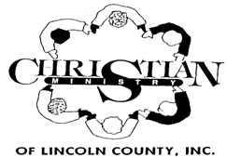

**2020**

**Christian Ministry Holiday Schedule**

**REMEMBER…SOUP KITCHEN IS ALWAYS OPEN… 11:30AM TO 12:30PM**

**January 1 – New Year’s Day**

**January 20 – Martin Luther King Day**

**April 10 – Good Friday**

**May 25 – Memorial Day**

**July 3 – Independence Day**

**September 7- Labor Day**

**November 11 – Veteran’s Day**

**November 26 & 27 – Thanksgiving**

**December 24, 25 & 28 - Christmas**