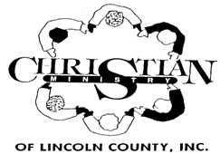

**2022**

**Christian Ministry Holiday Schedule**

***Including LINC Home Delivered Meals***

**December 31, 2021 – New Year’s Eve**

**January 17 – Martin Luther King Day**

**April 15 – Good Friday**

**May 30 – Memorial Day**

**July 4 – Independence Day**

**September 5- Labor Day**

**November 11 – Veteran’s Day**

**November 24 & 25 – Thanksgiving**

**December 26, 27 & 28 – Christmas**

**New Year’s Eve – January 2, 2023**