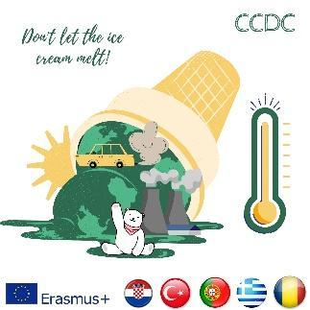

**Result and Report of the Digital Games Assessment Test in the 3rd Mobility**

The test (<https://forms.gle/DzhBCz37JREfdYhG7> ) was applied on 4th May 2023.

According to the results;

1. 18 online teachers took part in the assessment test. Teachers are ranked as eighteen participants from Escola Secundária de Penafiel, University of Split, Osnovna škola Strožanac, SŠ Braća Radić Kaštel Štafilić, Şehit Murat Tuzsuz MTAL, Trabzon Yeşiltepe Primary School, Anadoluhisari Secondary School, Mustafa Kemal Atatürk MTAL, Γυμνάσιο ΛΤ Χάλκης and Gymnasio L T Chalki.
2. The branch/domain of the participants is ranked as ICT, French and Portuguese, English, Associate Professor, Information Science, Food Technology, Microbiology, Ecology, Renewable Energy Teacher, Primary School Teacher, Maths, Turkish Language, ΠΕ 06, Computer Science.
3. 100% of the participants think that this training has helped them acquire a better understanding on how you can use digital games in the classroom to subconsciously raise students’ awareness on climate change and its impact on the environment.
4. Participants think that games are a great way of motivating and assessing students’ knowledge. The training has appeared to be wonderful according to the participants, with digital games they believe they can practice and learn more about climate change. Participants have come up with an idea that with their knowledge, they can teach students this engagement which will promote a better atmosphere in class as well as a subconscious effective learning.
5. 100% of participants think that these kinds of games are effective.
6. All of the participants find these kinds of games effective and define them as simple, useful, motivating, interesting and fun. They think that students like digital apps and it helps facilitate a warm atmosphere at class.
7. 94,4% of the participants find these kinds of games motivating. 88,9% of the participants also believe that games help students reinforce or master the already taught content. 72,2% of the participants suggest that games can teach students new content. 66,7% of the participants think that games provide information about student learning.
8. To teach supplemental content not mentioned by curriculum standards and to cover content mandated by curriculum standards are ranked equally at 61,1% rate in terms of delivering core and supplemental curriculum content that will lead to increased students’ awareness on climate change and its impact on environment. 55,6% of the participants are likely to plan to assess students on supplemental knowledge and /or skills. 50% of the participants consider conducting formative and summative assessment of students’ standards-based curriculum knowledge and/or skills.
9. Participants think that there are strong aspects of the content of the training session such as working as a team, creative activity, actual knowledge, accessible content, interesting supplement, comprehensive study, imaginative atmosphere, and intriguing context.

1. Participants have some suggestions to improve the content of the training session such as better coordination, more detailed instructions, adding animation characters and sound effects, providing learners with well-prepared materials, feasible resources and time management. A great deal of participants find the games comprehensive enough, though.

The visuals from the results were shared below:

Formlar yanıt grafiği. Soru başlığı: Q1- Do you think this training has helped you aquire a better understanding on how you can use digital games in the classroom to subconsciuosly raise students’ awarness on climate change and its impact on environment ?


. Yanıt sayısı: 18 yanıt.

Formlar yanıt grafiği. Soru başlığı: Q2 Do you believe that this kind of digital games are effective ?

 . Yanıt sayısı: 18 yanıt.

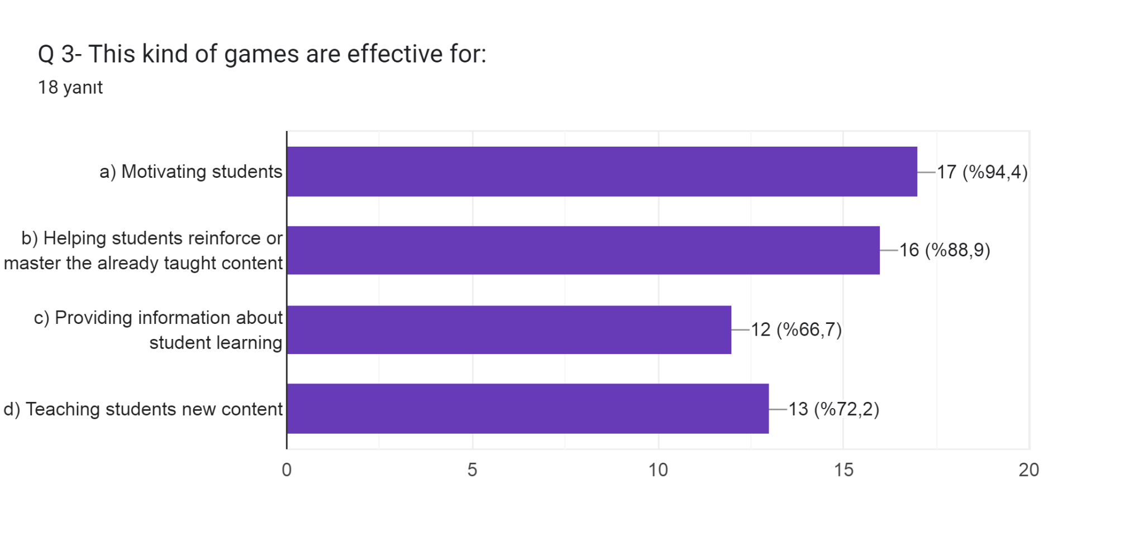

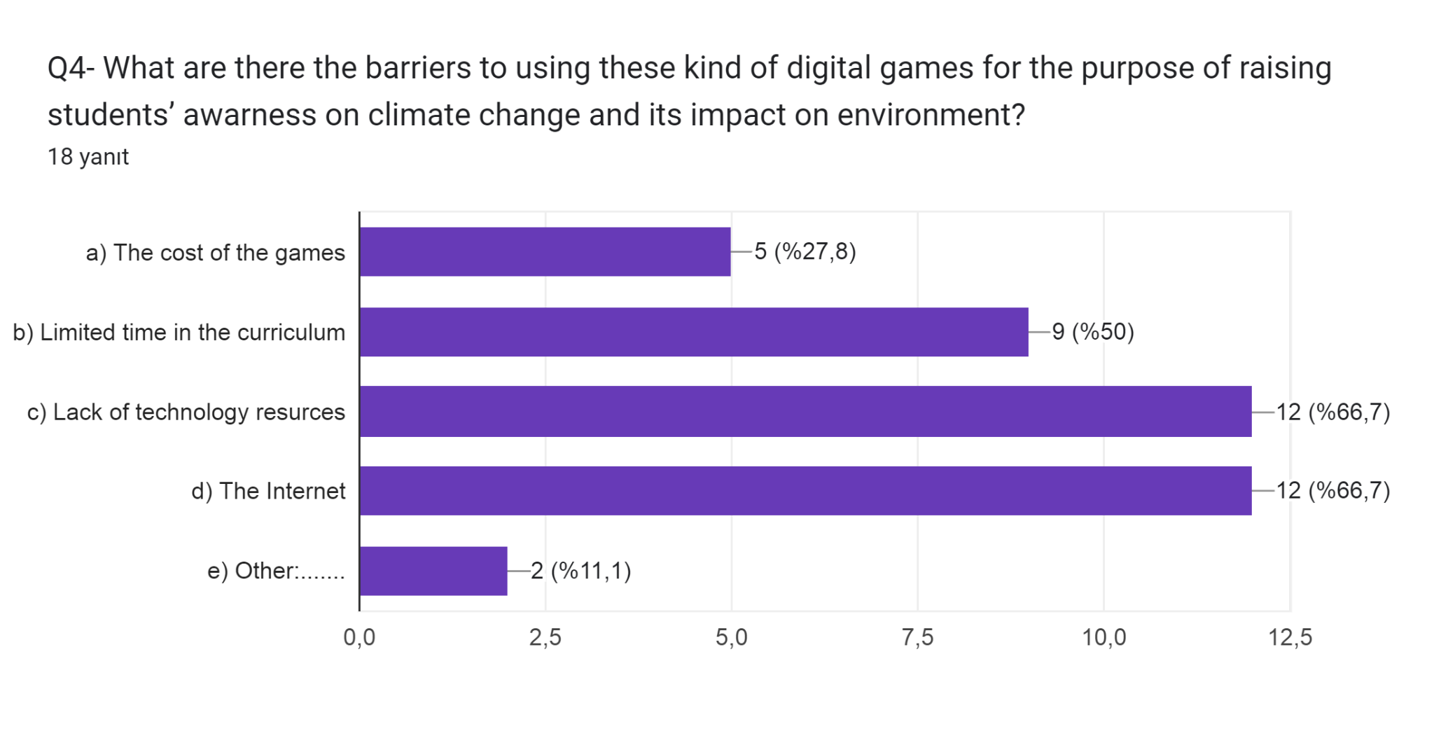

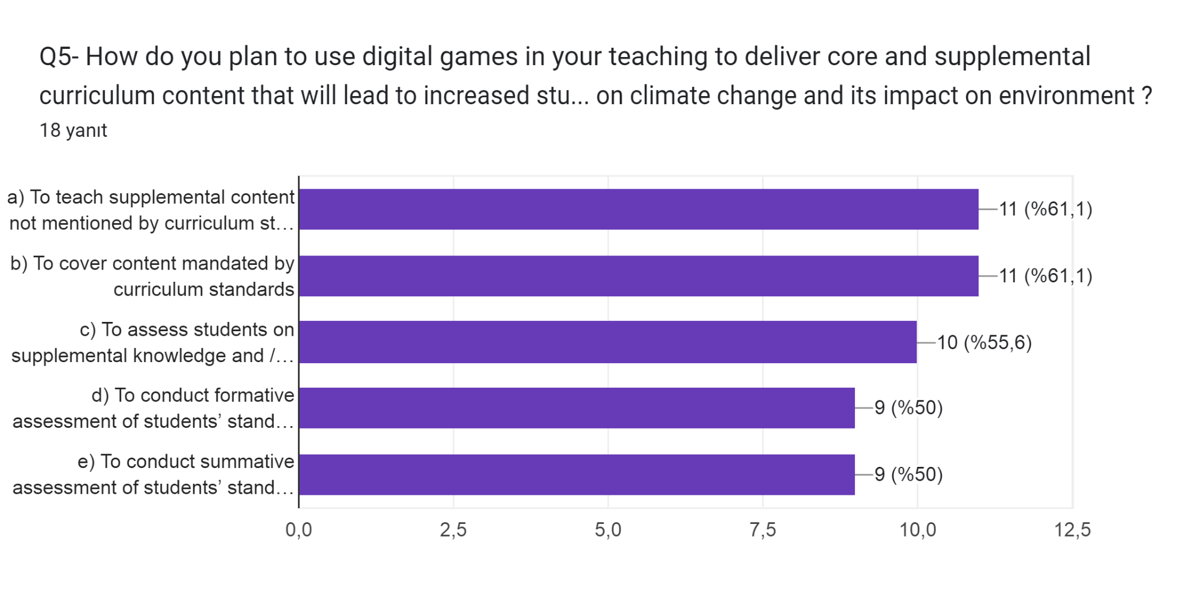

"*The European Commission's support for the production of this publication does not constitute an endorsement of the contents, which reflect the views only of the authors, and the Commission cannot be held responsible for any use which may be made of the information contained therein."*