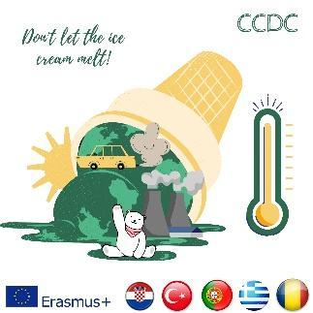

**The Result and Report of the Transnational Meeting Assessment Test for Online Students in the 4th Meeting (Croatia)**

The test was applied in the 4th transnational meeting held in Split, Croatia (01-05 October 2023). 21 online students have implemented the test (<https://forms.gle/BYzg2mVGB7DSYBGx8> ). The report from the result can be seen below;

According to the results;

1. The participants were from Hoca Ahmed Yesevi Anatolian High School, Escola Secundária de Penafiel, and Gymnasio Halki.
2. 42.9% of the participants rated the satisfactory aspect of the games played in the mobility as 5 out of 5, whereas the other 42.9% of them rated it as 4 out of 5. 9,5% of the participants rated the satisfactoriness of the games as 2 out of 5, while 4.8% of them rated as 1 out of 5.
3. 54.4 % of the students rated the organization of the activities as 5 out of 5. While 18.2% of them rated the organization as 4 out of 5, 27,3% of them rated it as 3 out of 5.
4. 54.5% of the online participants/students thought that attendance was well organized and they rated it as 5 out of 5. 36.4% of the online participants rated this organization as 4 out of 5, whereas 9.1% of them thought it could be rated as 3 out of 5.
5. 63.6% of the participants stated that online games are well designed and students have acquired the knowledge of how to make games and they rated it as 5 out of 5. The rest of the participants, 36.4% of them rated it as 4 out of 5.
6. 90,9% of the participants rated the parkour’s organization as 5 out of 5. However, 9,1% of them rated it as 4 out of 5.
7. 72,7% of the participants thought that the mobility in Split met their expectations and rated it as 5 out of 5. 27,3% of them found it fulfilling in the ratio of 4 to 5.

The visuals from the results were shared below;

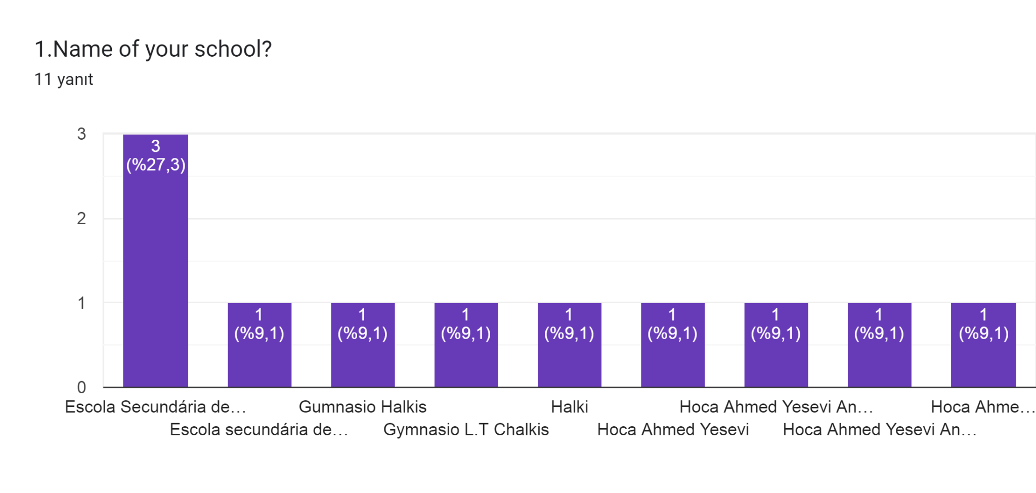

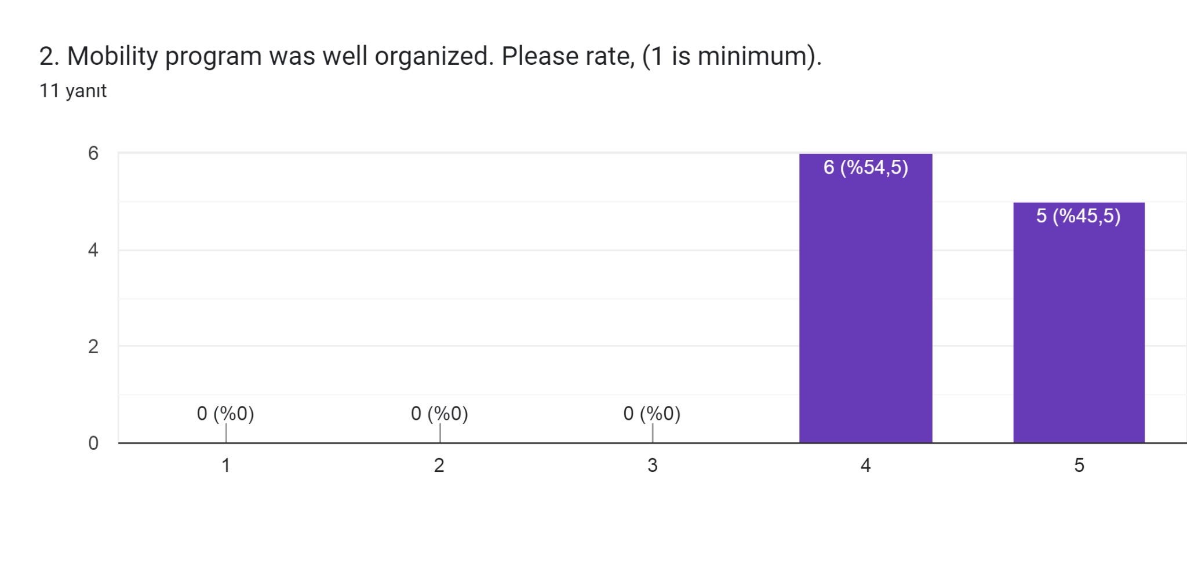

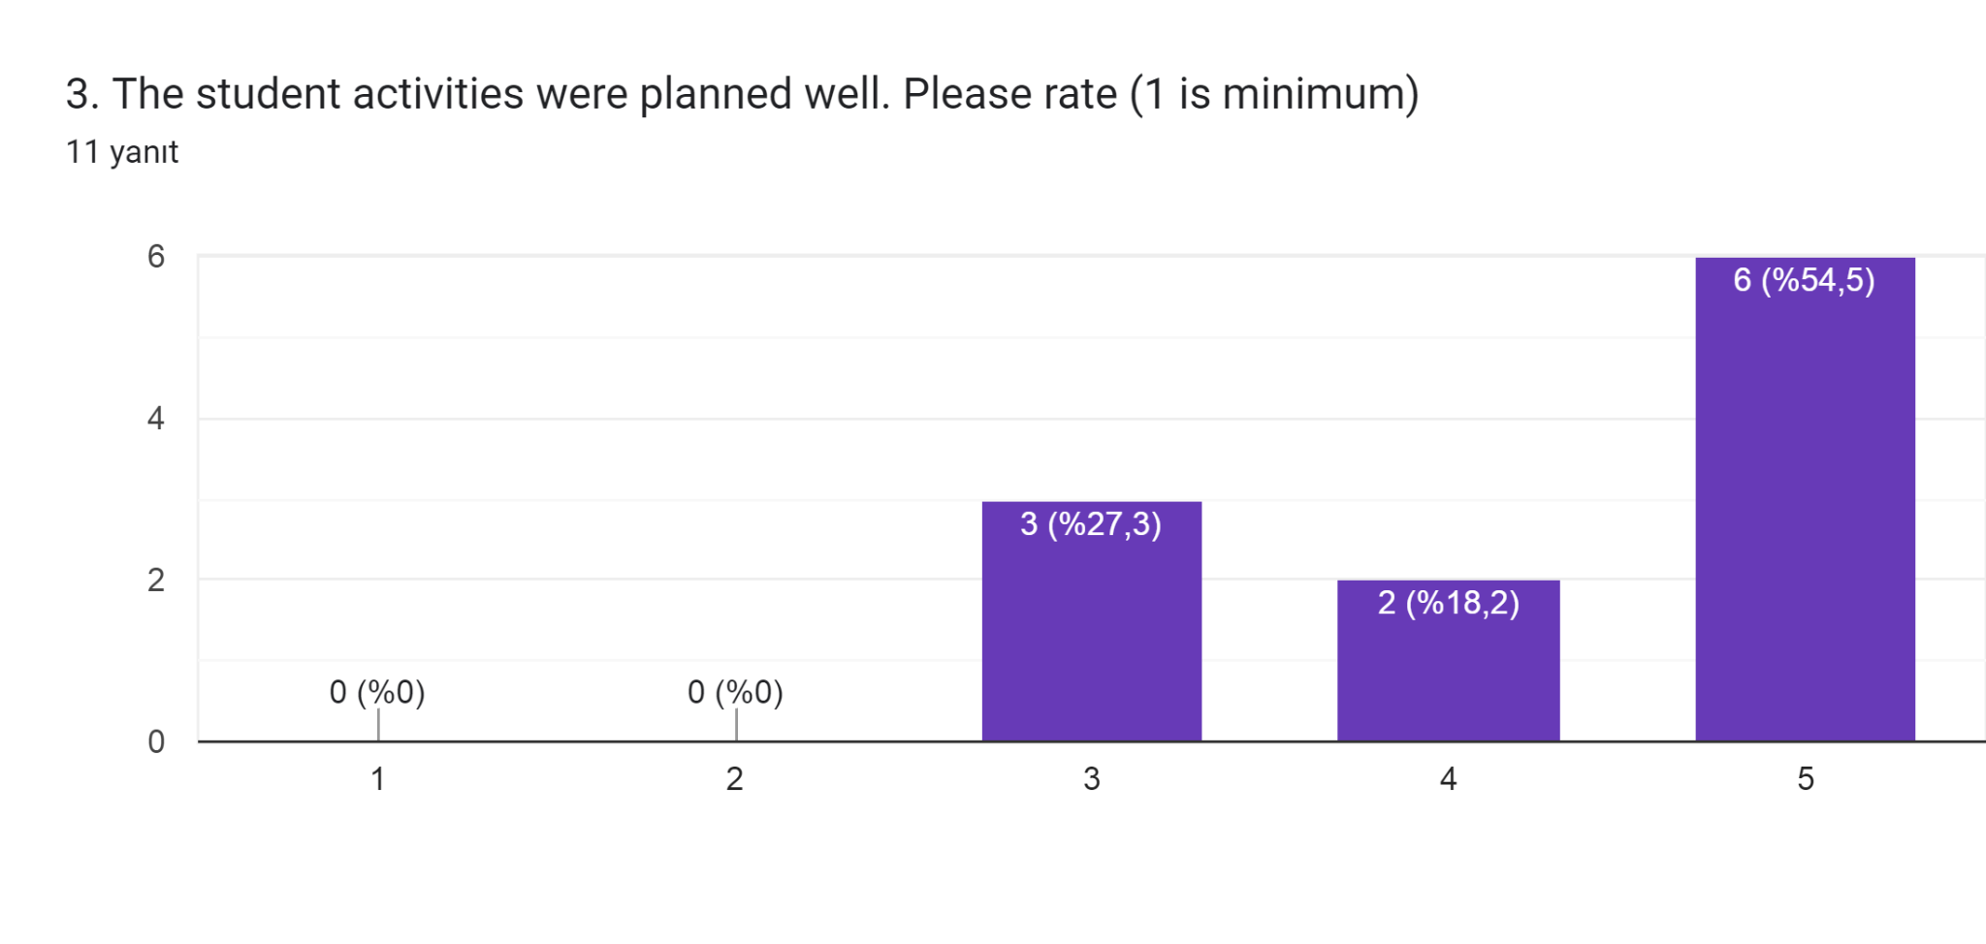

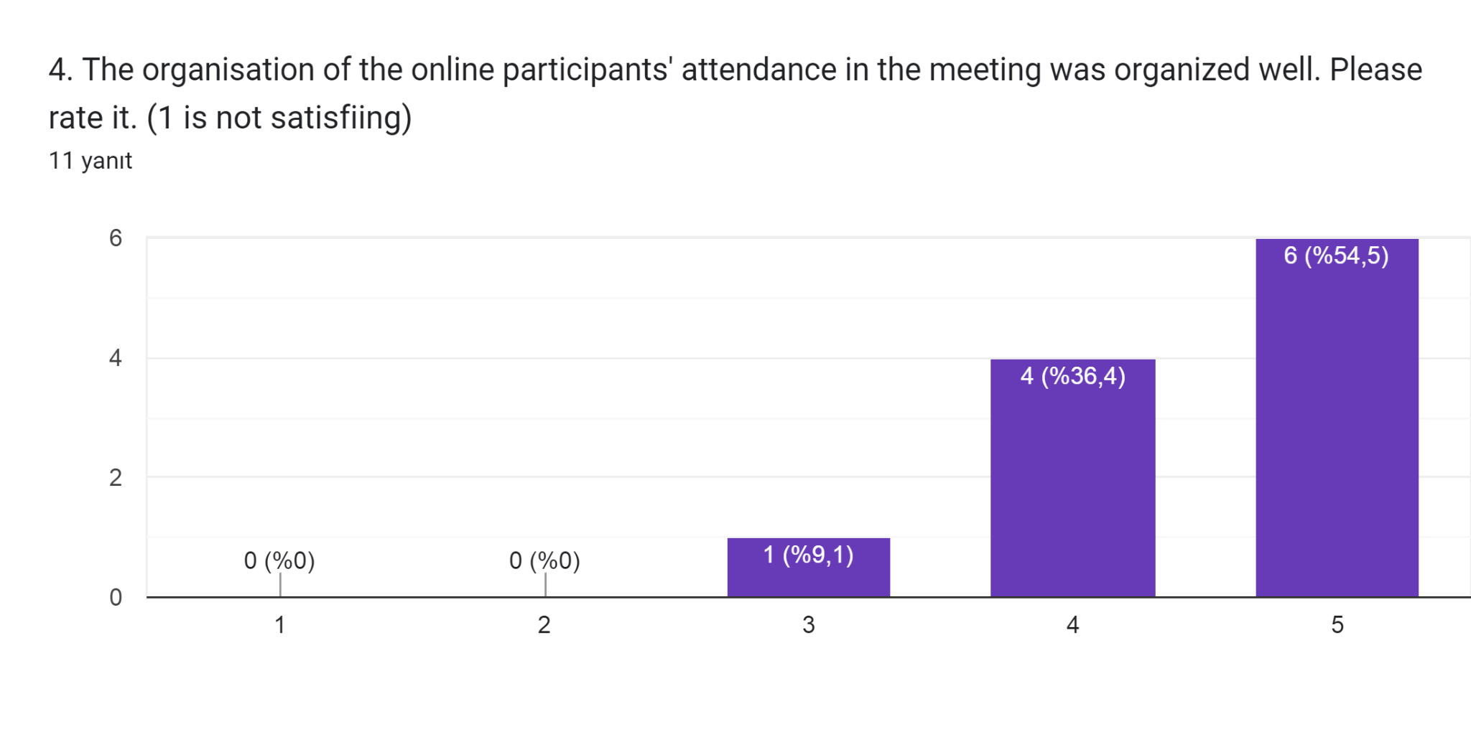

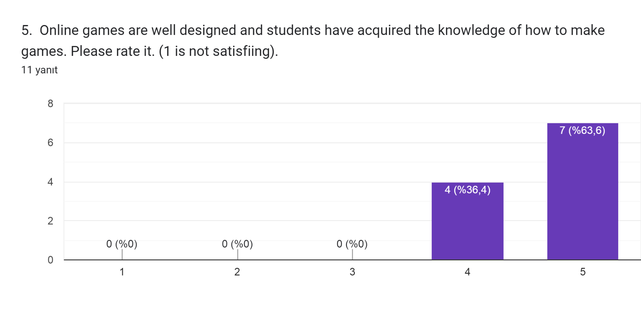

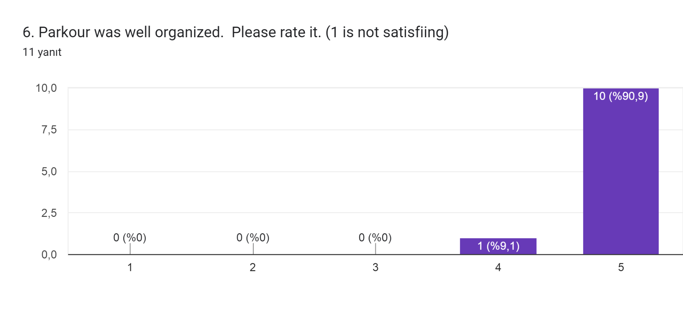

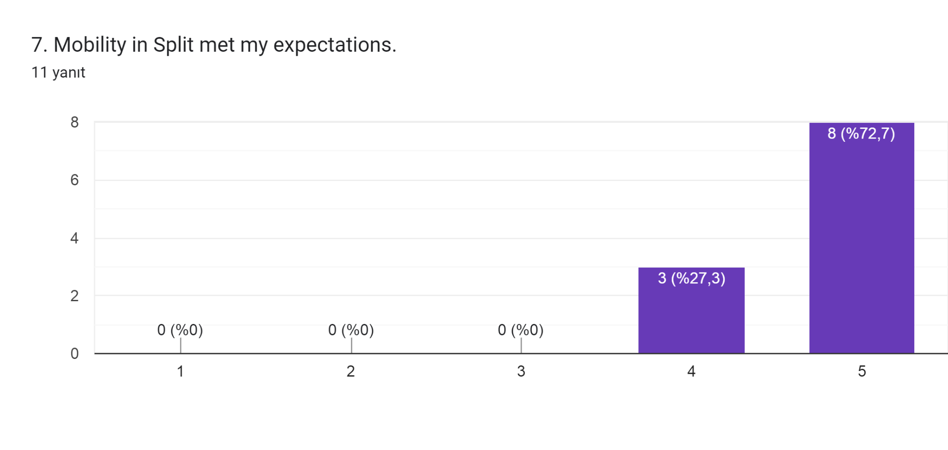

"*The European Commission's support for the production of this publication does not constitute an endorsement of the contents, which reflect the views only of the authors, and the Commission cannot be held responsible for any use which may be made of the information contained therein."*