LUNGS Whitepaper

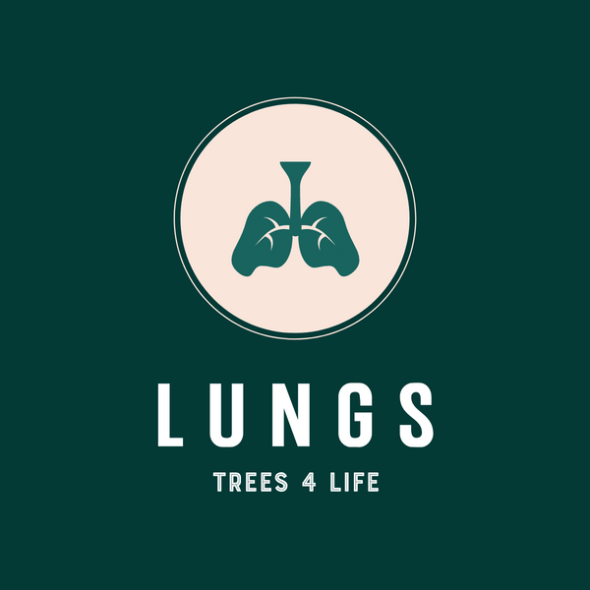

BUY BACK YOUR PLANET - “If you can’t beat them, buy them out” – Hansjorg Wyss

Overview

Lungs is a blockchain based multi-media ecosystem, centred around an interactive digital forest online platform and app.
The purpose of which is to raise funds that feed directly into World Land Trust’s 'Buy an Acre' forest projects and engage a global user network on a long term basis. Thus, vastly expanding the power and effectiveness of the World Land Trust (WLT) model to efficiently purchase and protect larger sections of Forest globally.

Through the platform and app we sell parcels of a digital forest and give the funds to World Land Trust (WLT)

We incentivize interaction within the digital space through innovative gaming elements, to educate and encourage long term donating and micro-donating towards the ongoing protection of the Forest reserves.

By using the provenance and tangibility of blockchain technology we aim to bridge the gap between donators and conservation efforts by pairing our LUNGS tokens with geographic co-ordinates mapped from the real forest, to relay it’s data and facts to the owners of the matching digital space within the platform.

We reward real world or in app positive actions. We use technology and creative arts to reward, inspire, educate, connect and direct the power of individuals all working together towards a symbiotic relationship with the natural world.

We form partnerships in order to spread our user network and symbiotic society model globally and across as many industries as possible affording our users a wide ecosystem to be a supporting part of and to benefit from.

Buy Back Your Planet will be the MO of LUNGS. Because that’s what we aim to do. The aim of LUNGS is to harness technology and creative multimedia to turn every member of the general public into ‘positive action global citizens’, putting the power and responsibility for our planet’s natural world into the hands of those that, given the correct support network, will nurture and protect it.
We want every person to be part of the LUNGS network, taking an active role whether that be as an app user, a creative input node, business participation, a conservationist, or a reserve employee. From volunteer to investor, we want everyone. Because we believe that every single person on earth is not only accountable but powerful, no matter their circumstance.
One individual choice or action can make a difference, combining billions of individuals making the right choice and taking the right actions can change the world.

