SEMINAR ENROLLMENT AGREEMENT 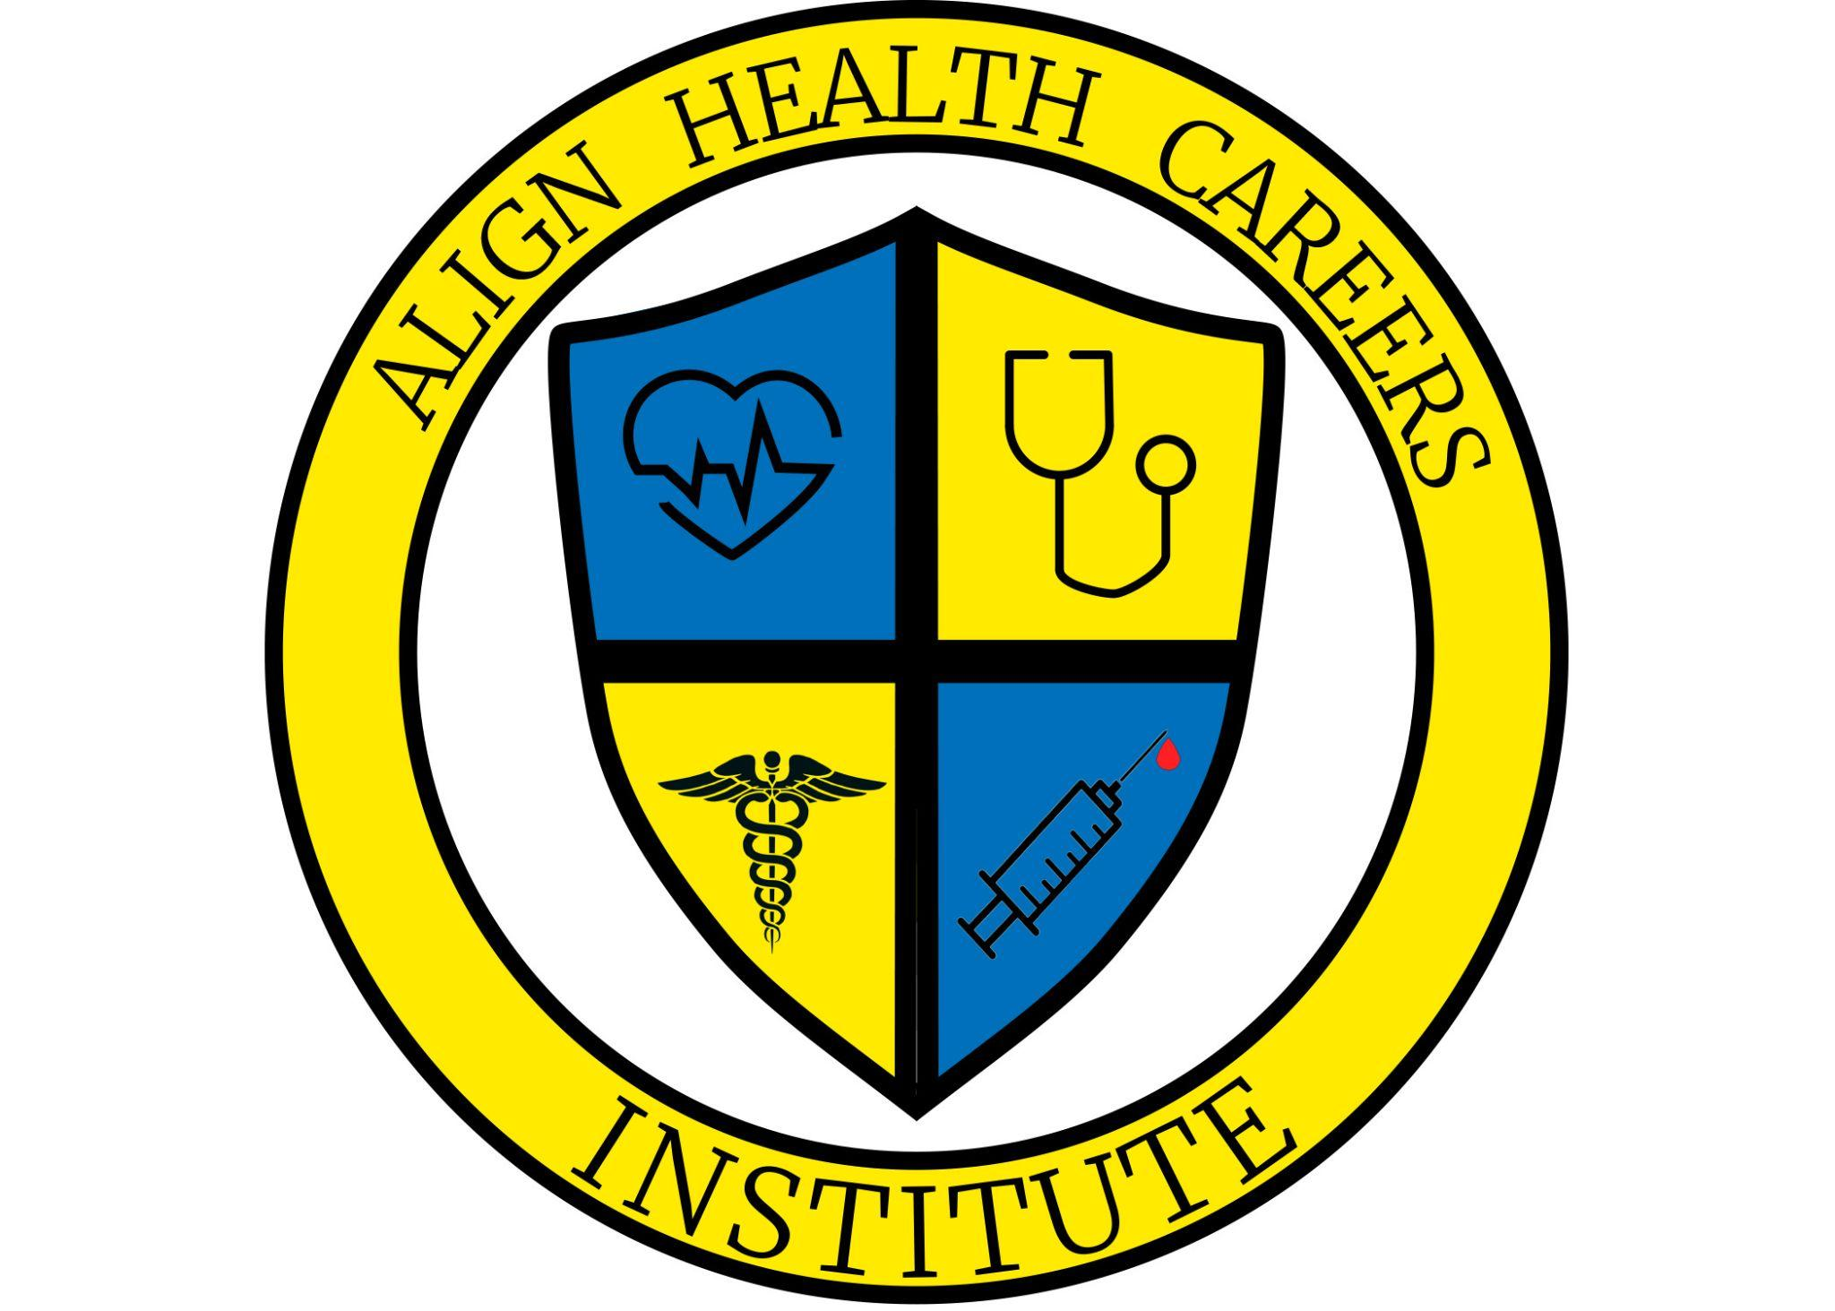

School Name: ALIGN HEALTH CAREERS INSTITUTE, LLC
Address: 2080 N. HWY. 360 #385
City: GRAND PRAIRIE State: TEXAS Zip: 75050
Telephone:469-984-6203 E-mail Address: ALIGNHEALTHCAREERS@GMAIL.COM

Student Information
First Name: Last Name:
Address:
City/State/Zip:
Telephone:
E-mail Address:
DOB:

COURSE and COURSE COST
Circle One/Highlight One:
IV Therapy Seminar

Phlebotomy Seminar

Contact Hours 3.5 Cost $350.00

Contact Hours 3.5 Cost $350.00

Nursing Assistant Seminar Contact Hours 24 Cost $450.00

*Fee is estimated and based on current cost and subject to change.

METHOD OF PAYMENT (check one)
Money Order ( ) Cashier Check ( ) Cash ( ) Other ( )
Approved and regulated by the Texas Workforce Commission, Career Schools and Colleges, Austin, Texas.

Phlebotomy Release of Liability Form (Page 1 of 2)
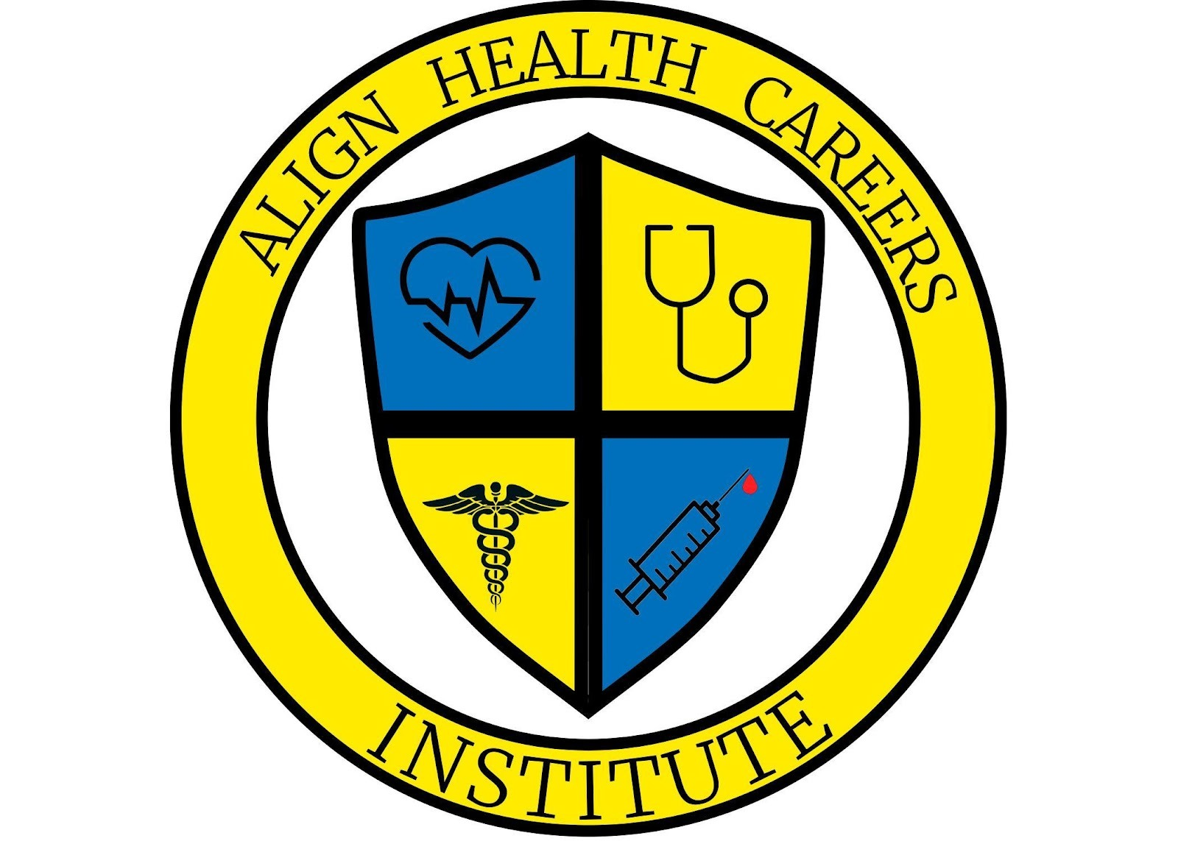
This section must be completed ONLY by participants enrolled in the Phlebotomy Seminar. If you selected IV Therapy or Nursing Assistant, do not complete this section.
The purpose of this document is to limit the amount of liability Align Health Careers Institute, LLC holds in regard to phlebotomy practices held on campus among students in the Phlebotomy Technician Program.
The following procedures are performed among students:
- Phlebotomy – the inserting of a needle into the arm of another person for the purpose of withdrawing blood.
- Finger Stick – the inserting of a lancet into the finger of another person for the purpose of withdrawing blood.
I UNDERSTAND AND HEREBY EXPRESSLY ACKNOWLEDGE that, as part of the instruction that I am to receive in the Phlebotomy Technician Program, I may be asked to perform phlebotomy and finger stick procedures or that another student may be asked to practice these procedures on me. Further, I understand and hereby expressly acknowledge that these activities might, under some circumstances, pose certain health-related risks.
I HEREBY RELEASE, WAIVE, DISCHARGE AND COVENANT NOT TO SUE Align Health Careers Institute, LLC, its officers, directors, board members, agents, servants, employees, assigns, or successors, or students of the schools Phlebotomy Technician Program, from any and all liability, claims, demands, actions or causes of action arising out of any damage, loss or injury to my person or my property or resulting in my death, while enrolled in Align Health Careers Institute, LLC Phlebotomy Technician Program and participating in the activities contemplated by this RELEASE, whether such loss, damage, or injury is caused by the negligence of the training center, its officers, agents, servants, employees, assigns, or successors, or students of Align Health Careers Institute, LLC Phlebotomy Technician Program or from some other cause. I hereby assume full responsibility for and risk of bodily injury, death or property damage that I suffer while performing the above-stated procedures from Align Health Careers Institute, LLC Phlebotomy Technician Program or from any person involved, employed or representing Align Health Careers Institute, LLC Phlebotomy Technician Program and participating in the activities contemplated by this release, caused by the negligence of Align Health Careers Institute, LLC, its officers, directors, agents, servants, employees, assigns, or successors, or students of Align Health Careers Institute, LLC Phlebotomy Technician Program or otherwise.
I FURTHER UNDERSTAND that I may decline participation without penalty at any time. Consent to participate will allow me to perform the above-stated procedures on another member of the class and/or he or she may also perform those skills on me. All skills will be performed under the direct supervision of Align Health Careers Institute, LLC Phlebotomy Technician Program.
By signing this form, I am consenting to performing the procedures stated above and to having the above procedures performed on me and I am releasing Align Health Careers Institute, LLC from liability from any injury that might occur as a direct result from these procedures.
I HAVE READ AND VOLUNTARILY SIGN THE RELEASE AND WAIVER OF LIABILITY, and further agree that no oral representations, statements of inducement apart from the foregoing written agreement have been made. Further that I have read and that I understand this release of liability agreement, that I have been given an opportunity to ask any questions I might have had, and that those questions have been answered in a satisfactory manner. I also understand that I am free to withdraw my consent to the procedures at any time.
If the student is under 18 years of age, and not an emancipated individual, you must complete this form and it must be signed by a custodial parent or guardian.

Phlebotomy Release of Liability Form (Page 2 of 2)
Student Name (Print):
Date of Birth:

Student Signature:
Parent or Guardian Signature, if applicable:

Date:

I certify that my answers are true and complete to the best of my knowledge.
DISCLAIMER AND SIGNATURE
If this application leads to enrollment, I understand that false or misleading information in my application or interview may result in my release.

Printed Name:
Signature:
Date:

