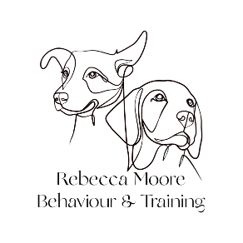

Referral Form for Dog Behaviour Consultation

Behaviour problems may arise both directly and indirectly as a result of concurrent or previous medical problems. Veterinary involvement is therefore essential in eliminating organic causes of the problem and prioritising the diagnostic and treatment strategy to be used in any given case. To safeguard the welfare of your client and their pets, and indicate your approval or referral, please complete the following form and return it with the patient’s medical history:

Referring Veterinarian:

Practice Name and address:

Post Code:

Telephone: Email address:

Owner’s name: Patient’s name:

Species/breed: Age:

Sex inc. neuter status and date of neutering:

Brief details of the behaviour problem:

Are you aware if the owner is considering euthanasia in this case?

I hereby acknowledge my approval for the client described above to be referred for management, training and or/behavioural therapy of the current behaviour problem to Rebecca Moore Behaviour

Signed: Date:

Medical history

Date of last health check:

Are you able to clinically examine the patient? Yes / no

Please indicate if there are any current medical problems (e.g., orthopaedic, dental, endocrine):

Details of any ongoing medical conditions or treatments:

PLEASE ATTACH A FULL MEDICAL HISTORY AND ANY LABORATORY TEST RESULTS WITH THIS REFERRAL

Please scan and email this form along with the medical history to rebeccamoorebehaviour@gmail.com

