Grant Writer By The C
Writing samples
Grant proposal for NH non-profit A.R.T.S.: Adaptive Art, Respite & Therapeutic Play Services Inc.
The attached grant proposal is one of many written for this 501(c)3 organization over an 11-year period. Every year a grant funding search was performed matching A.R.T.S. to local & regional Charitable Trust Foundations & Charities. Grants were awarded to A.R.T.S. every year to fund specific projects. Twice A.R.T.S. was a Red Sox Foundation recipient.
Published Book Samples:
Meet Me Where I’m At by Cindy Best and Joyce Shor Johnson
This book was published by Future Horizons Inc., a leader in Autism resources, in 2017. It was designed as a visual tool to help children with autism advocate for themselves. Cindy Best created the concept, wrote the content and brought it to life as a book with the help of Joyce Shor Johnson. www.FHautism.com
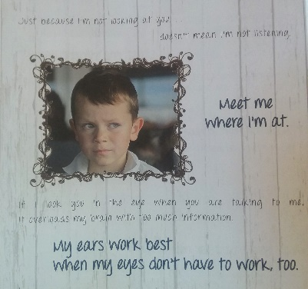
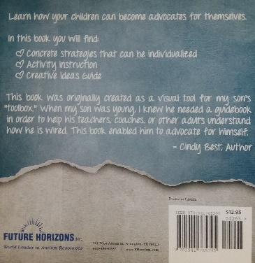
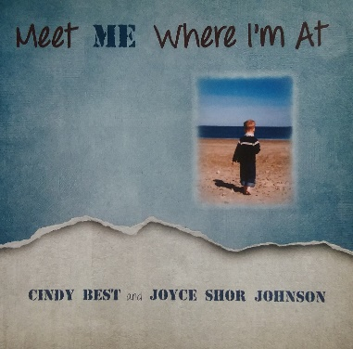

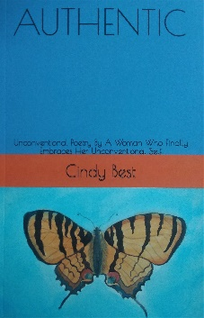
Authentic: Unconventional Poetry By A Woman Who Finally Embraces Her Unconventional Self by Cindy Best Self-published through Kindle Direct www.amazon.com

