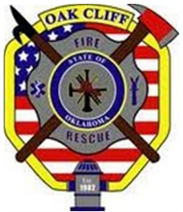

Job Posting

The Oak Cliff Fire Department is now accepting applications for paid firefighters.
Candidates applying should be a licensed EMT or higher and should also possess certification in Firefighter 1, Haz-Mat Operations, and NIMS 100, 200, 700, 800 (or the IFSAC/ Pro Board equivalent).
Please provide a cover letter, resume, copies of applicable certifications, and a completed application packet in person, to the Oak Cliff Fire Department station 1 located at 13425 S. Bryant Ave. Edmond, Ok 73034.
An application packet and information regarding the position, benefits, and compensation can be obtained by:
Contacting Fire Chief Blake Hutsenpiller at 405-340-9115
In person at Oak Cliff Station 1

Completed applications must be received on or before 5:00 p.m. on December 13, 2017. Candidates selected to continue the application process will be contacted after the closing date.
All candidates must successfully complete a written exam.
All candidates must successfully complete the Oklahoma State Firefighter Pension Minimum Physical Performance Agility Test.
All candidates must meet the eligibility requirements of the Oklahoma Firefighter Pension and Retirement System and pass an extensive background check prior to employment.

