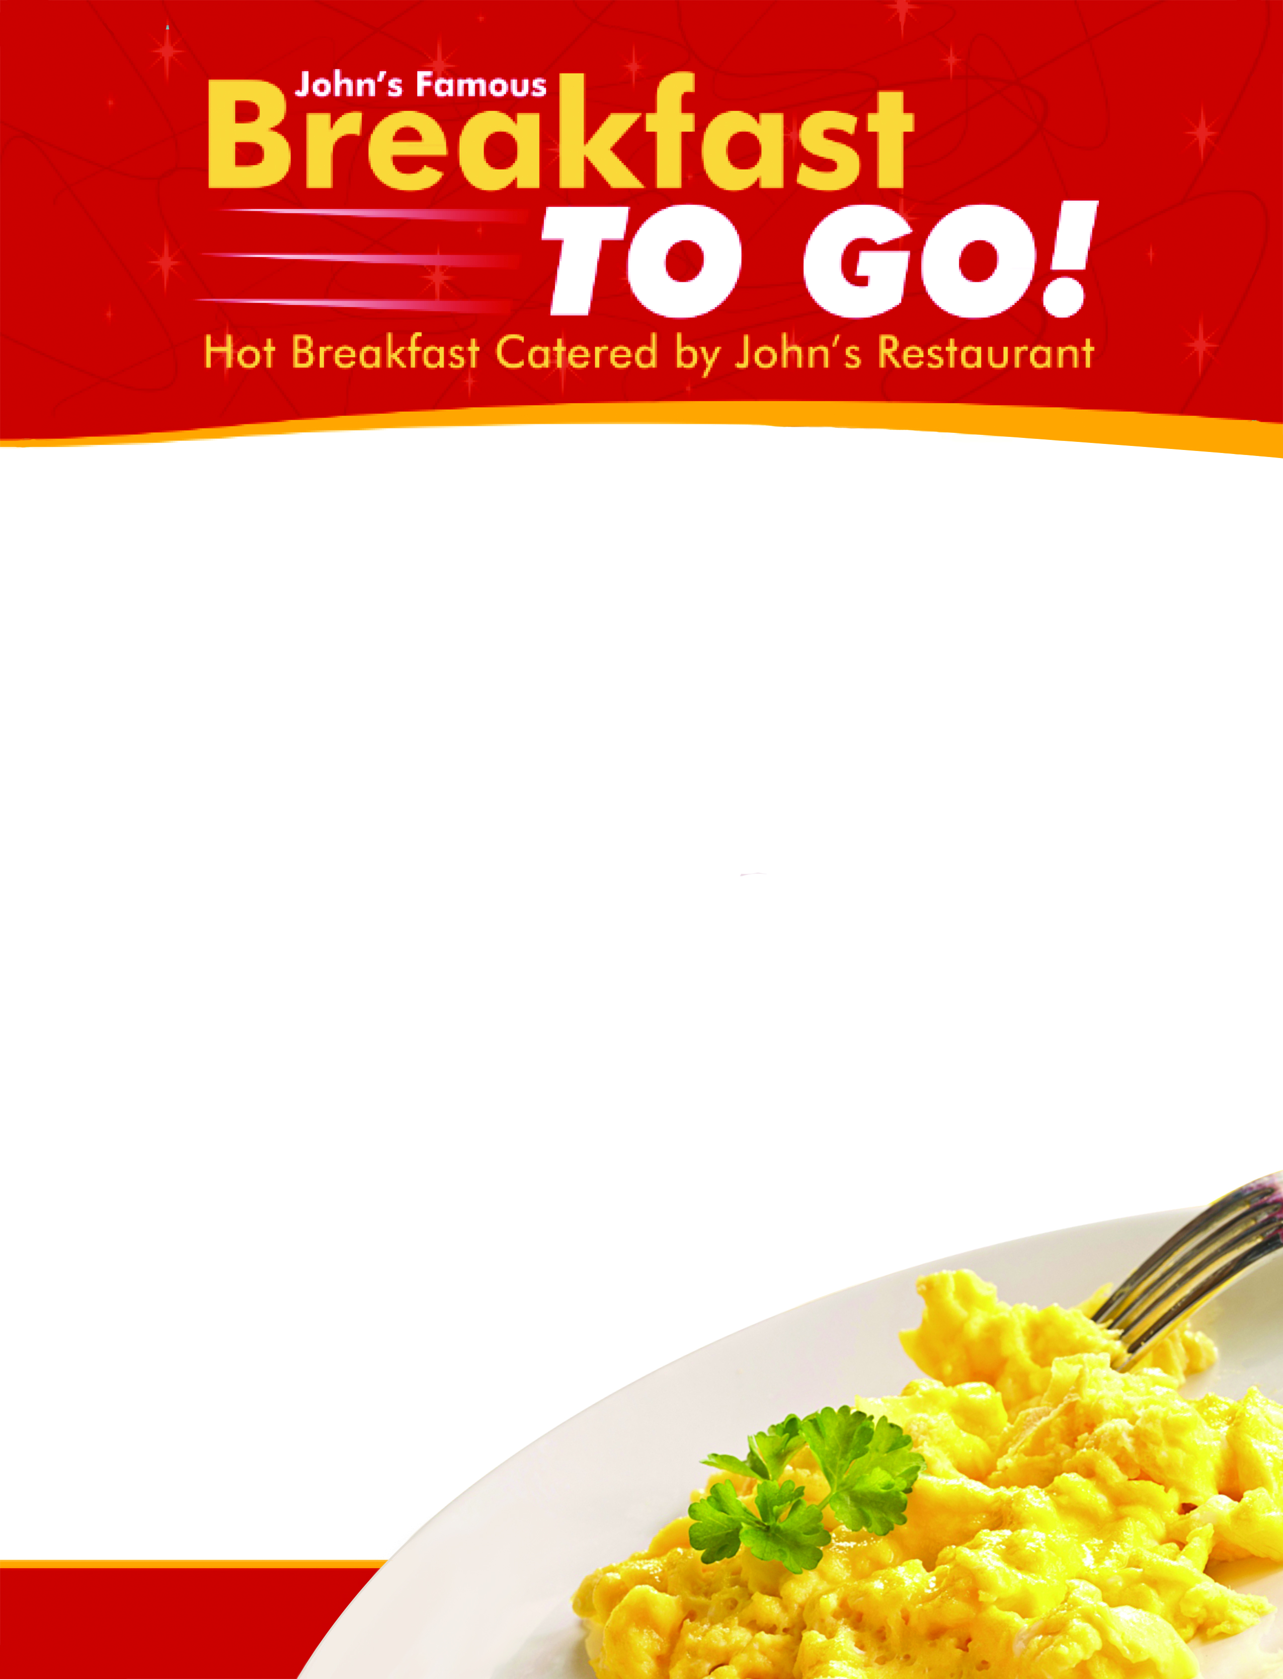
PICK THE BREAKFAST THAT IS RIGHT FOR YOUR GROUP
SERVES 10 TO 300+ PEOPLE

SERVED HOT AND READY TO GO WITH PLATES, SILVERWARE AND ALL THE FIXINGS.

ALL YOUR JOHN’S FAVOURITES!
EGGS, BACON, HOME FRIES, PANCAKES, ASSORTED BAGELS, COFFEE URN, JUICE

$9 per person
Includes eggs, bacon, sausage, potatoes and English muffins.

Add pancakes for $1.95

LUNCH OR DINNER CATERING

Sandwich trays to Roast Turkey Dinners….
Check out our catering menu for your next business meeting,
special event, or family function.

MORNINGS AND BREAKS
- Sweets Platter
Assorted squares including brownies, carrot cake, butter tarts. $2.50 per person.

- Assorted Muffins
A platter of freshly baked muffins. $2.25 each.

- Assorted Cookies
Freshly baked cookies. $1.50 each.

- Assorted Bagels
A platter of bagels, includes cream cheese. $2.79 each.

- Butter Tarts
A Canadian classic. $2.25 each.

- Fruit Platter. An assortment of seasonal fruit.
Small $38 (Serves 10-15)
Large $68 (Serves 16-25)
LUNCH
- Wrap Platter
An assortment of chicken, ham & cheese, and veggie. $9 per person.

- Sandwich Platters
A selection of assorted sandwiches. Served in quarters (halves by request only). $6.95 per person.

- Deluxe Cheese & Cracker Tray
Small $35 (Serves 10-15)
Large $68 (Serves 16-25)
Add meat - $15 small, $20 large

HOT ITEMS - CATERING
JOHN’S SIGNATURE ROAST TURKEY DINNER
- Choice of tossed or Caesar salad & rolls
- John’s famous Roast Turkey with dressing & gravy
- Corn
- Potato – choice of house roasted potato, rice or mashed potato
$19 / person

CHICKEN ENTRÉE

- Choice of tossed or Caesar salad & rolls
- Choice of marinated grilled Lemon Chicken, Chicken Mediterranean, BBQ Chicken
- Vegetable
- Potato – choice of house roasted potato, rice or mashed potato
$16 / person

CHICKEN SOUVLAKI

- Greek Salad & Pitas
- Chicken Souvlaki (two skewers per person)
- Tzatziki sauce
- Potato – choice of house roasted potato, or John’s special seasoned rice
$16 / person

CHICKEN PARMESAN WITH PASTA or POTATOES

- Choice of tossed or Caesar salad & garlic bread
- Chicken topped with melted mozzarella and marinara cause served with Penne noodles in John’s famous
meat sauce
- You may also substitute roasted potatoes instead of spaghetti
$18 / person

PASTA

- Garlic Bread
- Choice of tossed or Caesar salad
- Penne noodles topped with John’s famous meat sauce
$13 / person

SIDES
- BACON SLIDERS
Served with Honey Mustard on side

- MINI CHICKEN SKEWERS
Mini Souvlaki sticks are a great appetizer for your group! Served with a choice of Tzatziki (our favourite), BBQ, or Honey Mustard dressing. $75 for approximately 50 mini skewers.

- SAMOSAS
Deep fried, vegetarian Indian style Samosas. Served with dipping sauce. $45 per tray.

- BONELESS CHICKEN WINGS
$65 for approximately 60-70 bite sized boneless chicken wings. Choice of BBQ or Honey Garlic.

- TOSSED SALAD or SALAD OF THE DAY
Complete with Ranch (or your choice) dressing. $3.75 per person.

- GREEK SALAD or CAESAR SALAD
Fresh Romaine topped with feta, black olives, onion and Greek dressing. $4.25 per person.

- VEGGIE TRAY
An assortment of veggies & ranch dip.
Small $30 (serves 10-15)
Large $60 (serves 16-25)

- ROCKET SALAD
$3.75 per person (seasonal)
- Box
Serves 8-10 for $16 QTY.

- ½ Large Thermos
Serves 30 for $35 QTY.

- Large Thermos
Serves 60 for $69 QTY.

- Tea Service
Serves 8-10 for $16 QTY.

COFFEE & BEVERAGE
- Soft Drinks (355ml cans)
$1.50 per person QTY.

- Bottles Water
$2 per person QTY.

- Assorted Juices
$2 per bottle QTY.

Our special insulated thermos serves up to
60 people and keep coffee fresh for up to
4 hours without burning or altering the flavour!

Includes cream, sugar and cups.

All coffee thermoses are to be returned
at the end of the day. Customer to drop off urn.

ROAST BEEF

- Choice of tossed or Caesar salad & Rolls
- Delicious Roast Sirloin of Beef served with gravy
- Vegetable
- Potato – choice of house roasted potato, rice or mashed potato
$19 / person

BBQ Ribs

- Choice of tossed or Caesar salad & Rolls
- BBQ Ribs
- Vegetable
- Potato – choice of house roasted potato, rice or mashed potato
$18 / person

SEAFOOD

- Choice of tossed or Caesar salad & Rolls
- Choice of Lemon Tilapia or Lemon Pickerel (add $2.00) – other fish varieties are available.
Ask about our selections.
- Vegetable
- Potato – choice of house roasted potato, rice or mashed potato
$17 / person (Note: Seasonal and fresh fish may be available. Ask us!)

Ask us about custom and specialty items.

Above orders require 72 hours notice in most cases.
Minimum order is 10 unless otherwise noted.
Prices do not include HST.

Hot items delivered in insulated boxes on request.
Boxes returned the same day by customer unless other arrangements are made prior to the event.

DELIVERY AVAILABLE
$10 charge for Sarnia. $15 charge to Petrolia, Bright’s Grove, Camlachie & Wyoming. $30 charge to Forest.
ALL PRICES SUBJECT TO CHANGE WITHOUT NOTICE.

LET JOHN’S COOK FOR YOUR NEXT LUNCH, DINNER, MEETING OR FUNCTION!
HOW ABOUT LETTING US BRING A GREEK DINNER TO YOU?

INCLUDES:
GREEK SALAD
PITAS OR ROLLS (PICK ONE)
Pita OR Rolls

ENTRÉE
Chicken Souvlaki

SIDE (PICK ONE)
Greek Style Roasted Potatoes OR Seasoned Rice

DESSERT (OPTIONAL)
Baklava (add $2 per person)

PRICING AND CONDITIONS
$16 per person (lunch portion $12 per person available daily until 3pm) One lunch Souvlaki
$2 per person for Baklava
4 days notice is required for most orders. Minimum order is 10
Paper plates, napkins, etc. available by request.
DELIVERY AVAILABLE
$10 charge for Sarnia. $20 charge to Petrolia, Bright’s Grove, Corunna, Camlachie & Wyoming. $30 charge to Forest.

ALL PRICES SUBJECT TO CHANGE WITHOUT NOTICE.

