We are Richard & Beverly McLemore and have accepted a huge task in taking care of our loved ones living with dementia. These may be your parents, relatives, peers or church friends – everyday, common people who deserve the respect that’s due them because of their age and status in our culture.

But our culture is changing.

You probably don’t know me, but I’m a veteran career senior executive in technology, having opened Oracle in Austin (2007) and the growth of other companies. So, I know technology and dementia, having been my dad’s primary caregiver previously. I wanted to take the two subjects I have vast experience with and see what contribution could be made for others lives.

My wife, Beverly, worked a decade with the AANP.org – the Nurse Practitioner national organization.

If I say the words ‘nursing home’, what were your immediate thoughts? Based on your upbringing, did your thoughts turn dark maybe even negative? Or, where they bright, pleasant but fleeting memories?

Our parents, relatives, friends and certainly us, deserve more from long-term care providers.

My passion is solely about caring for the elderly – the Baby Boomers. Those of us born between 1946-1964. Entering or already retired. My peers, family and friends. EVERYONE is aging, no exceptions.

We are in what experts have coined *‘The Silver Tsunami’*. This tsunami – as it will exists now and rapidly expanding – comes during (and due to) a combination of a few things – a large Baby Boomer generation approaching (or already in) retirement, longer life expectancy for the elderly, and a reduced birth rate, meaning that there are fewer younger people to balance the shifting workload.

Time to sober up and look at this graph from the US Census…

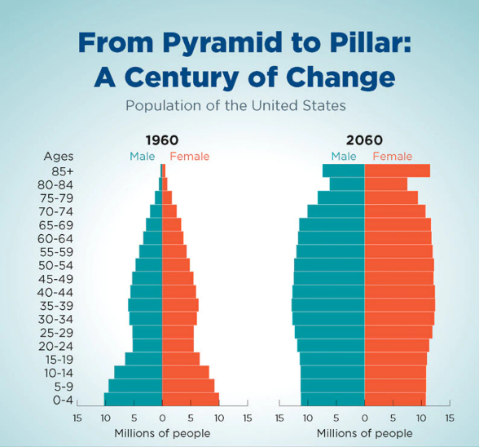

Me?  I want to take care of **Mom**!  And **Dad**! And my **loved ones**!!

The term silver tsunami fails to account for the asset of increasing numbers of older people, many of whom are reaping the benefits of better health and increased longevity. Its economic assumption presupposes a future of healthcare delivery that resembles the past. We are re-valuing how, and what, we pay for in healthcare and where we should invest in prevention. Even the delivery of long-term care will evolve in the future.

Also, this phrase does not convey what it means to get old and be old. The swell of people in the wave are individuals, with lives of purpose, meaning, and, yes, difficulty. Aging is a first-person experience.

But our culture remains awash with negative images and stereotypes of older people. Ageism is used to diminish and devalue people and is a convenient way to divide adults into two categories: us and them. Ageism distracts from the fundamental truth that advanced age is a period of human development.

We’ve all seen heartwarming movies about ‘paying it forward’.

*Pay it forward*is an expression for when the recipient of an act of kindness reciprocates by doing something kind for someone else, rather than simply accepting or repaying the original good deed. What you have is a unique way of paying it forward to your loved ones, associates – even yourself.

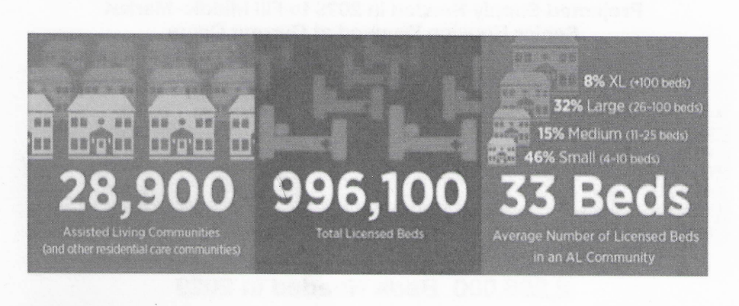

How? After researching the marketplace movement, there is going to be a great transition, impacting ordinary seniors in both financial and self-respect ways.

Financially, the impact of living at home vs a memory care facility is a major consideration. Memory care facilities typically charge $7000/mo for their services versus living in your own mortgage-free home. As your abilities diminish, you can duplicate everything you’ll receive in a facility in your own home.

First, is the location – the Dementia Proofed home. We will be in neighborhoods, where you live. Available for visits with your primary caregiver(s) and family, and close to familiar amenities.

Secondly, we are in residential homes, not brick/mortar/steel buildings. Yes, our homes will offer MORE than traditional facilities in many distinguishing ways – the usage of technology will be prevalent but unseen.

Third, we will adopt cutting-edge technologies that will provide definable and measurable results for the resident with dementia. ‘Big box’ facilities work hard to staff and provide 15:1 coverages of caregivers to residents. We find that unacceptable and will consult to deliver a constant and predictable 1:1 coverage ratio.

We’re going to do the ‘right things’ by our residents. They won’t have to move any personal items and furniture from their houses. You keep your animals, dogs and cats. We’ll even provide our residents with robotic animals if they prefer. We believe in total comfort for our residents, which is why they will be supplied with a technically-upgraded home, with underlying technology deployed such as ‘stand-up recliners’, even elevators or stairlifts where appropriate.

We have a vision and responsibility to help as many seniors as possible.  The ***Silver Tsunami*** is real and coming.  What is the ***Silver Tsunami*** you ask?  Simply put, it’s the Baby Boomers – born 1946-1964, and we’re aging in masses.  There are over 77 million Baby Boomers in the US, with 10,000 turning 65 every day!  4,000 are turning 85 every day!!  It’s estimated by AARP that 70% or 57M will required assistance with their Daily Living Activities.  It’s further estimated that 10% of the Boomers need Memory care (dementia, Alzheimer’s Disease) today and growing to 20% by 2030.

I personally set a target to serve 1,000 seniors in the next 5 years.  That’s a lot of homes in a lot of places.  But one thing I know for certain, my peers are frustrated by all the competition they face doing their ‘jobs’ in healthcare because of the uncertainty they face – ie. Inflation, energy shortages, immigration challenges, etc in our economy.

Not us.  We’re finding God’s blessings everywhere – the market is ready for higher standards of care in neighborhoods, not facilities.  Our level of care is 1:1, whereas big box facilities struggle with 15-20:1.  We will have certified senior living professionals supporting your house.

We are partnered with the best providers in every aspect of delivering personal care to our residents with dementia. We sought partners who shared the same passion and commitment we have for our residents. Enjoying relationships with Intelligence Dementia Coaches to our relationships with dementia health professionals globally to offering the security and conveniences that technology offers to seamlessly provide continuous and loving compassion to your loved ones.

Thanks for your interest.  We both like to take care of people and people take care of us.  The founder of RALA, Gene Guarino, coined the phrase – ***‘Do good and do well’*** which is so powerful, we’ve adopted it as our mantra.

We’ve been trained, attended advanced training and even more training. We’re ready to take the personal challenge of providing assisted living and memory care to the millions of baby-boomers who are going to require it.

What better social cause can you personally support than taking care of Mom and Dad?

This ain’t ‘bout us – it’s about our Parents and Elderly friends living with dementia. Come join this worthy endeavor and honor our elderly.

Set a invitation on Calendly.com/Richard-20

Let’s talk!

[post a new signature block with my photo and logo here]