Global Emergency Management, LLC
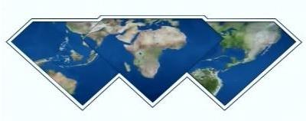

GEM…Moving Recovery Forward

April 28, 2025
Via Electronic Delivery
From: Rhonda L. Sorina
Global Emergency Management, LLC (GEM)
201 St. Charles Ave, Suite 200
New Orleans, LA 70170
(985) 503-0879
rhonda@globalemllc.com
www.globalemergencymanagementllc.com
Attn: Dr. Niemah Nefertiti Royal
P.O. Box 1423
Inglewood, CA 90301

Re: Letter of Recommendation in Support of Dr. Niemah Nefertiti Royal for an Honorary Doctoral Degree in Nutrition Science
To Whom it May Concern:
It is with immense pleasure and without reservation that I recommend Dr. Niemah Nefertiti Royal of We Are OMG Organization for an Honorary Doctorate in Nutrition Science. I had the distinct honor of meeting Dr. Niemah in Hilo, Hawaii, during the harrowing aftermath of the Kilauea Volcanic Eruption disaster. In the face of such devastation, Dr. Niemah stood as a beacon of unwavering support, working tirelessly day and night to provide essential aid to families who had lost everything. Her dedication to ensuring survivors had access to shelter, food, medical attention, and crucial mental health services was truly inspiring and demonstrated a profound commitment to humanitarianism.
What struck me most about Dr. Niemah was her innate ability to create a physical and mental safe space for those grappling with unimaginable trauma. Her focus on the unique needs of women and children was particularly noteworthy, reflecting a deep understanding of their vulnerabilities in crisis situations. Dr. Niemah possesses a rare combination of empathy, strength, and practical skills that allows her to connect with individuals on a profound level, offering solace and empowering them on their journey toward healing. Her presence alone brought a sense of calm and reassurance amidst the chaos.
Beyond her exceptional work during the Kilauea disaster, Dr. Niemah has personally impacted my life in a profound way. During a significant health crisis of my own, Dr. Niemah provided invaluable guidance and support. Her expertise in holistic wellness and her ability to translate complex nutritional information into practical steps empowered me to make transformative changes. I can unequivocally state that Dr. Niemah’s guidance took me from a place where I felt as though I was merely surviving each day to a place of vibrant health and living in victory. Her compassionate approach and unwavering belief in my ability to heal were instrumental in my recovery.
Dr. Niemah’s remarkable contributions have not gone unnoticed. She has received numerous honors and accolades for her tireless efforts and impactful work. Furthermore, her leadership extends to coordinating major events such as the Global Love Music Festival, showcasing her ability to bring people together for positive change. Dr. Niemah is a passionate and articulate advocate for social justice issues, extending her reach and influence from the local community in Hilo, Hawaii, to global initiatives across Africa. Her commitment to creating a more equitable and just world is evident in all that she does.
In conclusion, Dr. Niemah Nefertiti Royal is an extraordinary individual whose dedication, compassion, and unwavering commitment to serving others make her an invaluable asset to any endeavor. Her ability to provide both immediate relief in times of crisis and long-term support for healing and well-being is truly exceptional. I wholeheartedly recommend Dr. Niemah without any reservation and believe she will continue to make a significant positive impact on the lives of countless individuals and communities. Please do not hesitate to contact me if you need any additional information regarding her outstanding attributes!
In Strength and Blessings,
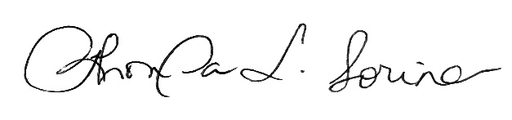
Rhonda L. Sorina, CEO
Global Emergency Management, LLC (GEM)

