NORTH WRESTLING
WE WANT YOU THIS WINTER SEASON!

Anybody Can Wrestle
From 99 pounds through 285 pounds, we have a spot for YOU! No experience? Not a problem!
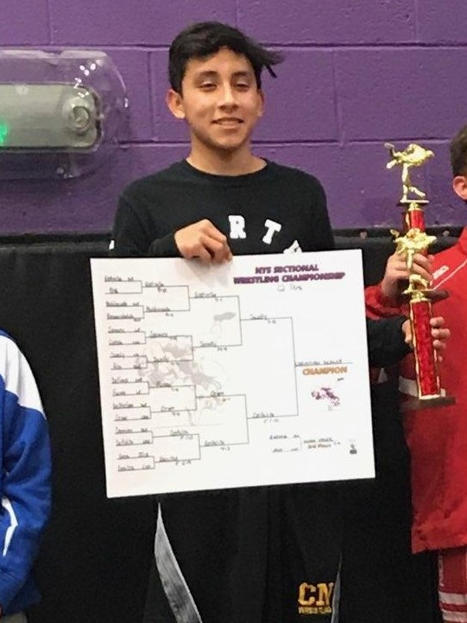 Christian Scally (99 lbs.) Alexis Diaz (126 lbs.) Record: 37-7
JV Section I Champion 1st Team All-County, All-League,
All-Section

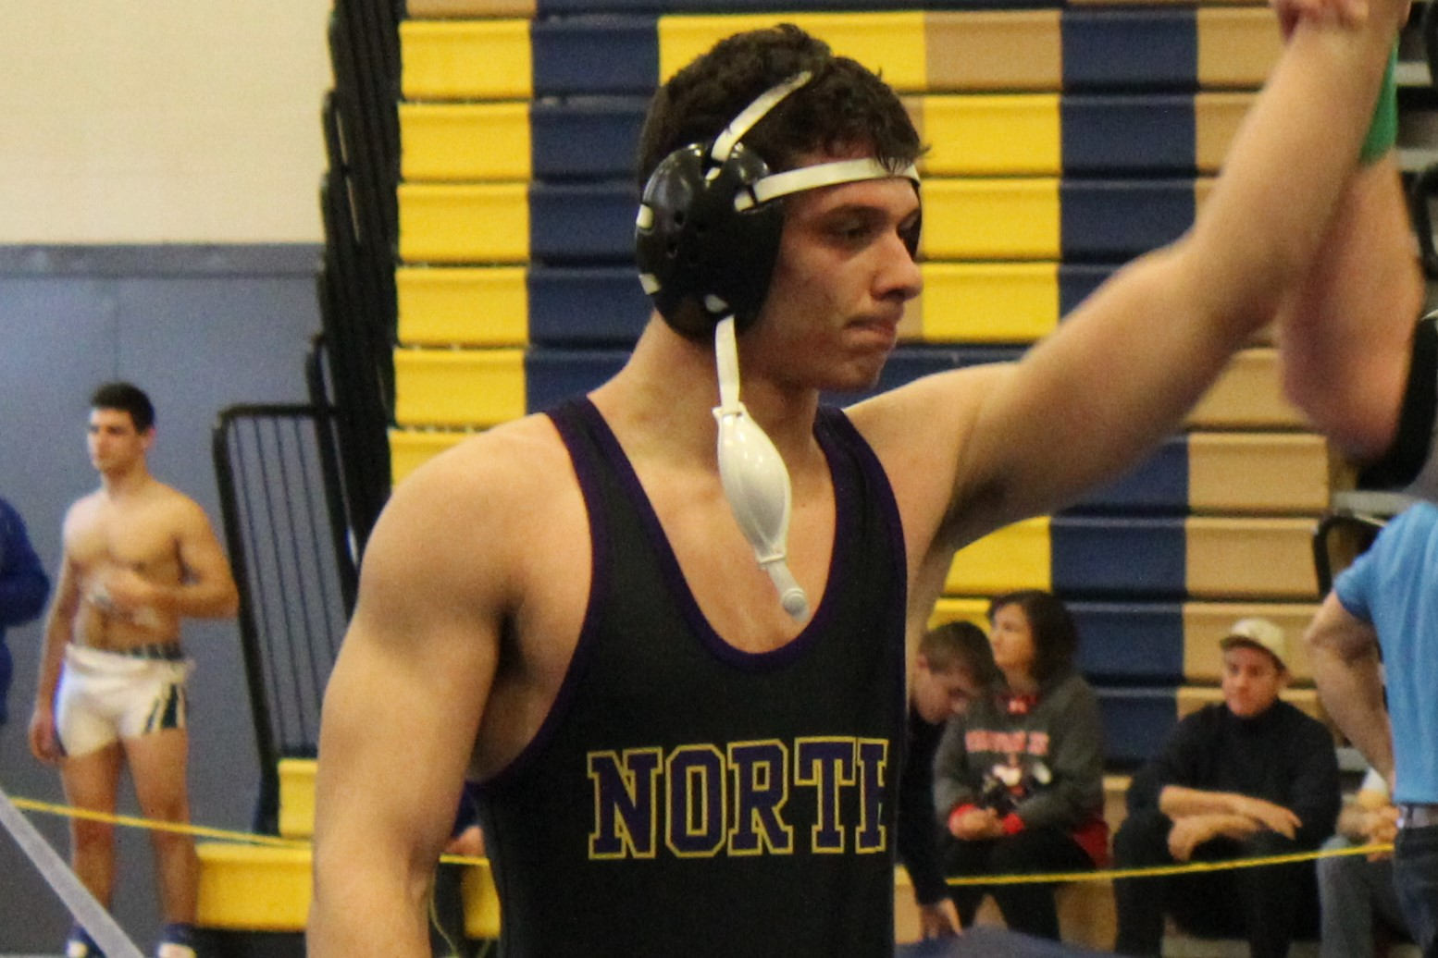

Ryan Stern (132 lbs.) Record: 37-8 Michelangelo Caruncho (182 lbs.)
1st Team All-County, All-League, 1st Team All-County, All-League,
All-Section, NYS Qualifier Team MVP Record: 30-2
_______________________________________________________________
SIGN UP ONLINE TODAY!

