NORTH WRESTLING
WE WANT YOU THIS WINTER SEASON!

Anybody Can Wrestle!
No matter your size or weight, there is a place for you in wrestling. In some sports, only certain body types are able to succeed: in football, you may need to be heavier/bigger; in basketball, you need to be somewhat tall; and in track, you need speed and stamina. In wrestling, as long as you are tough and have the desire to win, nothing else matters. Weight classes ensure fairness amongst the competitors, so you’re never too small or too big to participate. There are NO CUTS in wrestling. As long as you have the desire to be a member of the team, we will teach you everything you need to to be successful.
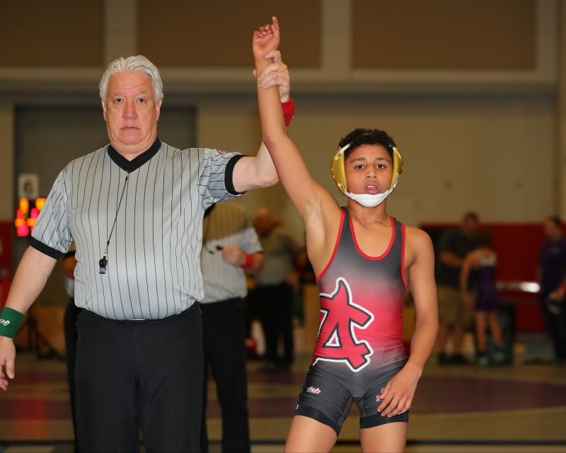From 99 pounds up to 285 pounds

- Foundation Sport. Wrestling is about balance, agility, hand –eye coordination, flexibility, positioning, strength, speed, explosiveness, footwork, hustle, mental focus, mental toughness, core strength, concentration, competition, and endurance. Wrestling will make you better at all other sports.
- Self-Confidence. ]Wrestling teaches hard work, self-improvement, sense of accomplishment, camaraderie of team, 1 on 1 aspect, and self-defense to name a few.
- Roadmap to Success. Wrestling is the perfect example of what it takes to be successful in life: goal setting, hard work, determination, focus, love of challenges, love of competition, confidence, being coachable, mental toughness, discipline, creativity, teamwork and accountability.
__________________________________________________________________________
SIGN UP ONLINE TODAY!

