WE WANT YOU!!!
RAMS Wrestling
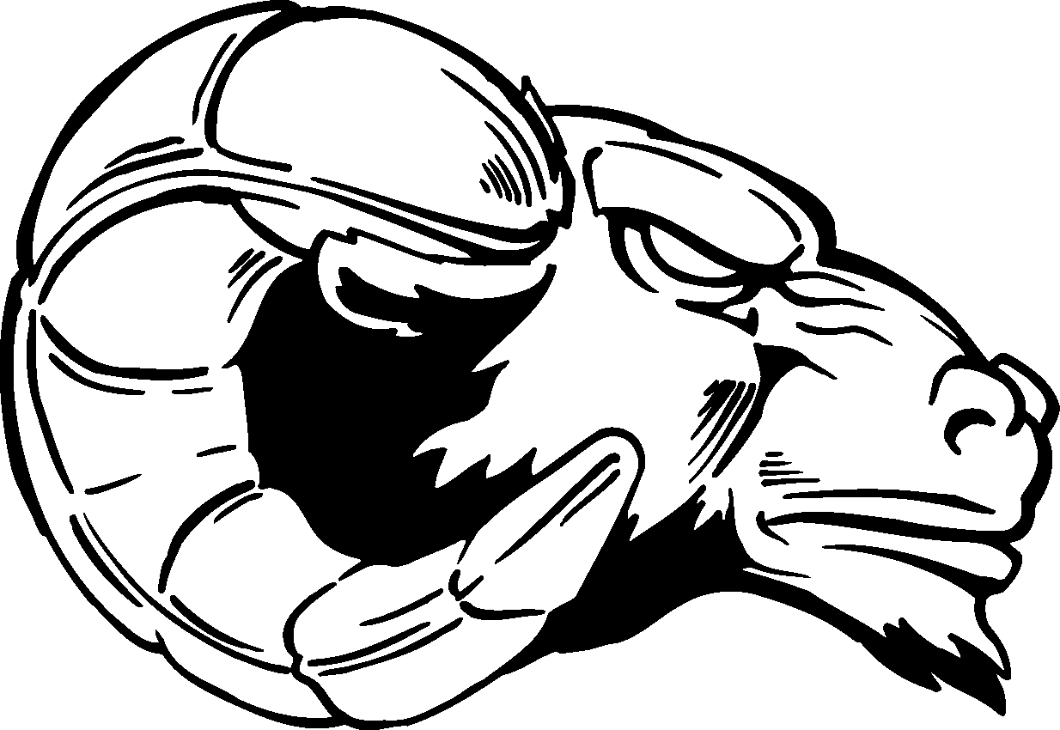

No experience? Not a problem!

We are looking for athletes of ALL sizes and weights from 90 pounds all the way up to 285 pounds.
___________________________________________________
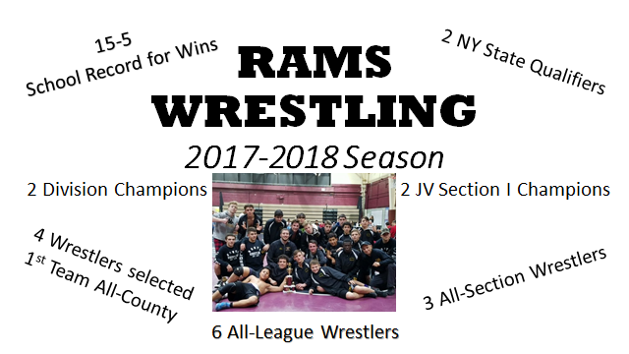
___________________________________________________
SIGN UP ONLINE TODAY!

