NORTH WRESTLING
WE WANT YOU THIS WINTER SEASON!
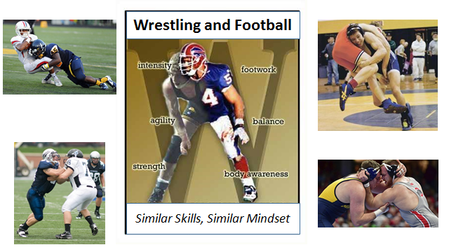

“WRESTLING IS A FOOTBALL PLAYER’S BEST OFFSEASON WORKOUT”
Mark Schlereth played 12 NFL seasons and won three Super Bowls with the Denver Broncos and Washington Redskins. But he says his toughest athletic challenge—that prepared him for his successful pro football career—was as a high school wrestler, where he was a state champion at Anchorage, Alaska's Robert Service High School. "Physically, it's the most challenging sport I've ever been involved with and from a pure mental toughness standpoint, nothing beats wrestling,” says Schlereth, now a popular NFL analyst with ESPN. "If you look around the league, it's uncanny how many player have wrestling backgrounds.” “You have defensive backs, linebackers, guys who know how to create leverage, use their hands, and are strong on their feet. Those skills taught in wrestling are just a vital part of football. "
”The best tacklers are wrestlers,” he notes. “It seems to come naturally to them. Their ability to stay balanced and drop their level to make a tackle is unbelievable. The most important thing to me is their toughness. Every wrestler seems to have mental and physical toughness to them."
Roddy White says that wrestling taught him skills that he still applies every day as one of the NFL’s top offensive weapons. “I’ve been getting into a wrestling stance since I was 7 years old," he explains. "It’s the same stance I use at the line of scrimmage. It was really good for me to have that in wrestling, because it made everything easier in football. Even throwing people to the ground, I attribute that to wrestling. It puts you in such an advantage. Being a great wrestler helps you so much in football—leverage, balance, quickness, hand-to-hand combat.”
_____________________________________________________________________________________________
SIGN UP ONLINE TODAY!

