NORTH WRESTLING
WE WANT YOU THIS WINTER SEASON!

How Wrestling Builds Better Football Players
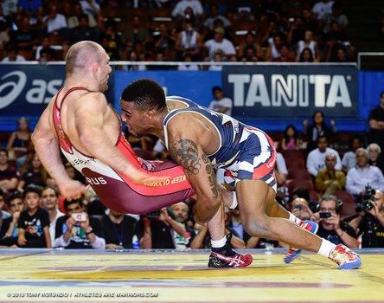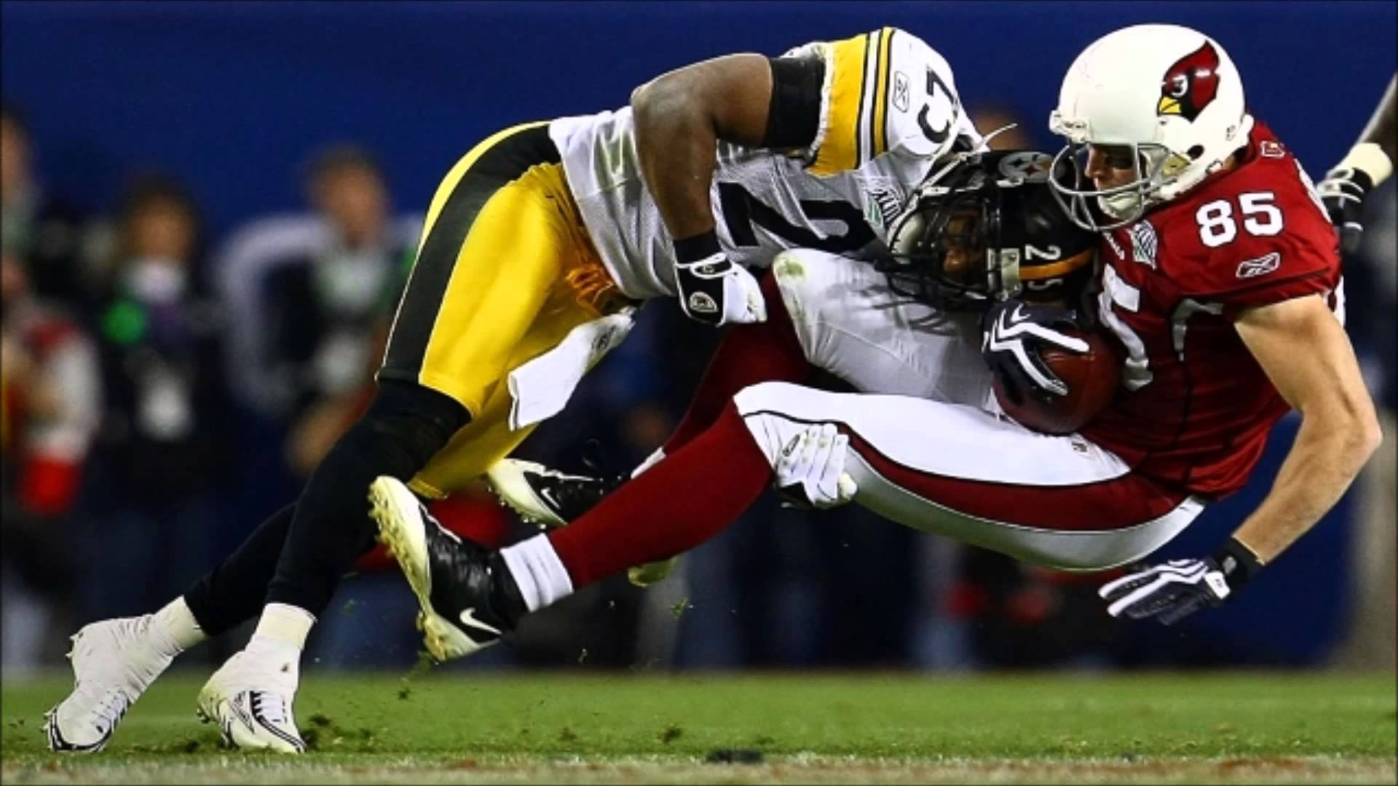

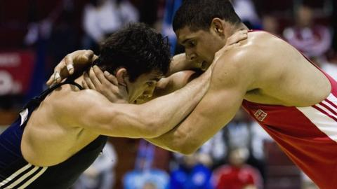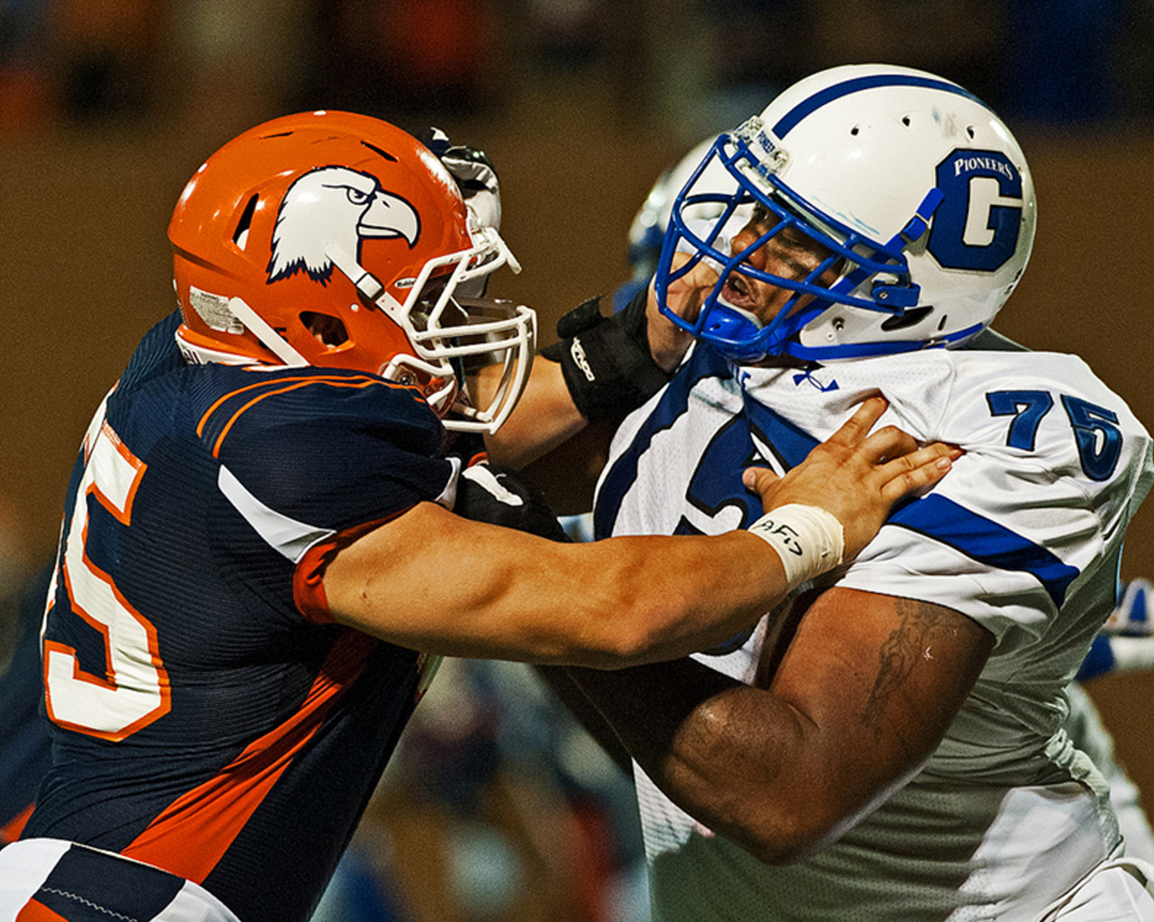

Wrestling involves balance and control against an external resistance, leverage and positioning, and the ability to move a non-willing opponent which are skills needed for all football positions.

Wrestling also emphasizes hand control, stance, footwork, endurance, quickness and strength. In wrestling, if you get control of the hands, if you get that inside step, you have the edge just like in football.
__________________________________________________________________________________
SIGN UP ONLINE TODAY!

