CLARKSTOWN NORTH MAT CLUB, INC.
RAMS WRESTLING CLUB
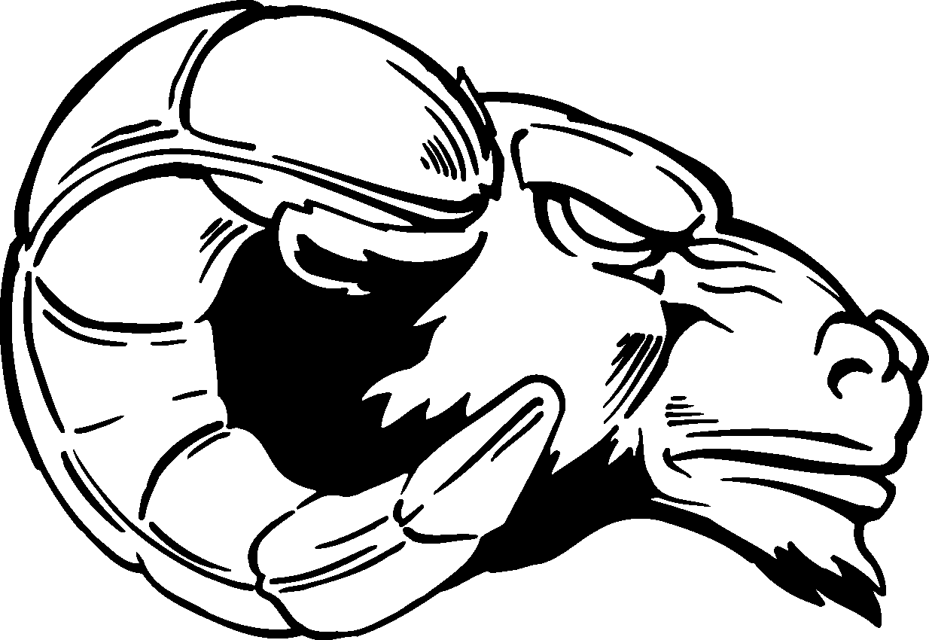 2019-2020

Who can wrestle?: ANY student in 1st through 8th grade from the smallest and lightest to
the tallest and heaviest! Wrestling is for EVERYONE!!

Day/Time: MONDAYS and WEDNESDAYS 6:30 – 7:15 kindergarten thru 4th grade
7:15 – 8:15 5th grade thru 8th grade

Dates: a 12-week program beginning on December 2, 2019 and ending on March 7, 2020

Location: Clarkstown North High School Wrestling Room

Cost: $125.00 – Each wrestler will receive a mandated USA Wrestling insurance card, a
RAMS Wrestling Club t-shirt, and a team photo.

Registration: This will take place on the first few nights the club begins starting at 6:15 P.M.

RAMS Kid Wrestling Club Head Coach
Coach Jack Granata – North High School’s first wrestler to earn NCAA All-American honors when he placed 5th for Hunter College in 1998. Coach Granata was a Rockland County and Divisional Champion and upon graduation was #1 in career wins and # in career pins for North. Coach Granata has been our youth wrestling since the club’s inception over 10 years ago.

Current High School wrestlers will also be volunteering at each kid practice session.

Why ALL Kids Should Wrestle
1. Wrestling is a sport where you can be short or tall, big or small, and still compete on a level playing field with other competitors of the same weight.
2. Wrestling develops agility, balance, reflexes, and strength in every major muscle group which can also dramatically improve one’s ability to perform in other sports.
3. Wrestling is a great way to build confidence and self-defense skills.
4. Win or lose, wrestlers must shake their opponent’s hand ensuring that sportsmanship always remains a vital part of the sport.
5. Wrestling is a natural activity, one of the first forms of physical play that young children do without ever having been taught and is FUN!

For further information, contact Coach Jack Granata at 653-1342

The Clarkstown North Mat Club/Rams Wrestling Club is a not for profit organization run by volunteers dedicated to teaching the fundamentals of scholastic wrestling to the children of Clarkstown Central School District.

