CLARKSTOWN NORTH MAT CLUB, INC.
RAMS WRESTLING CLUB
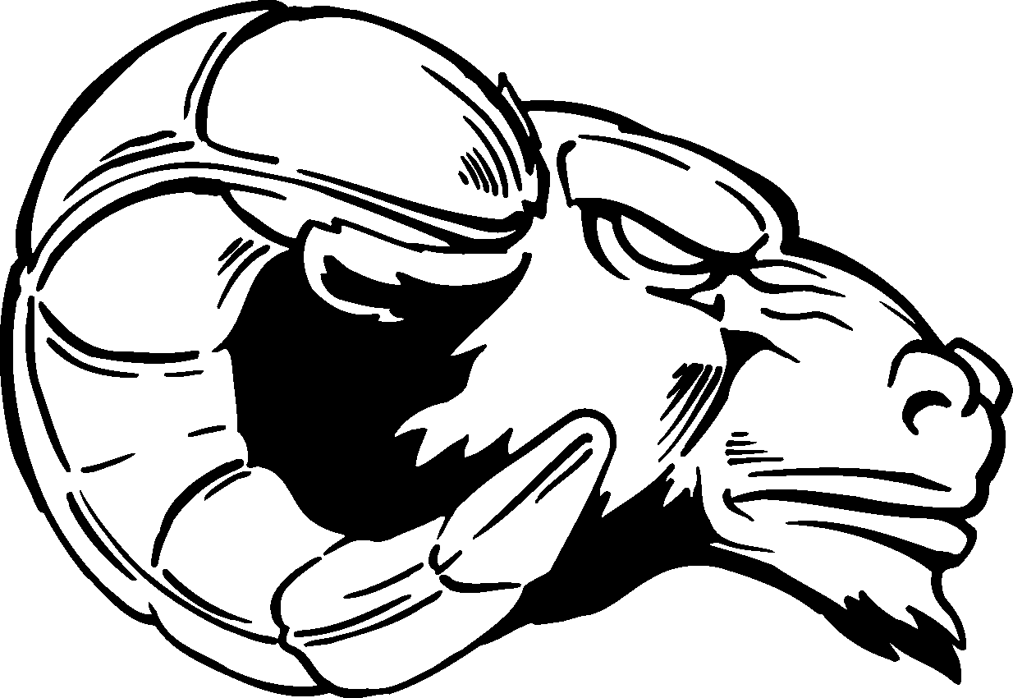 2022-2023

Who can wrestle?: ANY athlete in 3RD-6TH grade for both boys and girls from the smallest and lightest to
the tallest and heaviest! Wrestling is for EVERYONE!!

Day/Time: MONDAYS and WEDNESDAYS 6:30 PM - 7:30 PM

Dates: a 12-week program beginning on November 28, 2022, and ending on March 1, 2023

Location: Clarkstown North High School Wrestling Room

Cost: $125.00 – Each wrestler will receive a mandated USA Wrestling insurance card and a
RAMS Wrestling Club t-shirt

Registration: This will take place on the first few nights the club begins starting at 6:15 P.M.
For further information, please email North Head Coach Tony Mellino at AMELLINO@CCSD.EDU

RAMS Kid Wrestling Club Coaching Staff
Coach Joe Alexander, a 5-year former wrestler for the RAMS and Coach DJ Cifuni, a former RAMS Wrestling team MVP, will be conducting all club practices along with our exemplary Varsity and JV Wrestling Student/Athletes there to assist each evening.

Why ALL Kids Should Wrestle
1. It is FUN! All kids love to wrestle around with each other, spend time with a group of young kids and this will become apparent really quick. In addition to learning wrestling moves, kids practice usually consists of fun games as warmups or cool downs and a lot of times games are played that contain wrestling related skills. Kids love coming into wrestling rooms, because a huge room that has padding on the floor and walls is super fun to run around and do flips and somersaults in. Kids wrestling is a good way for kids to learn basic wrestling skills, meet other kids, and have a great time.

2. THE Perfect Foundation Sport! Wrestling is the perfect foundation for all other sports. Wrestling is balance, agility, hand –eye coordination, flexibility, positioning, strength, speed, explosiveness, footwork, hustle, mental focus, mental toughness, core strength, concentration, competition, and endurance. Wrestling will make our youth better at all other sports.

3. Exercise! Wrestling is one the world’s most premier physical fitness sports. Wrestling develops strength and endurance. Poor health is a major issue in our society today and wrestling will help develop a love of exercise and physical fitness in our youth.
The Clarkstown North Mat Club/Rams Wrestling Club is a not-for-profit organization run by volunteers dedicated to teaching the fundamentals of scholastic wrestling to the children of Clarkstown Central School District.

