

Hello, I would like to take this opportunity to introduce myself to you.

My name is, Laura, and I am the Welfare Officer at Cheadle and District swimming club. Here, at Cheadle and District swimming club, we aim to provide a safe and secure environment for all of our young swimmers.

Should any swimmer or parent/guardian have any safeguarding concerns that they wish to inform the club about then please contact me via email [Welfare.cheadleasc@outlook.com](mailto:Welfare.cheadleasc@outlook.com) or if you wish to speak to me in person, please email me to arrange this.

Within my role as Welfare Officer, I use wavepower as a reference guide at all times. You can access this by following this link <http://www.swimming.org/swimengland/wavepower-child-safeguarding-for-clubs/>

Other organisations that can assist you if you require help and support are;

* Childline 0800 1111 <http://www.childline.org.uk>
* 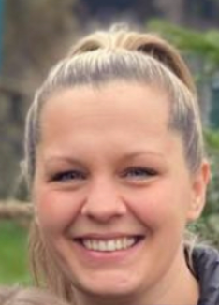Swimline 0808 100 4001 [www.swimming.org.uk](http://www.swimming.org.uk)
* County welfare officer Kate Mullinder [kate@staffsasa.co.uk](mailto:kate@staffsasa.co.uk)
* NSPCC helpline 0808 800 5000

Many thanks for your time.

Laura.