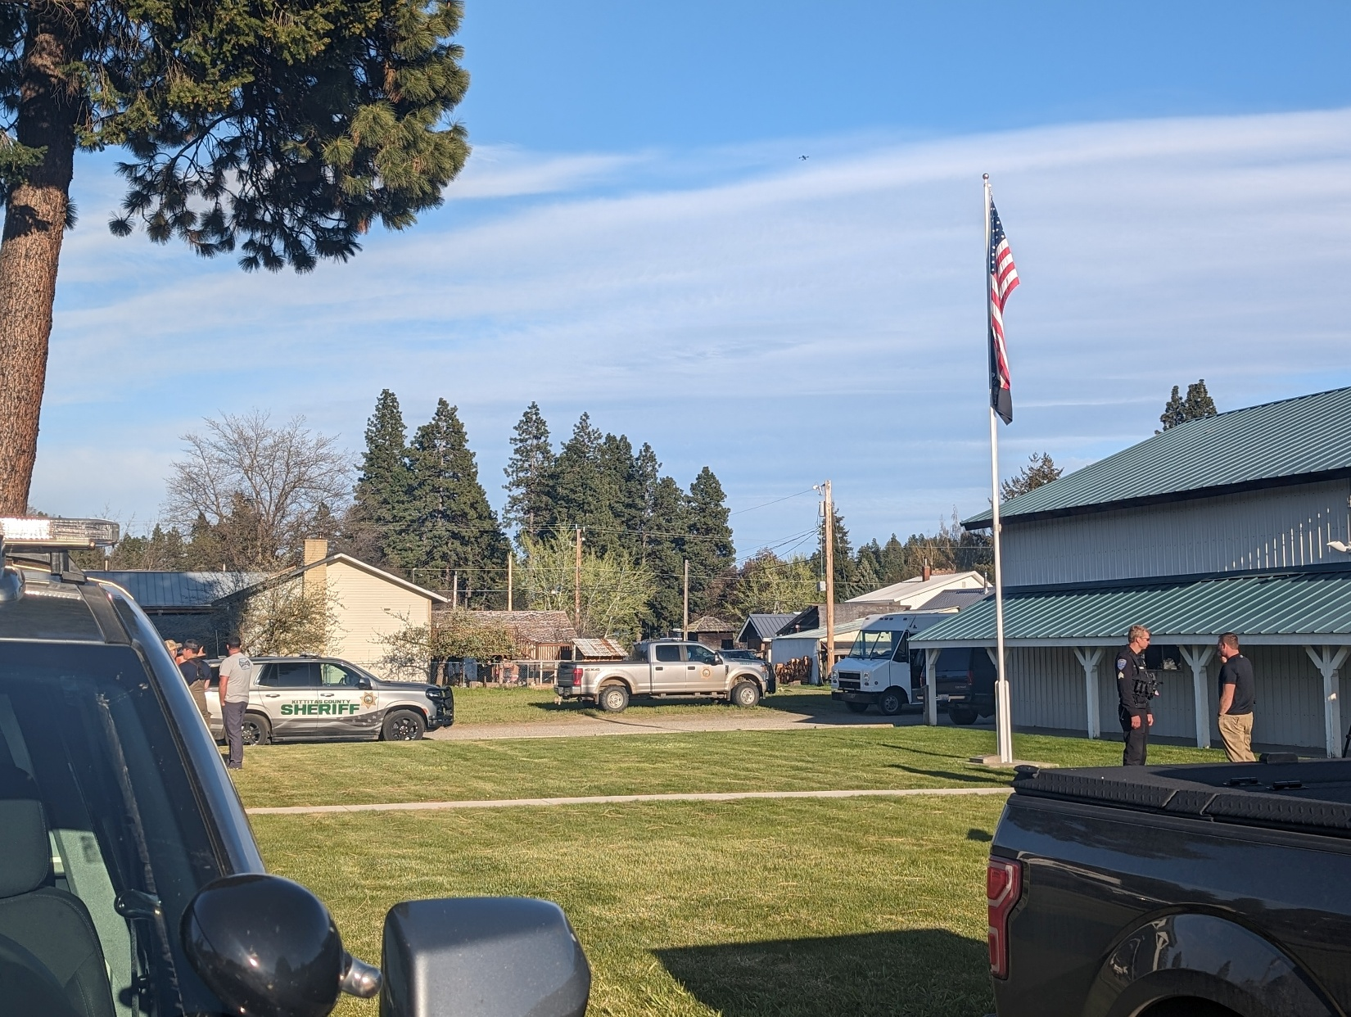**KITTITAS COUNTY SHERIFF’S OFFICE**

SOUTH CLE ELUM ANNUAL REPORT

**2024**

The Kittitas County Sheriff’s Office experienced a 12% increase in total calls this year, with 16,028 calls for service in 2023 and 17,973 calls for service in 2024. South Cle Elum experienced a 14% increase in total calls from 250 in 2023 to 285 in 2024. South Cle Elum accounted for approximately 1.5% of the total calls that KCSO had in both 2023 and 2024.

**COMPARISONS**

|  |  |
| --- | --- |
| Crimes against persons reports increased by 17% in South Cle Elum (12 reports in 2023 versus 14 reports in 2024) while the entire agency saw an increase of 9% in these types of calls. | Police male outlineProperty crime reports **decreased** by **50%** in South Cle Elum while the agency as a whole saw a 2% **increase**. Civil matters similarly were nearly halved in South Cle Elum. |
|  |  |
| Siren with solid fillHandcuffs with solid fillArrests in South Cle Elum decreased by 42%, from 12 in 2023 to 7 in 2024. Arrests county-wide increased by 15%, from 319 to 366. | |
|  |  |
| In South Cle Elum, traffic stops remained approximately the same as 2023. | Agency-wide, there was a 15**% increase** in traffic stops, **46% increase** in traffic infractions issued and **35% increase** in traffic related arrests. There was a 6% decrease in non-injury collisions and an 8% decrease in injury collisions. There was also a 30% reduction in parking-related calls. |

|  |  |  |
| --- | --- | --- |
|  | South Cle Elum | Agency-Wide |
| Property Crime Reports | 50% decrease | 2% decrease |
| Crimes Against Persons Reports | 17% increase | 9% increase |
| Proactive Activity | 19% decrease | 27% increase |
| Public Assistance Calls | 11% decrease | 5% increase |
| Civil Matter Calls | 43% decrease | 21% decrease |
| Traffic Stops | 6% decrease | 15% increase |
| Traffic Infractions | 100% increase | 46% increase |

**SOUTH CLE ELUM DETAILED STATISTICS**

*\*Please note that these statistics are meant to provide an overall picture and may not be completely accurate. For example: a vehicle observed speeding through South Cle Elum but stopped outside of the city limits will not be represented in the data for South Cle Elum.*

**2024**

|  |  |  |  |  |  |  |  |  |  |  |  |  |  |
| --- | --- | --- | --- | --- | --- | --- | --- | --- | --- | --- | --- | --- | --- |
|  | **JAN** | **FEB** | **MAR** | **APR** | **MAY** | **JUN** | **JUL** | **AUG** | **SEP** | **OCT** | **NOV** | **DEC** | **TOTAL** |
| Total Calls | 23 | 22 | 25 | 28 | 31 | 26 | 32 | 22 | 24 | 17 | 14 | 21 | **285** |
| Total Custodial Arrests | 0 | 0 | 0 | 0 | 0 | 0 | 0 | 0 | 2 | 0 | 1 | 2 | **5** |
| Total Non-Custodial Arrests | 0 | 1 | 0 | 0 | 1 | 0 | 0 | 0 | 0 | 0 | 0 | 0 | **2** |
| Total Cases Referred | 1 | 0 | 1 | 0 | 0 | 0 | 1 | 1 | 2 | 0 | 0 | 0 | **6** |
| Total Ongoing Investigations | 0 | 0 | 1 | 0 | 0 | 1 | 0 | 0 | 0 | 1 | 0 | 0 | **3** |
| Total Reports Written | 1 | 3 | 3 | 1 | 3 | 3 | 7 | 2 | 4 | 3 | 1 | 4 | **35** |
| Total Property Crime Types | 1 | 0 | 1 | 0 | 1 | 0 | 1 | 1 | 0 | 2 | 0 | 0 | **7** |
| Total Property Crime Arrests | 0 | 0 | 0 | 0 | 0 | 0 | 0 | 0 | 0 | 0 | 0 | 0 | **0** |
| Total Crimes Against Persons | 0 | 2 | 1 | 1 | 2 | 1 | 3 | 2 | 2 | 0 | 0 | 0 | **14** |
| Total Crimes Against Persons Arrests | 0 | 0 | 0 | 0 | 1 | 0 | 0 | 0 | 0 | 0 | 0 | 0 | **1** |
| Total Proactive Activity Call Types | 12 | 7 | 1 | 0 | 0 | 0 | 4 | 2 | 2 | 0 | 1 | 1 | **30** |
| Total Civil Matter Call Types | 2 | 0 | 3 | 0 | 6 | 0 | 1 | 0 | 2 | 1 | 0 | 2 | **17** |
| Total Suspicious Activity Call Types | 0 | 0 | 2 | 3 | 1 | 0 | 1 | 0 | 2 | 0 | 3 | 2 | **14** |
| Total Public Assistance Call Types | 1 | 0 | 5 | 6 | 4 | 5 | 6 | 2 | 2 | 4 | 1 | 5 | **41** |
| Total Traffic Stops | 0 | 2 | 1 | 1 | 5 | 0 | 2 | 0 | 2 | 3 | 0 | 0 | **16** |
| Total Traffic Warnings | 0 | 2 | 1 | 1 | 4 | 0 | 1 | 0 | 2 | 3 | 0 | 0 | **14** |
| Total Traffic Infractions | 0 | 0 | 0 | 0 | 1 | 0 | 1 | 0 | 0 | 0 | 0 | 0 | **2** |
| Total Traffic Related Arrests | 0 | 0 | 0 | 0 | 0 | 0 | 0 | 0 | 0 | 0 | 0 | 0 | **0** |
| Total Non-Injury Collisions | 0 | 0 | 0 | 0 | 0 | 0 | 0 | 0 | 0 | 0 | 0 | 0 | **0** |
| Total Injury Collision | 0 | 0 | 0 | 0 | 0 | 0 | 0 | 0 | 0 | 0 | 0 | 0 | **0** |
| Total Illegal Parking Issue Calls | 0 | 0 | 0 | 0 | 0 | 0 | 0 | 0 | 0 | 0 | 0 | 0 | **0** |
| Total Parking Infractions Issued | 0 | 0 | 0 | 0 | 0 | 0 | 0 | 0 | 0 | 0 | 0 | 0 | **0** |