Cook Inlet Beluga Whales
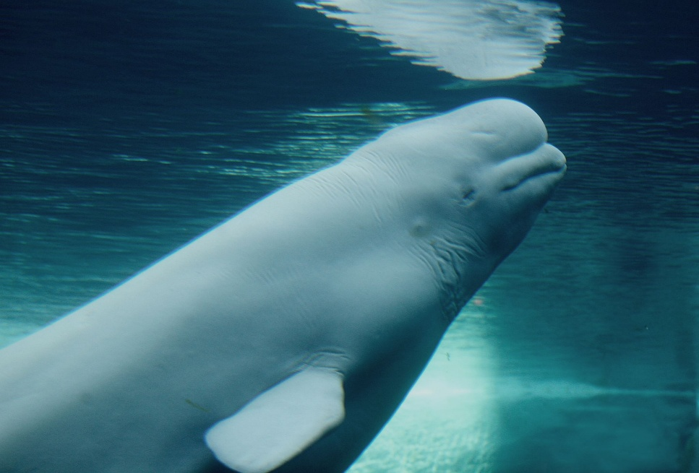

Endangered Cook Inlet Beluga Whales, only about 280 left in the wild. They have been on the endangered species list since 2008.

Beluga Whales are also known as the Canaries of the sea, because of all the noise they make, in fact they use echolocation in order to hunt their prey and navigate. Belugas have a keen sense of sight both in and out of water. A calf will be dark grey in color and will lighten as they become mature One of their most notable features is the large bulb on their head that helps them control their noises. Belugas have a thick layer of blubber that

The Cook Inlet Beluga Whale provides a valuable food source for the native people in the Cook Inlet area. Due to the massive decrease in population the harvesting of Beluga Whales has been regulated and tightly monitored throughout the past couple of years, and even with the regulated hunting the number has not gone up very much with an estimated 331 individuals.

Ways to Combat depleting Cook Inlet Beluga Whale Counts
- Restrict the harvesting both commercially and for subsistence
- Make sure they have a viable food source and a consistent one throughout entire year.
- Make sure there are not harmful environmental factors in the area where Belugas live
- Make sure that it has a reliable food source and will be able to be easily accessible to the Beluga in whichever environment the resides.
- Spread the word about belugas, give people information about them and make sure they know the facts about them and all that they need to grow in population

