**St. Andrews Woman’s Club**

2024-2025



**Be the willing hand to help someone**

**April 2025 NEWSLETTER**

Member of the General Federation of Women’s Clubs (GFWC) since 1963

Contact: Susan Dox, Co-president ………….……sdox0103@gmail.com

Debbie Bell, Co-president………….……dbell815@gmail.com



**Officer Reports:**

**President – Susan Dox & Debbie Bell**

What an exciting time of year for our club! At our April Board Meeting, the Board reviewed the recommendations for donations to local charities. We are so pleased to announce SAWC is able to donate $ 9200 this year to the various charities!

Thank you for your support and dedication to our community. The club will vote on the recommendations at our April meeting on April 28th.

Our May Banquet and Installation of Officers will be held on Monday, May 19th at Roxanne’s Market, 2900 Dreher  Shoals Road, Columbia 29212. The dinner will begin at 6:00 pm.  We look forward to celebrating our club year with each of you.

More details are enclosed in this newsletter.

Thank you, Gail Elfert, for providing the basket donated by SAWC for our

 GFWC-SC State Convention coming up April 25- 27th.

Congratulations to our  2025-26  Newly Elected  Officers:

Presidents - Kristin Fields & Maureen Taylor

1st Vice Presidents - Becky Travis & Anne Marie Shepherd

2nd Vice Presidents- Lynne Hauptner & Marie DeLoach

3rd Vice Presidents - Frances Hill & Susan Smith

Treasurers- Jo Norris & Diane Bozard

Secretary- Laura Nichols

Advisors - Susan Dox & Debbie Bell

We look forward to seeing everyone at our April General Meeting on April 28th!

**1st Vice President – Beth Smith-Pollom & Becky Travis**

**2nd Vice President – Lynne Hauptner & Ann Martin**

Ann and I are looking forward to welcoming our four new members at the May banquet.  See you there.

*For Outstanding Clubwoman of the Year:*

The membership will vote for Outstanding Clubwoman of the Year at the April general meeting.  Please be thinking of your nominee.

**"Past recipients within the last ten years and the current club president(s) are ineligible for this award."**

Those ineligible for the award are:    Kaye Jones, Mary North, Ann Martin, Barb Kogut, Susan Smith, Katherine Keckeisen, Gail Elfert, Debbie Bell, Lynne Hauptner and Susan Dox.

**3rd Vice President Ways & Means – Frances Hill & Susan Smith**

No report.

**Secretary – Laura Nichols**

I'm new and need your help!!  ATTENDANCE IS IMPORTANT!

Hello ~ Please do your best to let me know if you are going to be absent from a meeting.  Feel free to email ( [Lecnichols49@gmail.com](mailto:Lecnichols49@gmail.com) )  or shoot me a text (803-463-4446).

Don't forget to sign in.   Since I don't know all the names and faces yet, please check in with me. Thank you!

**Treasurer – Jo Norris & Sarah Ostergaard**

The balance as of April 18, 2025 is below:

      Checking:  $14164.28

      Savings:    $  3364.80

We will be accepting payment for the May Banquet at the April meeting. The cost is $30 if you pay by cash or check and $31.00 if you pay by either Venmo or credit card.

The finance committee is meeting on April 28 to prepare a budget to be voted on by the club in May.

**Advisor – Laurie O’Kelly**

This month, we will vote on the recipient for the Dianne McCarty Spirit Award. This is awarded to the sustaining member who best exhibits the spirit of the club and will be presented at the May Banquet. Sustaining members are active members with at least 15 years of continuous service in a GFWC club and are identified with an * by their name on the membership pages. Please be sure to vote at the April meeting or email me your vote at LLOK385@aol.com.

**Community Service Project Reports:**

Arts and Culture – Rachel Richardson & Nancy Schmidt

Submitted by Shari Johnson: Croatia: Made famous by the HBO series, Game of Thrones. Croatia is more than iron thrones and dragons. Croatia is a beautiful country nestled along the Adriatic Sea with a rich cultural heritage. It has become an idyllic destination for every tourist: from beaches and mountains to history and adventures for all ages. Croatians welcome tourist from May to October, with the tourism season peaking in July and August. Croatia is best known for its dramatic coastline with picturesque beaches and stunning cliffs overlooking the Adriatic Sea. Locals boast the Adriatic Sea is the most peaceful and transparent of the Mediterranean-you will find no sharks here-just the occasional pod of dolphins guiding you to your next destination. A favorite amongst visitors is to island hop: to sail and visit some of the 1244 islands and coves. Cruises are very popular and relatively affordable.

For history lovers, Croatia offers ten UNESCO World Heritage Sites. From the Diocletian Palace, Ruins from the Roman Era in the fourth century. Wine Lovers and foodies are surprised that Croatia has a rich wine history dating back to the ancient Greeks. After wine tasting, one can enjoy fresh seafood with locally sourced olive oil and cheeses.

Croatia is often compared to Italy’s Amalfi Coast, but better.

Civic Engagement & Outreach – Shelly Langston

Happy Easter everyone! I wish you all a wonderful Easter with your family and friends.  
  
Jo Norris, A member of our club and an USO Volunteer has provided a list of items the USO is in need of. The USO is especially in need of luggage for service members who are traveling back home and have no luggage. The luggage or suitcase must be able to be closed. RTC If you have a travel bag or travel suitcase you are not using, please bring it to our April General Meeting. Jo will be glad to take it to the USO along with any other requested items on the sheet that is attached.

Education & Libraries – Jane Ashley Durham & Maureen Taylor

Environment – Gail Elfert

**BRING ALL YOUR PLASTIC BAGS AND “FILM” to the April meeting** because we will need it to reach our 1000 lb. goal by the end of April! As of April 17, we have deposited and been credited with **952 lbs**., so I know we can hit that magic number and get the “buddy bench” for Leaphart Elementary School in only 7 months.

Put on your calendar that **May 17 is our next Adopt-a-Highway trash pickup** on St. Andrews Road. We will have another one on August 15, but that one will count for next club year. This project is open to all club members, and remember – there are prizes!

We are delighted to have the Executive Director of Keep the Midlands Beautiful, Traude Sander, as our guest speaker for the April meeting. This organization coordinates the Adopt-a-Highway program among other programs aimed at keeping our highways, streets, sidewalks, waterways, and shore areas clean and safe to use.

Five club members enjoyed our environmental “field trip” to Georgetown County on April 9-11 when we toured the Tom Yawkey Wildlife Center and strolled the grounds of Brookgreen Gardens. If there is enough interest, I will try to plan another trip next club year.

Due to the interest of so many members last month after our speaker told us about the plight of the Monarch butterflies, I picked up 30 packets of Milkweed seeds and they will be available at the April meeting to the first 30 people who promise to plant them! Remember, this is the only plant that can help save the Monarch!

At the end of this newsletter will be the revised Carolina Wildlife Wish List. Traditionally, our CSP and club have brought items that are on their wish list to the April meeting, and this year we have added two other optional ways for you to donate: 1) bring a few dollars to add to our “pot” to purchase a few high priority items and 2) go on your own to their Amazon wish list which is listed and purchase items that will go directly to Carolina Wildlife. Remember, this is an opportunity, not an obligation, so participate if you wish to do so. IF you purchase anything from their Amazon list, please let me know so we can include that in our report.

|  |
| --- |
|  |

Health & Wellness – Barbara Cross & Daryl Hendrix

Our CSP and the Education CSP worked together to provide a wonderful breakfast for the Teachers and Staff at Seven Oaks Elementary School on Tuesday, April 8th. This was our way of reminding them how very special they are to our community and to our children. Items were donated by various businesses, club members and CSP funds. The teachers and staff were most appreciative.

In addition, Seven Oaks Elementary School nominated our club as their pick for Volunteer of the Year. Several club members attended the breakfast held in our honor. Although we didn’t win the district prize it was very nice to be recognized for our volunteer efforts over the last year.

April is Child Abuse Awareness Month and we have a temporary display of blue pinwheels and signs at the entrance to Leo’s Landing hoping to draw attention to this very important issue.

We will be collecting any old**hearing aids and/or glasses**that you would like to donate at our April meeting. These will be given to our local Lion’s Club.

Committee members, we will have a short meeting after the general meeting. Thanks.

**Standing Committee Chairs & Special Appointments:**

Leadership/WHRT – Kristin Fields

The GFWCSC leadership committee is considering holding a mini-LEADS program. This program will be a half-day session, cost is $20, date is the Friday before Summer Session in August.

The GFWCSC March magazine has more information.

If you are interested in attending, please send  Janet Prince email at [jhprince@aol.com](mailto:jhprince@aol.com).

Thank you.

Fellowship – Jan Mitchell-Conner

April Birthdays:  Marion St. Clair

**IMPORTANT DATES TO REMEMBER:**

April 25-27 GFWC-SC State Convention Greenville

April 28 General Meeting 6:30pm

May 5 Board Meeting (Joint Board) 6:30pm

May 19 Annual Banquet details in newsletter

Following page is a picture submitted by Shari Johnson:

The Architecture of strength memorial was unveiled in 2021. “Serving as a daily reminder of women’s strength, perseverance, and power,” the 17’ statue created by Deedee  Morrison stands at the corner of Main and Gervais.

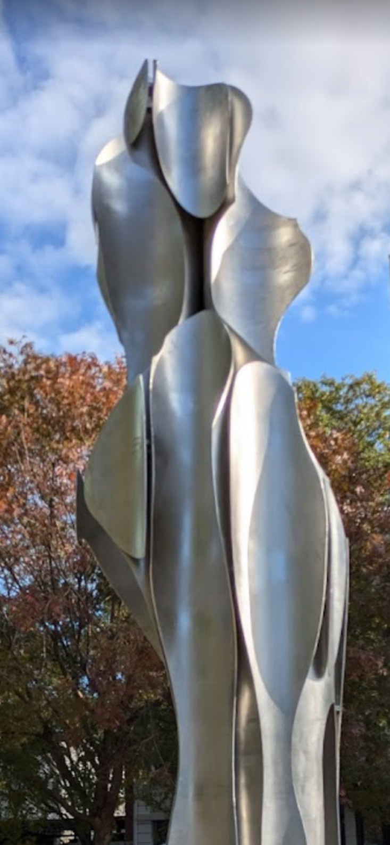

**Carolina Wildlife Wish List**

Food – Year Round

* Canned Salmon
* Purina Dog Chow Green Bag
* Blue Buffalo Wilderness Puppy Food (Blue Bag)
* Blue Buffalo Wilderness Cat Food (Purple Bag)
* Shelled and Unshelled Nuts (Pecans, Walnuts, Almonds)
* Wild Bird Seed – (*No Pre-mixed Blends*)
* (Millet, Sunflower Meats, Cracked Corn, Safflower)
* Rodent Block
* Unflavored Pedialyte or Equivalent
* Meal Worms and Super Worms from Pet Smart

Cleaning and Bedding

* Laundry Detergent (NO SCENT)
* Laundry Bleach
* Dawn Dish Soap
* Hand Soap
* Facial Tissues (lotion free)
* Paper Towels
* Mops & Brooms
* Towels, Blankets
* Fleece Blankets

General Supplies

* Feather Dusters – Only New/Real Feathers
* Zip Ties
* Scotch Tape
* Duct Tape
* Light Green Card Stock
* Nitrile Gloves (all sizes)
* Small 6″ Wicker Baskets
* Garden Hoses and Spray Nozzles (heavy use)
* First Class Postage Stamps
* Pine Straw, Wheat Straw
* Scrub Brushes
* 48” UVB Fluorescent Bulbs
* Copy Paper
* 33-gallon trash bags

**OR** find Amazon wish list items:[www.amazon.com/hz/wishlist/ls/1EJH9UMUTW35F/?ref_=lol_ov_le](http://www.amazon.com/hz/wishlist/ls/1EJH9UMUTW35F/?ref_=lol_ov_le)

**OR** bring a few dollars $$ to add to our “pot” to purchase items on their high priority list