**St. Andrews Woman’s Club**

2024-2025



**Be the willing hand to help someone**

**March 2025 NEWSLETTER**

Member of the General Federation of Women’s Clubs (GFWC) since 1963

Contact: Susan Dox, Co-president ………….……sdox0103@gmail.com

Debbie Bell, Co-president………….……dbell815@gmail.com



**Officer Reports:**

**3rd Vice President Ways & Means – Frances Hill & Susan Smith**

Our Bunco FUNdraiser is this Thursday!!

We are counting on all club members to participate in some way to ensure our event’s success!!

There are 5 tickets still available. If you know of anyone who would like to attend, contact Frances for tickets.

If you volunteered to let us use your card table, you may bring them to Saluda Shoals on Thursday at 2 PM. Please come to the kitchen door at the loading dock and take the tables into the bunco rooms. If this will not work for you, please make arrangements to deliver your tables to Frances before Thursday.

If you are working at the event, please wear your black SAWC apron. If you are playing bunco, please wear your SAWC name tag.

Instructions for all workers will be sent by one of the committee members. If you do not receive instructions, please contact Frances or Susan.

**President – Susan Dox & Debbie Bell**

Who is ready to welcome SPRING with more hours of daylight, blossoms blooming and buzzing bees? We are, so goodbye winter!!!

WOW! Many, many thanks to Susan Smith & Beth Smith Pollom for making the extra efforts to obtain additional funding for our charities! Such a wonderful surprise to help those in need!!!

We are very excited about our Bunco fundraiser and appreciate all who will make it very successful and fun!

Our 1st VPs Beth & Becky have completed the final round of reports due on March 15 to GFWC-SC and the Rating Sheet report required by the President has also been completed.

The GFWC-SC Convention will be in Rock Hill, SC April 25-27. You can go to GFWC-SC.org and scroll to the Dec 2024 magazine to find info for Hilton Garden Inn reservations.

Registration for the Convention will be in the March 2025 magazine. Please let us know if you plan to attend or have any questions.

We will vote on the slate of officers at the March 24 General Meeting and

\***REMEMBER TO WEAR BLUE** in support of colorectal cancer awareness month*

**1st Vice President – Beth Smith-Pollom & Becky Travis**

We thank you for your help in completing the reports.  The final items have been submitted.  If you submitted a report, then please send Beth a copy for our records.

The CSP’s need to meet with your committees to determine how you plan to spend your money before the Club year ends.  Please remember to record your activities to share with your next CSP chairman.  The current officers need to record their activities, too.

The May Banquet is scheduled for May 19th at Roxanne’s.  We hope to have registration available at the March meeting.

**2nd Vice President – Lynne Hauptner & Ann Martin**

Please welcome Sara Reandeau, a friend of Susan Dox, as our newest SAWC member.  She is looking forward to BUNCO and getting involved.

If you have any corrections or additions to your membership info, please give them to me to keep our records updated.  Thanks.

Spring is just around the corner!!

**Secretary – Laura Nichols**

I'm new and need your help!!  ATTENDANCE IS IMPORTANT!

Hello ~ Please do your best to let me know if you are going to be absent from a meeting.  Feel free to email ( [Lecnichols49@gmail.com](mailto:Lecnichols49@gmail.com) )  or shoot me a text (803-463-4446).

Don't forget to sign in.   Since I don't know all the names and faces yet, please check in with me. Thank you!

**Treasurer – Jo Norris & Sarah Ostergaard**

The Progress Foundation check and the additional money donated was happily delivered to Seven Oaks Elementary School last Friday leaving our current checking account balance at $9152.63.  The savings account balance is $3363.77.   See you at Bunco.

**Advisor – Laurie O’Kelly**

The past presidents and 1 new member enjoyed getting to know each other over dinner last month. See you all at Bunco!

**Community Service Project Reports:**

Arts and Culture – Rachel Richardson & Nancy Schmidt

Submitted by Patty Cavanaugh:

The 1993 Nobel Prize in Chemistry was awarded to Dr. Kary Mullis for the invention of the Polymerase Chain Reaction (PCR). Dr. Mullis’ groundbreaking invention is the process used to simplify a single copy or a few copies of a piece of DNA into something large enough to be visible in the laboratory.

Today, PCR is indispensable to medical and biological research, and none of the tremendous strides made in DNA research in the last three decades—including cloning, the use of genetic fingerprints in both paternity testing and forensic science, the identification of hereditary diseases, the treatment of infectious diseases, and the study of evolutionary history, to name a few, would be possible without the invention of PCR. I am submitting this history of Dr. Kary Mullis in honor of and memory of *my friend*, Bernice Frederick, his mother. Patty Cavanaugh

The Liberty Bell Replica in Columbia, SC:

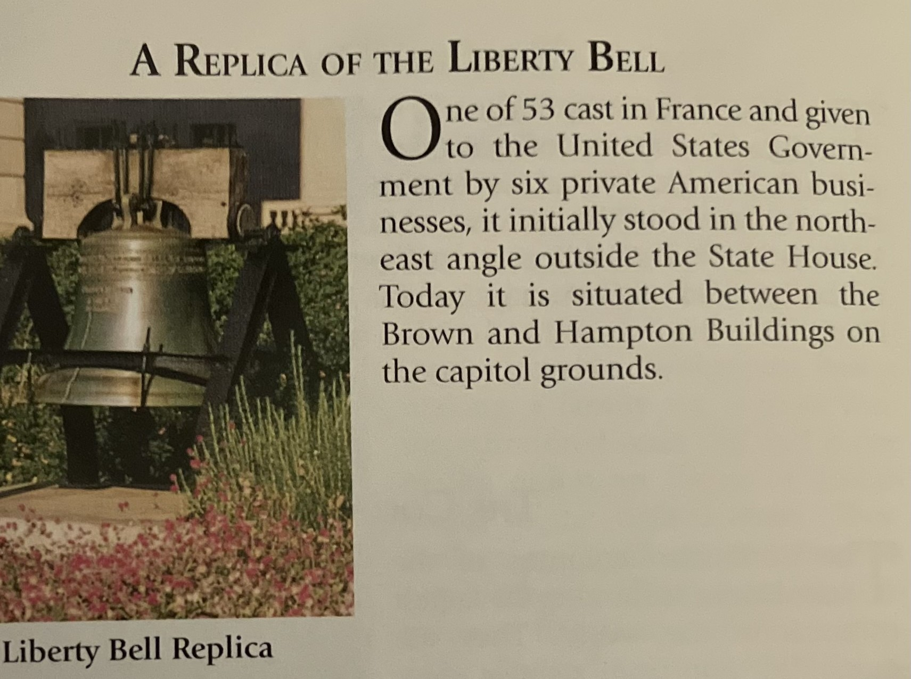

Civic Engagement & Outreach – Shelly Langston

March is Women's History month and I have some military news to provide you.

The South Carolina Ambassadors for the Military Women's Memorial, of which Shelly is one of the Ambassadors, sent a proposed Resolution to SC Legislature requesting the Resolution be passed Honoring the 6888 (Six Triple Eight) United States Women’s Army Corps Central Postal Battalion for their service to our country and the service they provided in World War ll. The Six Triple Eight received the Congressional Gold Medal of Honor in 2022. As March is Women’s History month, this was significant as the Six Triple Eight Army Women's Battalion consisted of over 850 African American women, 33 of them were from South Carolina, who were sent to Birmingham, England, to distribute the backlog of mail. Over 17 million pieces of mail were distributed and was completed in three months’ time instead of the mandatory 6 months they were given. Upon success of distributing the mail in London, they were sent to Roen, France to help with the back log of mail there. Shelly submitted the draft Resolution to her House Representative, Jay Kilmartin, and the proposal was accepted and passed by the House and sent to the Senate for concurrence. The proposal was accepted by the Senate and is now in the Governor’s office for signature.

There is a movie out on Netflix about the 6888 (Six Triple Eight) you may want to watch. Directed by Tyler Perry and Kerry Washington plays the lead, Major Charity Adams, who grew up in South Carolina.  Despite discrimination and war-torn conditions, they persevered. Their motto was No Mail, Low Morale. These women had a job to do and an opportunity to show their country they could do any job presented to them. This was their mission and we will not fail. (Great movie per Beth!)  
  
Also in March there is a Midland Veterans Experience Action Center (VEAC) for all military veterans and family members.  If you have a family member or know a friend that served in the military or are a spouse of a military serviceman/servicewoman this 3-day event is a place to GET Assistance with your benefits.  No appointment is necessary!   *(Flyer is attached on last page)*

South Carolina Ambassadors, Shelly Langston, U.S. Navy, Barb Kucharczyk, U.S. Air Force, Denise Scarboro, U.S. Army, and Bambi Bullard, U.S. Marine Corps, were recognized by the Military Women's Memorial for the highest number of state registrations of military women in the country, registering over 1,300 military women from South Carolina in 2024. The President of the Military Women's Memorial had challenged all the states to register 500 women in 2024. Shelly Langston and Barb Kucharczyk were also presented with the Presidential Volunteer Service Award signed by President Joe Biden.

The USO at the Columbia Airport is again in need of luggage to offer to soldiers who are being discharged.  If you are doing any Spring cleaning and have any extras, I would be happy to take them.  They will accept backpacks, duffle bags or roller bags of any size.  The only requirement is that the luggage must be able to be zipped closed - no drawstring bags. Jo Norris can pick them up or you can bring them to the March meeting.

Education & Libraries – Jane Ashley Durham & Maureen Taylor

We are looking forward to seeing everyone at Bunco on Thursday!

The Education CSP would love to pass on this invite to as many of our Club members that can attend Seven Oaks Park, on Wednesday April 2nd at 9:00am. Seven Oaks Elementary has nominated the SAWC for District 5 Volunteer of the year. Love this! Great job ladies!

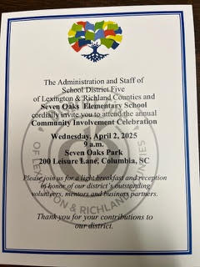

*\*\* Here is a little bit of follow up on one of our speakers, from Marie Deloach.*

Tom Poland, author, who has spoken at our club meeting will be having a book signing at Wingard’s Market on March 14 and 15 from 1-4. This is also Spring Fling at the market.

Environment – Gail Elfert

The plastic film deposit total will be at least 740 lbs. by the time you get this newsletter, with more plastic coming in every day! I expect that we will be well over the 3/4 mark on our 1000 lb. journey toward securing a sturdy TREX bench.  And I look forward to revealing to everyone at the next meeting who will be receiving that bench. Hint: there are some very excited children!!

Finally, we have a date for our environmental field trip to the Tom Yawkey Wildlife Center on the coast in Georgetown!  If you would like to join us on Thursday, April 10, for the 10 a.m. to 2 p.m. tour of this environmental and wildlife refuge "gem" let me know ASAP. There are 10 spaces reserved on the bus tour for our group, and they will be given on a first come-first served basis. We will leave Columbia on Wednesday, April 9, and spend the night in North Litchfield. There is no cost for the tour or for spending the night. More details will follow for those who claim a space.  A second tour may be booked in May if there is enough interest.

This month's speaker will be Savannah Jordan from the South Carolina Wildlife Federation which is the oldest conservation organization in the state.  Her presentation will include information related to our state GFWC-SC President's Special Project - Preserve Our Birds.

|  |
| --- |
|  |

Health & Wellness – Barbara Cross & Daryl Hendrix

**March is National Colon Cancer Awareness Month**. Colorectal cancer is the third most common cancer in both men and women in the US, and the second leading cause of cancer death. Early detection through screening can significantly improve survival rates. It is now recommended that screening begins at age 45.

The leading cause of colon cancer is environmental exposures. These include:

 1.  Diet: Low-fiber, high fat diets, high intake of processed meats and low intake of fruits/vegetables.

      (processed meats should be avoided -hot dogs, ham, bacon, sausage and red meat intake limited to 18 ounces or less per week).

 2.  Alcohol: excessive consumption

 3.  Tobacco: smoking

 4.  Sedentary lifestyle

Know your family history. An immediate family member with colon cancer increases your risk.

So, to reduce your risk of colon cancer: Eat a healthy diet, exercise regularly, maintain a healthy weight, quit smoking, limit alcohol and get regular screenings. (colonoscopy).

**Standing Committee Chairs & Special Appointments:**

Fellowship – Jan Mitchell-Conner

March birthdays:  Phyllis Plyler, Elizabeth Taylor, Rachel Richardson, Leann Angel, Carol Ann Williams, and Jane Jeffcoat.

Leadership/WHRT – Kristin Fields

This is a little late but very interesting WHRC article.

It's WHRC Wednesday, and the first Wednesday of Black History Month! Your Women's History and Resource Center Librarian often spends her morning commute reading history (naturally enough), and just this morning she learned about Clara Brown (1880-1885):  entrepreneur, philanthropist, and likely the first Black woman to settle in Colorado. Born into slavery, she became free in the 1850s and decided to head west in the hopes of finding her daughter, who had been sold away from her decades earlier. After a few years in Denver, she moved to Central City CO, where she opened a laundry business; over the years she served as a midwife and nurse in this mining community, and used her savings to support churches and schools. After the Civil War, she travelled to Kentucky and Kansas to help newly-freed African Americans make the move to Colorado. And throughout all of this, she never stopped looking for her daughter. At last, Eliza was found living in Council Bluffs, Iowa, and mother and daughter were reunited in 1882, returning to Denver.

Clara Brown died in Denver in 1885. Before her death she became the first woman to join the Society of Colorado Pioneers, recognizing residents who had arrived before 1861. In 1989 she was inducted into the Colorado Woman's Hall of Fame, and in 2022, into the Colorado Business Hall of Fame. (There's even an opera about her life story.) In my reading this morning I came across a reference to her membership in women's clubs, but haven't been able to pin that down yet; though the Colorado Federation of Women's Clubs was founded in 1895, and the Colorado Association of Colored Women's Clubs in 1904, there were clubs for both White and Black women in existence in Denver before Brown's death in 1885 - and her many charitable and philanthropic endeavors lead one to believe she had the spirit of a clubwoman, if nothing else.

As always, our Facebook posts can give only the briefest of glimpses into the histories we present; we encourage you to take some time to learn a bit more about Clara Brown's life and career. (Just don't do it on the subway if, like me, you're prone to tears when you read about a mother reuniting with a daughter she never stopped searching for. Sorry, fellow commuters!) I'll throw a link to her page at the Colorado Women's Hall of Fame into the comments, to get you started. And if anyone can shed light on her possible club membership, please let us know!

📷Clara Brown, circa 1875. From the collection of the Denver Public Library.

**IMPORTANT DATES TO REMEMBER:**

3/13/25 Bunco Saluda Shoals

3-24-25 General Meeting 6:30 Union United Methodist Church

4/14/25 Board Meeting 6:30

4-18-25 Newsletter article to Beth

4/25 – 4/27 GFWC-SC State Convention Rock Hill, SC

