**St. Andrews Woman’s Club**

2024-2025



**Be the willing hand to help someone**

**May 2025 NEWSLETTER**

Member of the General Federation of Women’s Clubs (GFWC) since 1963

Contact: Susan Dox, Co-president ………….……sdox0103@gmail.com

Debbie Bell, Co-president………….……dbell815@gmail.com

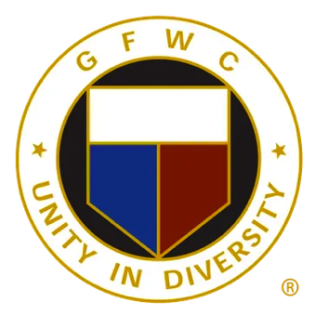

**Officer Reports:**

**President – Susan Dox & Debbie Bell**

**1st Vice President – Beth Smith-Pollom & Becky Travis**

**2nd Vice President – Lynne Hauptner & Ann Martin**

**3rd Vice President Ways & Means – Frances Hill & Susan Smith**

**Secretary – Laura Nichols**

I'm new and need your help!!  ATTENDANCE IS IMPORTANT!

Hello ~ Please do your best to let me know if you are going to be absent from a meeting.  Feel free to email ( [Lecnichols49@gmail.com](mailto:Lecnichols49@gmail.com) )  or shoot me a text (803-463-4446).

Don't forget to sign in.   Since I don't know all the names and faces yet, please check in with me. Thank you!

**Treasurer – Jo Norris & Sarah Ostergaard**

**Advisor – Laurie O’Kelly**

**Community Service Project Reports:**

Arts and Culture – Rachel Richardson & Nancy Schmidt

Civic Engagement & Outreach – Shelly Langston

Education & Libraries – Jane Ashley Durham & Maureen Taylor

Environment – Gail Elfert

|  |
| --- |
|  |

Health & Wellness – Barbara Cross & Daryl Hendrix

**Standing Committee Chairs & Special Appointments:**

Leadership/WHRT – Kristin Fields

Fellowship – Jan Mitchell-Conner

**IMPORTANT DATES TO REMEMBER:**