November 2024 Newsletter
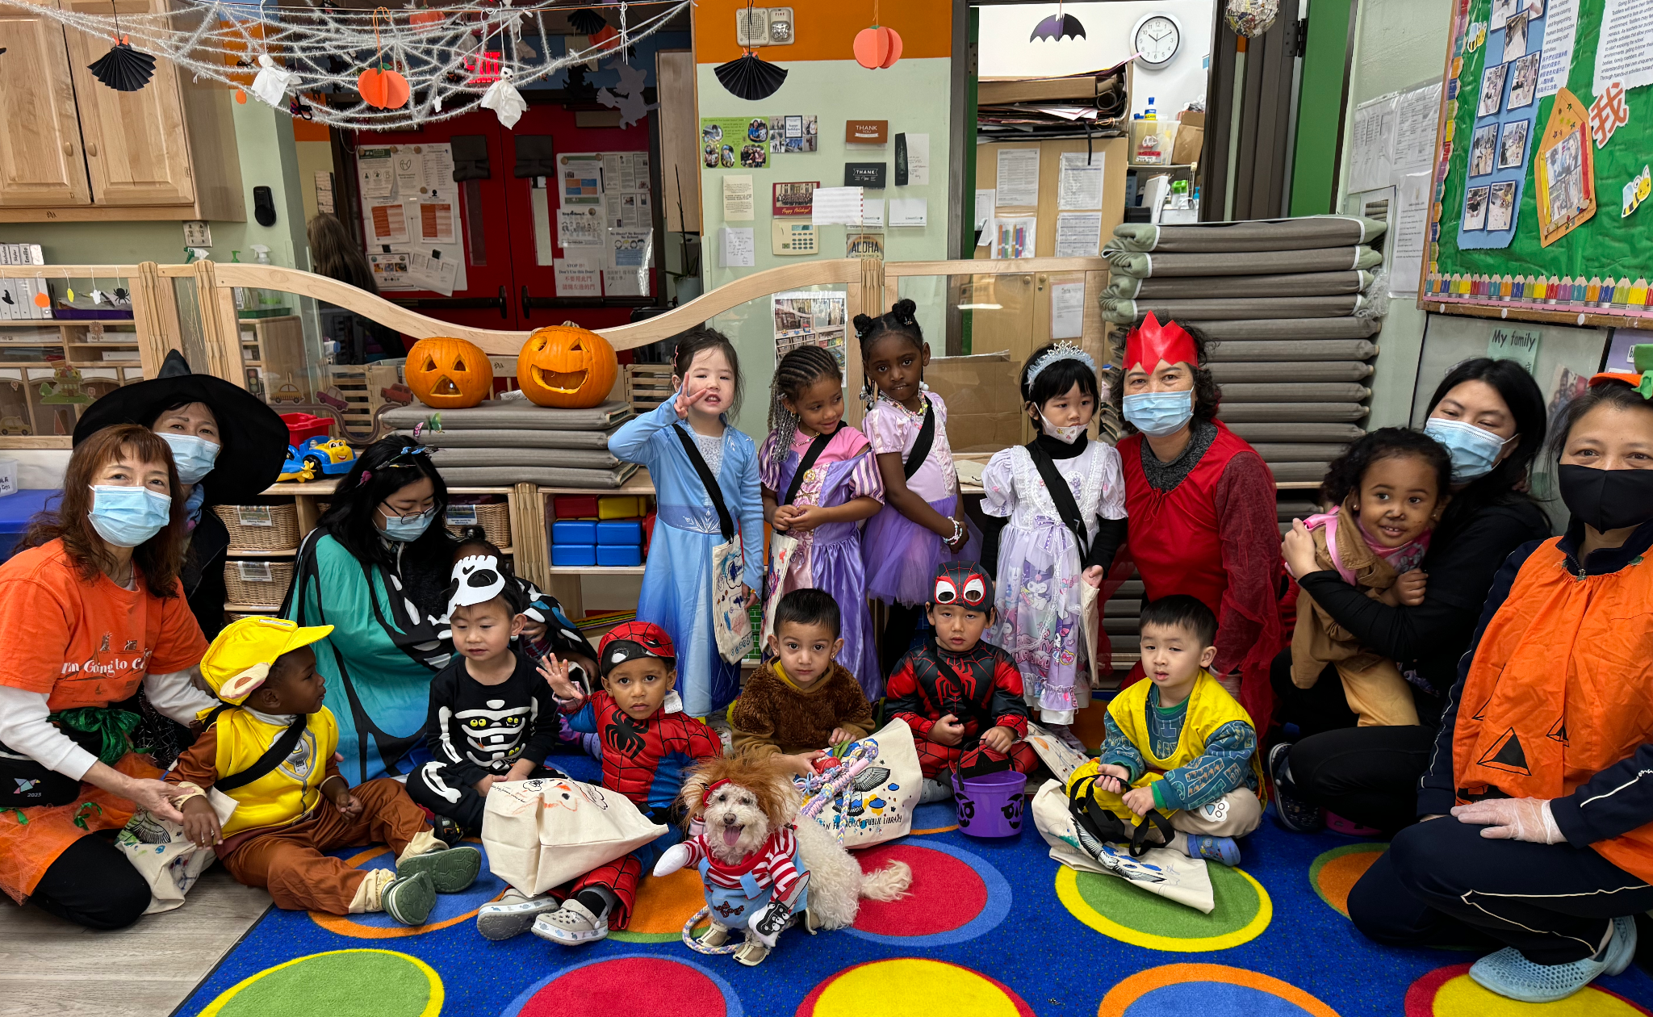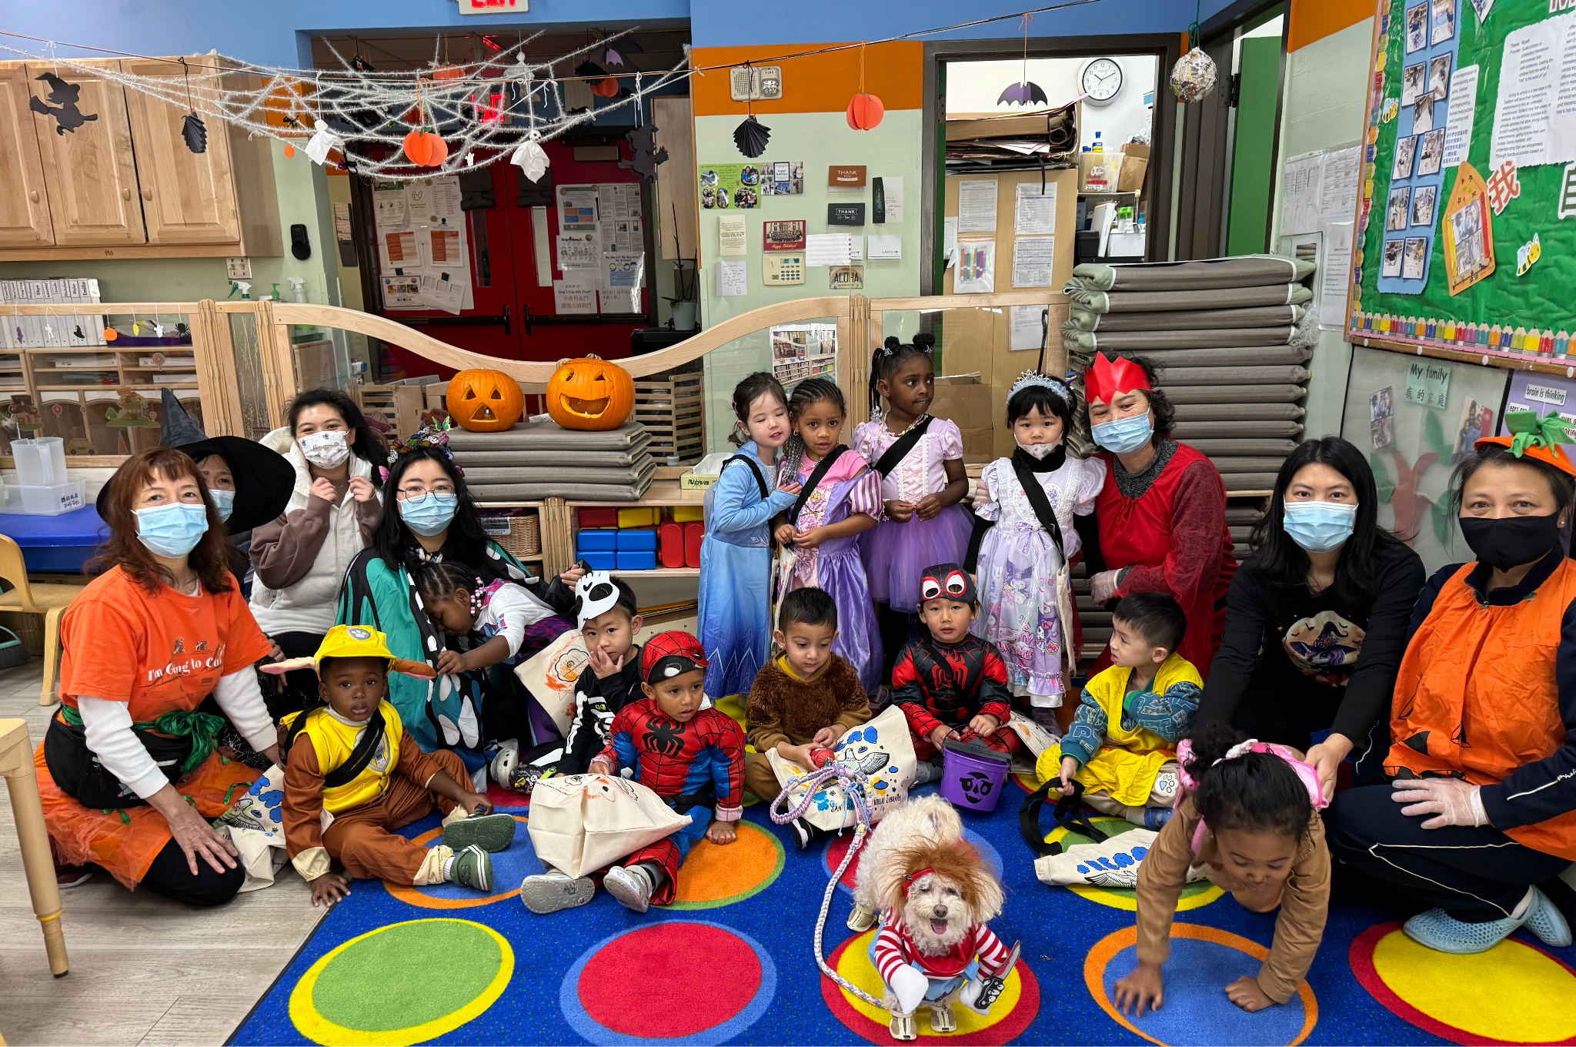
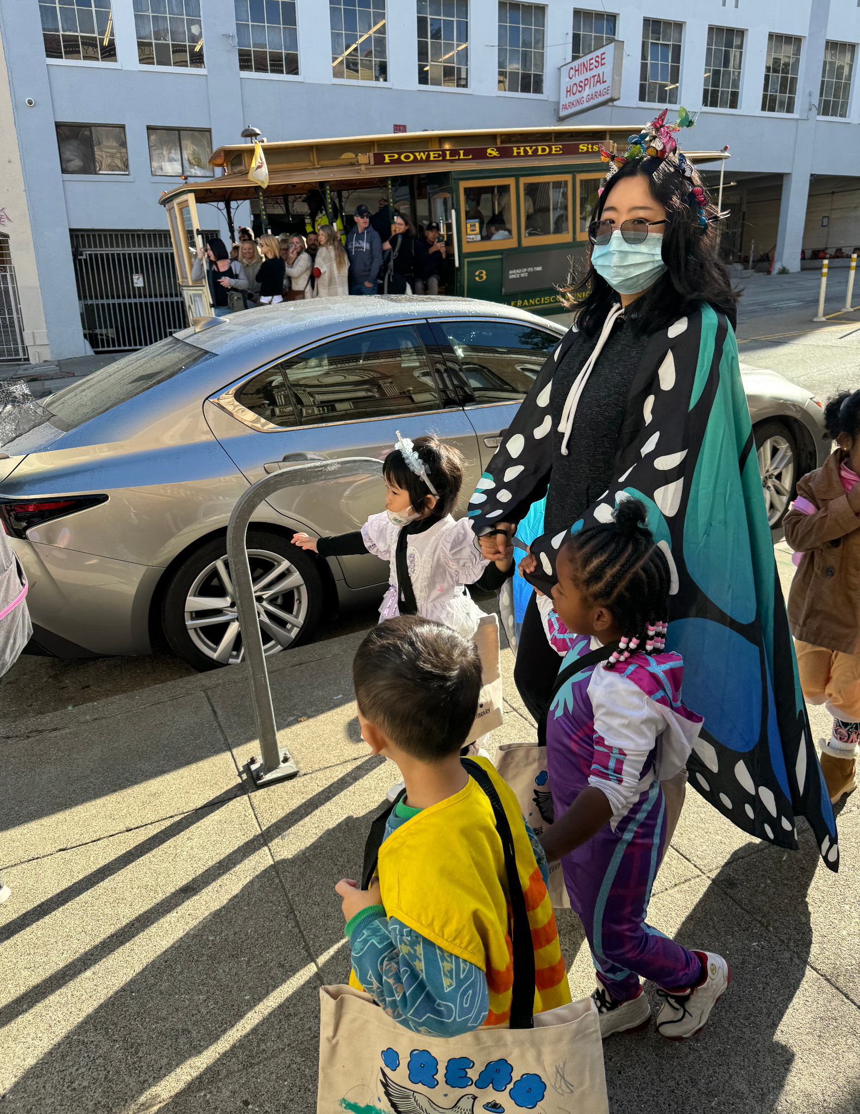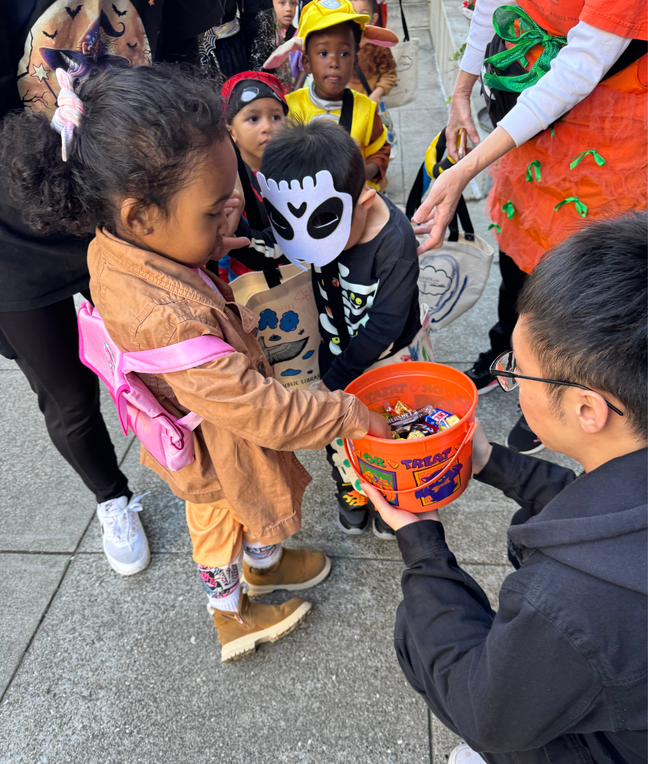
Halloween- Trick or Treat 2024
Dear Parents of the True Sunshine Community,

We had a great Trick-or-Treat around the neighborhood on Thursday, 10/31. The children were excited and doing well as we walked down the street for the treats. We had a guest (Mochi) join the walk. It was also Mochi’s birthday, and the children sang “Happy Birthday” to her. Mochi was happy, too.

The field trip to the pumpkin patch was great as well. I hope the parents who joined us enjoyed spending time with their children. All the children brought a pumpkin home, so I hope it was a good experience for them. Teachers have been planning activities around the pumpkins for children to do. I hope you also used the pumpkin your child brought home well.

We had our parent workshop on 10/21. It was all about children’s development and challenges. A recording was sent to you to view if you did not get a chance to attend. I have met with the PAC committees about the workshops we should organize for our community. If there is anything you are interested in, please let me know. We can put it into our schedule.

As we are into November. Children will be learning about appreciation and gratitude. They will also understand the importance of helping others and teamwork. Children will make “Stone Soup” as part of their activities. We will need parents to bring in different kinds of vegetables and chicken broth to make the soup. If you are interested in helping, reading the story, and showing the children how to make the “stone soup,” please let your teacher know. It would be a great, fun experience for our kids. Maybe it can also be a dish for our potluck.

As I mentioned, the Thanksgiving “Potlock” is an annual event that True Sunshine has been running for the past 8 years. It is an excellent time for our families to unite and share their cultures. On Wednesday, before Thanksgiving, True Sunshine holds a potluck where parents bring in the food families eat to celebrate. It is also a way for children to understand that many things we do need collaboration and support from others. Therefore, we need to appreciate and be grateful for what we have. Please sign up for what you can bring on November 27, 2024. A form will be posted for you to sign up. The potluck will start at 12.

Don’t forget that Daylight Saving ends on Sunday, 11/3. Switch your clock.

Reminders:
- Please inform the school by 9:30 a.m. that your child will be late or absent. No child will be admitted to school once the children are out to the park. No child will be onsite without the teacher’s supervision or can be dropped off at or picked up from the park.
- Parents are welcome to bring their children into the classroom to pick up and drop off their child/children. If it is after 9:20 am, parents, please take your child/children into the classroom and make sure your child/children wash their hands, put things away, and let the teacher know. Before entering the classroom, please wear a mask and shoe covers.
- If your child is not feeling well (with any cold symptoms), please do not bring him/her back to school. Have your child stay at home until he/she is all better. If your child is home due to fever or diarrhea, please ensure he/she is fever and/or diarrhea-free for 24 hours before returning to school.
- Please follow us and like our Facebook page and Instagram.

The Important Dates:
- 11/3/2924 Daylight Saving ends.
- 11/11/2024 Monday, Veterans Day, No School
- 11/27/2024 Wednesday, Potluck, Half-Day, Close at 1:30 pm.
- 11/28-29/2024 Thursday, Friday, Thanksgiving, No School

Sincerely,
Diana
Executive Director

2024年11月學校通訊

萬聖節Trick-or-Treat拿糖步行活動

親愛的家長，

10 月 31 日星期四，我們在學校附近進行了「不給糖就搗蛋」步行活動。 當我們沿著街道去拿糖果時，孩子們很興奮，亦表現得不錯。 當天我們有一位嘉賓（Mochi）加入了步行。 這天也是Mochi的生日，孩子們唱了《生日快樂》給她聽。 Mochi也很高興。

南瓜園的戶外旅遊也很棒。 我希望加入我們同行的父母夠享受了與孩子共度的時光。 所有的孩子都拿到一個南瓜。 我希望這對孩子們來說是一次很好的經驗。 老師們一直在為孩子們策劃圍繞南瓜的活動。 希望您也有機會使用孩子帶回家的南瓜。

我們於 10 月 21 日舉辦了家長研討會。 這都與兒童的發展和挑戰有關。 如果您沒有機會參加，我們已發送了培訓的錄影給您，供您參考。 我與 PAC 委員會開面，討論我們應該為我們的家長安排什麼類型的研討會。 如果您有什麼感興趣的主題，請告訴我。 我們可以把它納入我們的安排中。

當我們進入十一月。孩子們將會利用更多的機會學習欣賞和感恩。 他們還將了解幫助他人和團隊合作的重要性。 孩子們將製作“石頭湯”作為活動的一部分。 我們需要家長帶不同種類型的蔬菜和雞湯來熬湯。 如果您有興趣參與、閱讀故事並向孩子們展示如何製作“石頭湯”，請告訴您的老師。 對我們的孩子來說，這將是一次很棒、有趣的體驗。 也許它也可以成為我們聚餐的一道菜。

正如我所提到的，感恩節聚餐「Potlock」是 True Sunshine 過去 8 年一直舉辦的年度活動。 對我們的家庭來說，這是團結和分享文化的絕佳時機。 星期三，感恩節前，「真日陽」會舉辦聚餐活動，家長會帶您們家人在慶祝時會吃的食物來。這也是讓孩子們了解我們很多所做的事都需要許多人的合作和努力來達成。 因此，我們要珍惜並感恩我們所擁有的。 請於 2024 年 11 月 27 日報名參加您可以攜帶的食物。聚餐將於12點開始。

不要忘記夏令時將於 11 月 3 日星期日結束。 要更改你的時鐘。

溫馨的提醒：

- 請在早上 9:30 之前通知學校您的孩子將會遲到或缺席。 一旦孩子們出去了公園，就不會再讓孩子們入學。 沒有老師的監督， 孩子不行單獨待在教室裡，家長也不行自行到公園把孩子放下或從公園接孩子走。
- 歡迎家長帶孩子進教室接送您的孩子。如果過了9:20分後，請家長自行帶您的孩子進入教室，確認您的孩子洗手，東西方好，並讓老師知道。進教室前，請戴上口罩，鞋套方可進入。
- 如果您的孩子生病了（有任何感冒症狀），請不要帶您的孩子返回學校。 讓您的孩子待在家裡，直到他/她好起來。土國您的孩子是因為發燒或瀉肚子而回家，那您的孩子要24小時內沒發燒或瀉肚子後方可返回學校。 返回學校之前，需要獲得陰性的新冠病毒檢測結果。 請隨時告知我們測試結果
- 請關注並喜歡我們的Facebook頁面,和Instagram

重要的日子：

- 11/11/2024 星期一，退伍軍人節，放假
- 2024 年 11 月 27 日星期三，聚餐，半天，
下午 1:30 放學。
- 11/28-29/2024 星期四、星期五、感恩節、放假

校長，
Diana 謹上

