January 2025 Newsletter
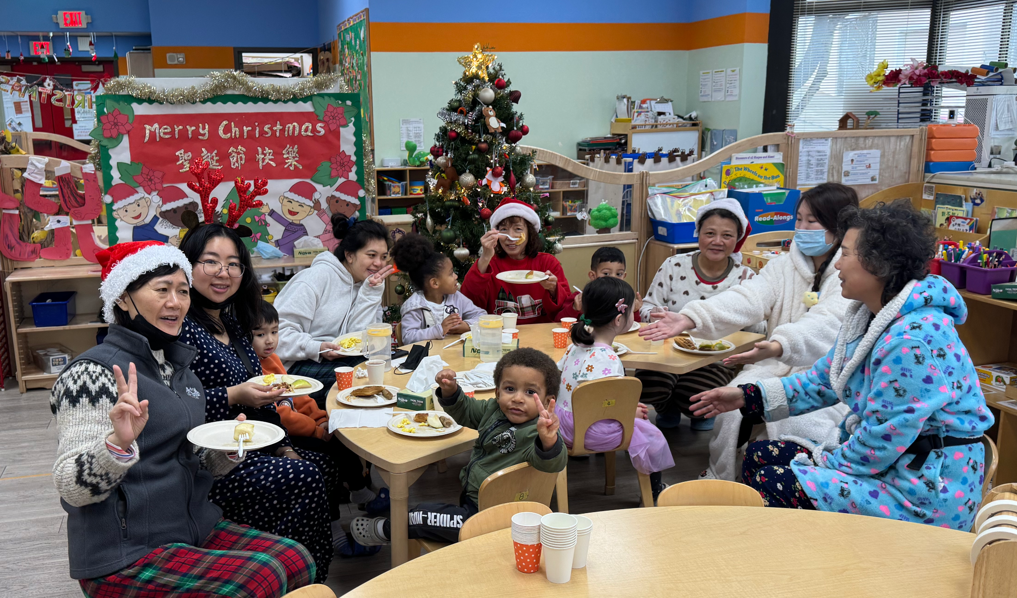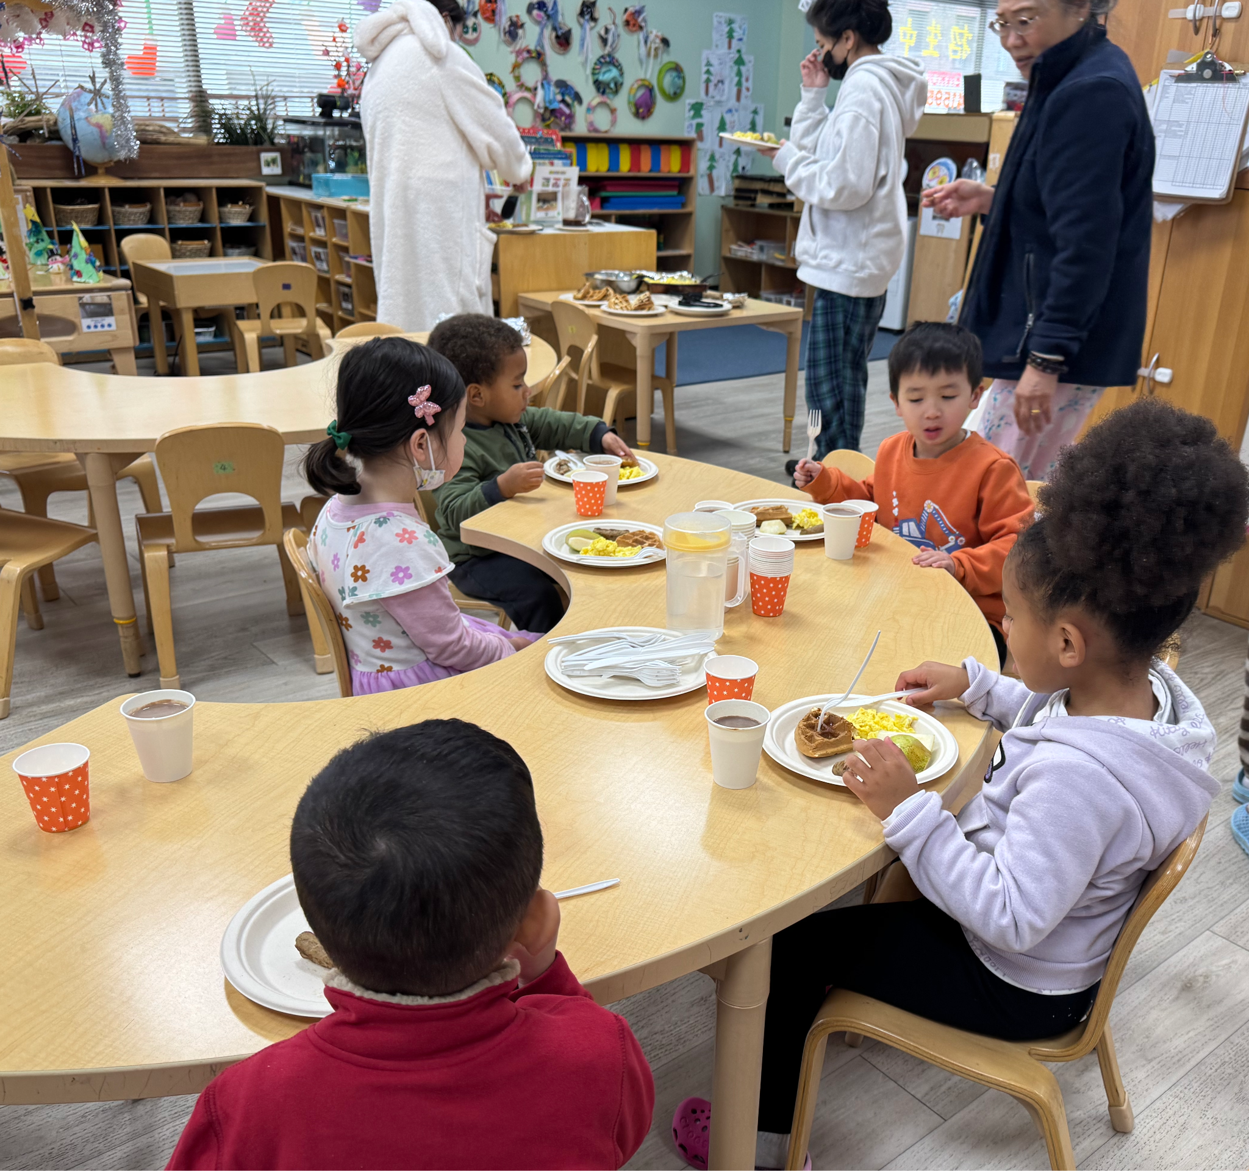
Pajama Party
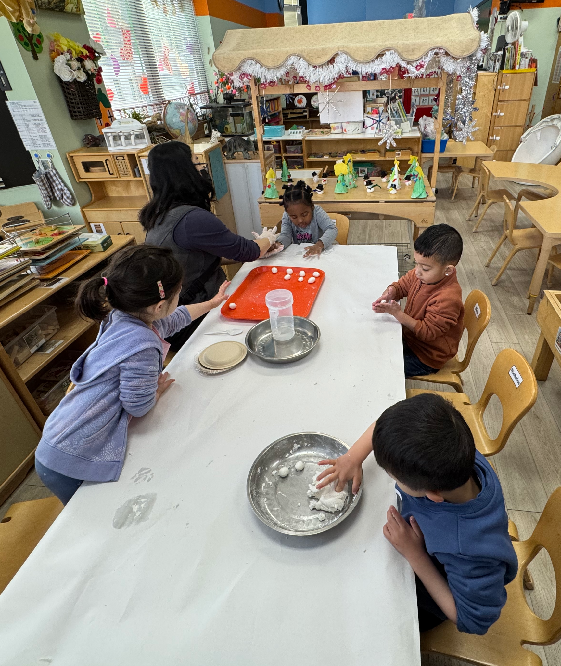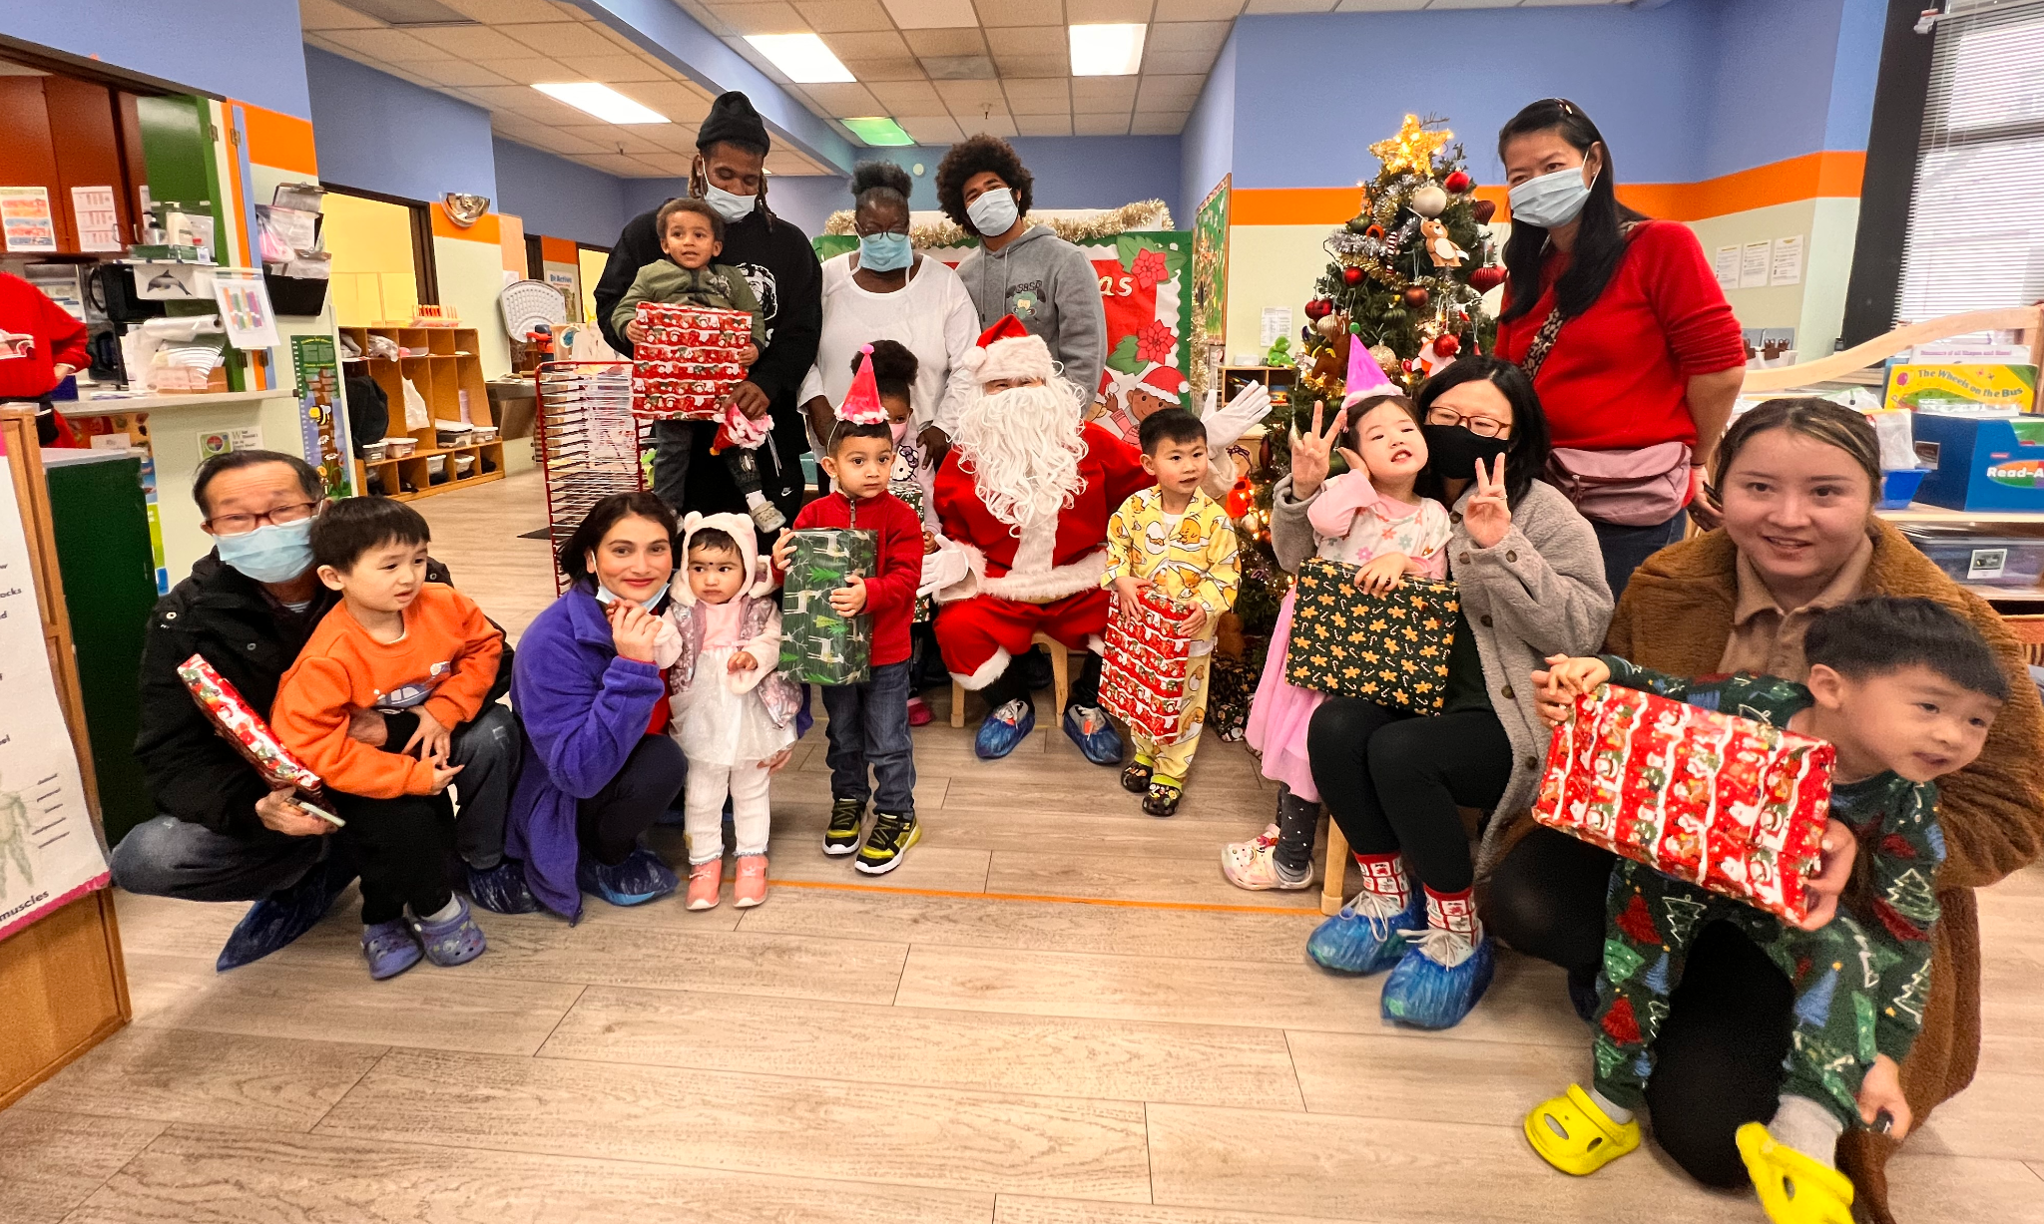
Winter Solstice- making rice ball Christmas with Santa
Dear Parents of the True Sunshine Community,

Happy New Year to all our families and friends!
The Pajama Party was fun, and the children gave a fantastic Christmas performance. Thank you, Santa (Nicholas’ Dad), for giving out the gifts to our children. It was fun to see you at True Sunshine.

2024 is over, and we are into 2025. In 2025, True Sunshine has many meaningful activities planned for our children and families. We look forward to your continuing participation and support. One of the most significant events would be the Spring Carnival. It will be held on Saturday, 5/3, from 10 am to 1 pm at Gorden J. Law Elementary School. Please spread the word about the fun event to your friends and families. We welcome them to join us for the fun.

We are planning a field trip to Monterey Bay Aquarium. We are still waiting for the reservation to be open to know the date. Please stay tuned.

The Lunar New Year is on January 29th (No School). Teachers will show our little ones the traditions of celebrating this special day. Children will also learn about the lion dance. A Lunar New Year performance will be held on 2/07 (Friday). We will let you know the time as we get closer to the date.

True Sunshine Preschool Center has served over 1500 families and nearly 2000 children. We provide nurturing care and enriched learning opportunities to our children. Our teachers are experienced and constantly update their knowledge in caring, supporting, and teaching the little ones through professional development and taking classes. Please refer True Sunshine to your families and friends if they have children between the ages of 2 and 5. We now have spaces to enroll children in both Toddler and Preschool programs. You can reach out to us for more information. Our number is 415-956-4207; call Jacqueline Li at 628-268-4148 to schedule a tour, or call/email me directly diana.kong@truesunshinepreschool.org.

Reminders:
- There has been a rise in COVID, flu, and cold cases. Please keep your child home until he/she is better. A mask may be asked to wear if one is still coughing. When returning to school, a negative COVID antigen test is required. Please show us the proof of conducting the test and the result.
- If your child is not feeling well (with any cold symptoms),
- Please do not bring him/her back to school. Have your child stay at home until he/she is all better. If your child is home due to fever or diarrhea, please ensure he/she is fever and/or diarrhea-free for 24 hours without medication before returning to school.
- Please inform the school by 9:30 a.m. that your child will be late or absent. No child will be admitted to school once the children are out to the park. No child will be onsite without the teacher’s supervision or can be dropped off at or picked up from the park.
- Please follow us and like our Facebook page and Instagram.
The Important Dates:

- 1/1/2025 (Wednesday) New Year's Day, No School.
- 1/20/2025 (Monday) Martin Luther King’s Day, No School
- 1/29/2025 (Wednesday) Lunar New Year, No School
- 2/7/2025 (Friday) Lunar New Year Performance, Time: TBA
Sincerely,
Diana
Executive Director

2025年1月學校通訊

睡衣派對
冬至-製作湯圓 聖誕老公公造訪

親愛的家長，

祝我們所有的家人和朋友新年快樂！

睡衣派對真的好玩，小朋友們的聖誕表演也非常的精彩。 謝謝聖誕老人（尼可拉斯的爸爸）分發禮物給我們的孩子。 很高興在 True Sunshine 見到您。

2024年已經結束，我們迎來了2025年，2025年，真日光為我們的孩子和家庭計劃了許多有意義的活動。 期待您繼續參與與支持。 最重要的活動之一就是春季嘉年華/園遊會。 活動將於 5 月 3 日星期六上午 10 點至下午 1 點在 Gorden J. Law 小學舉行。 請與您的朋友和家人宣傳這個有趣的活動。歡迎他們都可以參加。

我們正在計劃去蒙特利灣水族館進行戶外活動。 我們仍在等待預訂開放才能知道具體日期。請繼續關注。

農曆新年是 1 月 29 日（放假）。 老師們將介紹小朋友有關慶祝這個特殊日子的傳統。 孩子們還會了解舞獅。 2月7日（星期五）將舉辦農曆新年演出。 當日期臨近時，我們將告知您具體時間。

真日光學前教育中心已為超過1500個家庭和近2000名兒童提供服務。 我們為孩子們提供精心的關懷和豐富的學習機會。 我們的老師經驗豐富，並透過專業發展和參加課程不斷更新他們在照顧、幫助和教導小孩子方面的知識。 如果您的家人和朋友有 2 至 5 歲的孩子，請向他們推薦 True Sunshine。 您可以聯絡我們以獲取更多資訊。 我們的電話號碼是415-956-4207；請致電 628-268-4148 聯絡 Jacqueline Li 安排參觀，或直接致電/發送電子郵件給我 diana.kong@truesunshinepreschool.org。

溫馨的提醒：

- 新冠肺炎、流感和感冒病例增加。 請讓您的孩子待在家裡，直到他/她康復為止。 如果仍在咳嗽，可能會要求戴口罩。 返校時需進行 COVID 抗原檢測，結果為陰性。 請向我們出示進行測試的證明和結果。
- 請在早上 9:30 之前通知學校您的孩子將會遲到或缺席。 一旦孩子們出去了公園，就不會再讓孩子們入學。 沒有老師的監督， 孩子不行單獨待在教室裡，家長也不行自行到公園把孩子放下或從公園接孩子走。
- 如果您的孩子生病了（有任何感冒症狀），請不要帶您的孩子返回學校。 讓您的孩子待在家裡，直到他/她好起來。如果您的孩子是因為發燒或瀉肚子而回家，那您的孩子要再沒吃藥後的24小時內沒發燒或瀉肚子後方可返回學校。 返回學校之前，需要獲得陰性的新冠病毒檢測結果。 請隨時告知我們測試結果
- 請關注並喜歡我們的Facebook頁面,和Instagram

重要的日子：

- 2025 年 1 月 1 日（星期三）元旦，放假。
- 2025 年 1 月 20 日（星期一）馬丁路德金恩紀念日，放假
- 2025 年 1 月 29 日（星期三）農曆新年，學校停課
- 2025/2/7 日 （星期五）農曆新年演出，
表演時間：待定

校長，
Diana 謹上

