True Sunshine February 2025 Menu 
Monday | Tuesday | Wednesday | Thursday | Friday
03 | 04 | 05 | 06 | 07
A.M. Snack  Breakfast Cereal of the Day  Whole Fresh Fruit  Lunch  Natural Chicken Tenders  Steamed/Fresh Vegetables  Fresh Fruit  P.M. Snack  Homemade Brazilian Cheese and Coconut Stick | A.M. Snack  Home Baked Blueberry Muffin  Whole Fresh Fruit  Lunch  Chicken Alfredo Pasta  Steamed/Fresh Vegetables  Fresh Fruit  P.M. Snack  Homemade Mini Empanadas | A.M. Snack  Home Baked Black Sesame Seed, Pear Breakfast Bread  Whole Fresh Fruit  Lunch  Turkey Chili Con Carne + Vegetables  Home Baked Corn Bread Muffin  Fresh Fruit  P.M. Snack  Homemade Brazilian Cheese and Coconut Stick | A.M. Snack  Home Baked WOW Butter Mandelbrot  Whole Fresh Fruit  Lunch  Turkey Spaghetti Bolognese  Steamed/Fresh Vegetables  Fresh Fruit  P.M. Snack  A2 Organic Vanilla Yogurt  Yummy Chefables Rolled Oats Cereal | A.M. Snack  Cheddar Cheese & Scallion Bagel  Whole Fresh Fruit  Lunch  Mac & Cheese  Steamed/Fresh Vegetables  Fresh Fruit  P.M. Snack  Homemade Soft Pizza Pretzel Stick  Whole Fresh Fruit
10 | 11 | 12 | 13 | 14
A.M. Snack  Breakfast Cereal of the Day  Whole Fresh Fruit  Lunch  Natural Chicken Tenders  Steamed/Fresh Vegetables  Fresh Fruit  P.M. Snack  Chefables Very Own Cheese Sticks  Home Baked Crackers | A.M. Snack  Home Baked Poppy Seed Muffin  Whole Fresh Fruit  Lunch  Mac & Cheese  Steamed/Fresh Vegetables  Fresh Fruit  P.M. Snack  Pumpkin Seed & Coconut Biscuit | A.M. Snack  Home Baked Classic Banana Breakfast Bread  Whole Fresh Fruit  Lunch  COLD Southwest Chicken & Cabbage Salad  Buttermilk Cheddar Cheese Biscuit  Fresh Fruit  P.M. Snack  Homemade Mini Empanadas | A.M. Snack  Home Baked Lemon Ricotta Pancakes  Whole Fresh Fruit  Lunch  Bean and Cheese Pupusas  Steamed/Fresh Vegetables  Fresh Fruit  P.M. Snack  A2 Organic Vanilla Yogurt  Yummy Chefables Rolled Oats Cereal | A.M. Snack  Hodge Podge (Rice Porridge)  Whole Fresh Fruit  Lunch  Beef Stroganoff, Pasta  Steamed/Fresh Vegetables  Fresh Fruit  P.M. Snack  Homemade "POP" Rice  Whole Fresh Fruit
17 | 18 | 19 | 20 | 21
Closed | A.M. Snack  Breakfast Cereal of the Day  Whole Fresh Fruit  Lunch  Natural Chicken Tenders  Steamed/Fresh Vegetables  Fresh Fruit  P.M. Snack  Chefables Very Own Cheese Sticks  Home Baked Crackers | A.M. Snack  Home Baked Sour Cream Streusel Breakfast Bread  Whole Fresh Fruit  Lunch  Turkey Spaghetti Bolognese  Steamed/Fresh Vegetables  Fresh Fruit  P.M. Snack  Homemade Mini Empanadas | A.M. Snack  Home Baked French Toast Sticks  Whole Fresh Fruit  Lunch  Mac & Cheese  Steamed/Fresh Vegetables  Fresh Fruit  P.M. Snack  A2 Organic Vanilla Yogurt  Home Baked Mini Muffin | A.M. Snack  Home Baked Cacao Breakfast Squares  Whole Fresh Fruit  Lunch  Homemade Beef & Cheese Triangle Ravioli (red sauce)  Steamed/Fresh Vegetables  Fresh Fruit  P.M. Snack  Chefables Very Own Cheese Sticks  Homemade "POP" Rice
24 | 25 | 26 | 27 | 28
A.M. Snack  Breakfast Cereal of the Day  Whole Fresh Fruit  Lunch  Natural Chicken Tenders  Steamed/Fresh Vegetables  Fresh Fruit  P.M. Snack  Chefables Very Own Cheese Sticks  Home Baked Crackers | A.M. Snack  Home Baked Carrot Raisin Breakfast Bread  Whole Fresh Fruit  Lunch  Chicken Fajita Burrito  Steamed/Fresh Vegetables  Fresh Fruit  P.M. Snack  Home Baked Delimanjoo  Whole Fresh Fruit | A.M. Snack  Home Made Concha!  Whole Fresh Fruit  Lunch  Chefables Turkey Pepperoni Pizza PUFF  Steamed/Fresh Vegetables  Fresh Fruit  P.M. Snack  Pumpkin Seed & Coconut Biscuit | A.M. Snack  Home Baked Whole Grain 50/50 Waffles  Whole Fresh Fruit  Lunch  Mac & Cheese  Steamed/Fresh Vegetables  Fresh Fruit  P.M. Snack  A2 Organic Vanilla Yogurt  Yummy Chefables Rolled Oats Cereal | A.M. Snack  COLD Over Night Oats - Cup  Whole Fresh Fruit  Lunch  Turkey Spaghetti Bolognese  Steamed/Fresh Vegetables  Fresh Fruit  P.M. Snack  Homemade "POP" Rice  Whole Fresh Fruit
 |  |  | Serving Sizes Overview  1-2 Year Olds  Breakfast  WGR Grain 1/2 sl or svg or 1/4 c  Fruit/Veg 1/4 c  Milk 4 oz  Lunch/Supper  Meat/Alt 1 oz  WGR Grain 1/2 sl or svg or 1/4 c  Veg 1/8 c  Fruit (or 2nd Veg) 1/8 c  Milk 4 oz  PM Snack (2 items only)  Veg 1/2 c  Fruit 1/2 c  Meat/Alt 1/2 oz, 1/4 c  Grain 1/2 sl or svg, or 1/4 c  Milk 4 oz | Serving Sizes Overview  3-5 Year Olds  Breakfast  WGR Grain 1/2 sl/svg, 1/3c or 1/4 c  Fruit/Veg 1/2 c  Milk 6 oz  Lunch/Supper  Meat/Alt 1-1/2 oz  WGR Grain 1/2 sl or svg, or 1/4 c  Veg 1/4 c  Fruit (or 2nd Veg) 1/4 c  Milk 6 oz  PM Snack (2 items only)  Veg 1/2 c  Fruit 1/2 c  Meat/Alt 1/2 oz, 1/4 c  WGR Grain 1/2 sl or svg or 1/4 c  Milk 4 oz
Notes
- One Grain serving per day must be WGR, M/MA may be substituted for a breakfast grain (3X/week max).
- Unflavored Milk served at ALL breakfast and lunch meals. Whole milk (Infant/Toddlers <2 yrs), lowfat (1%) milk (preschool >2 yrs). All Milk served is rBST-free.
- Chefables reserves the right to substitute stated menu items if it becomes unavailable in the market or due to unforeseen circumstances.
Just some of the vegetables this month:
Arugula Asian greens asparagus avocado beets bok choy broccoli rabe Brussels sprouts cabbage carrots cauliflower celery chard collard kale leeks lettuces mushrooms mustard onion parsnips potatoes radicchio radishes rutabagas scallions spinach sunchokes squash (winter) sweet potato turnips
Just some of the fruits this month:
Apple Asian pear cherimoyas Grapefruit dates kiwi kumquat lemon limes mandarin oranges pomelos persimmons
= New menu offering | = Whole Grain Rich | = Vegetarian Menu Option |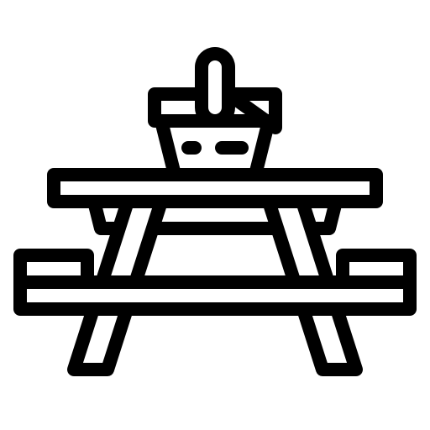 = Field Trip Menu Option |

