October 2024 Newsletter
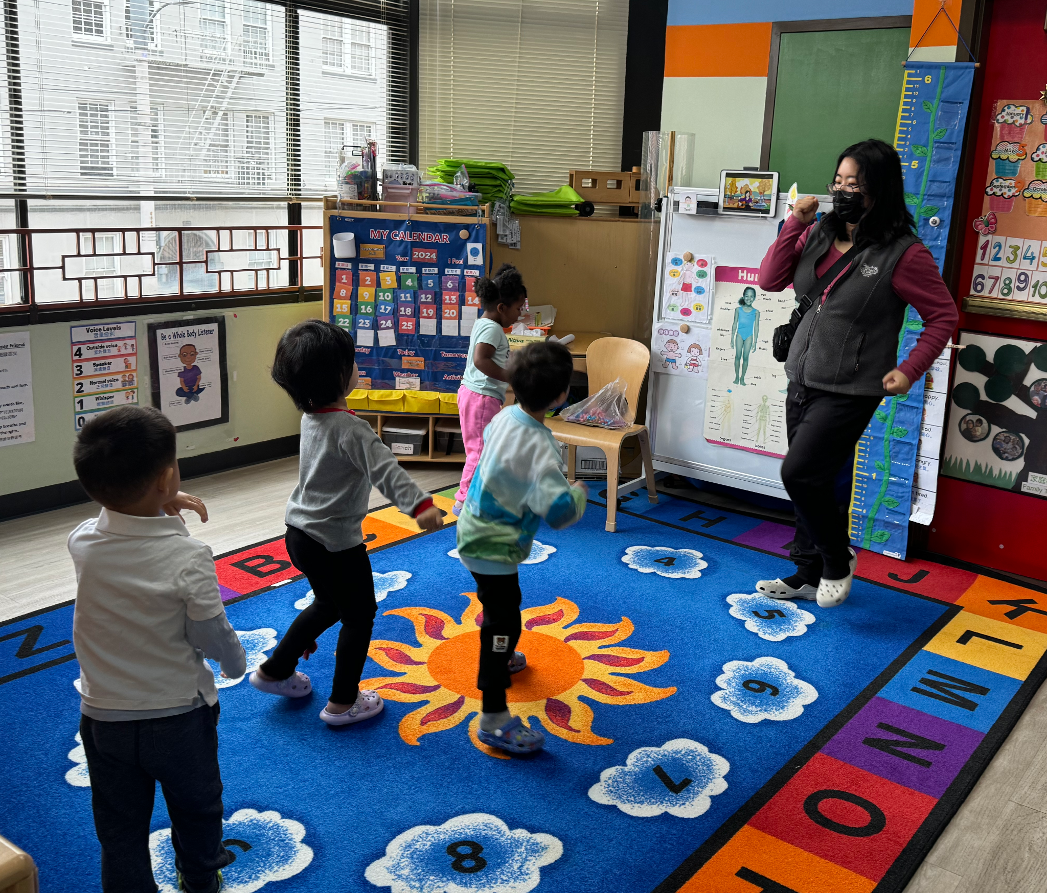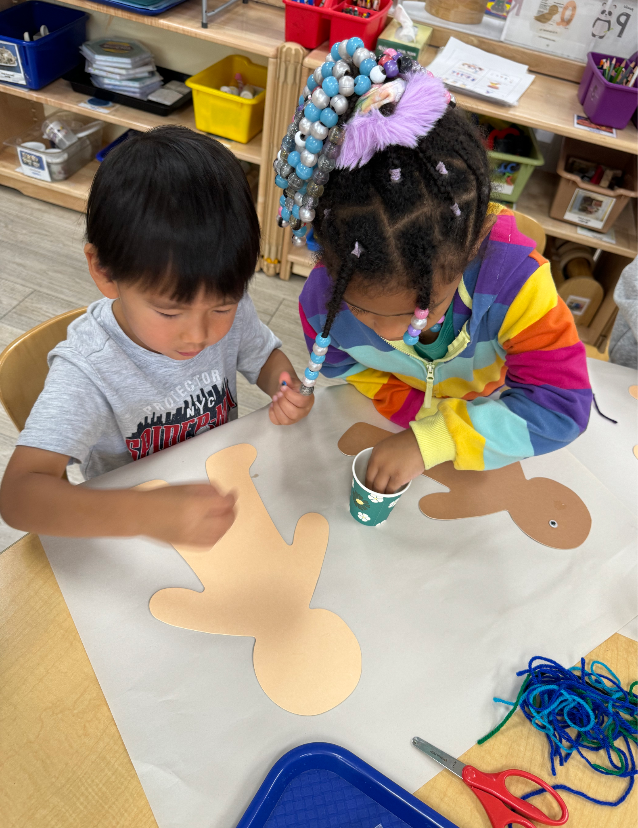
Dear Parents of the True Sunshine Community,

First, thank you for attending our Back-to-School Night on September 25, 2024. Your teacher will be sending out a copy of the presentation.

In September, the children learned about the routines, expectations, themselves and many others. They will continue with the theme “All About Me”, knowing the body parts, usages, sensory and etc.

We have our first on-bus field trip to Lemos Farm in Half-Moon Bay on October 23, 2024. Please sign the permission slip and return it to the teachers when you get the form. We will leave no later than 9:30 am, and return to the school by 1:30 pm. Please note, if your child has difficulties following directions, we won't be able to have your child join the field trip if you are not the chaperone. It is all for the safety of your child and others.

Thank you to the parents who have signed up to become room parents for your child’s class and/or Parent Advisory Committee (PAC) members. Your teachers will email you about what you can help with as room parents, and I will email you if you signed up for the PAC. Thank you in advance for what you do for the school.

On Monday, October 21, 2024, a parent workshop is scheduled at 7:00 pm. It is an hour-long workshop. It is all about child development. We noticed that since COVID, we are dealing more challenges with children. Understanding how children development helps parents to have a better ideas how children should be at each stage. If there is anything needs to be address, it would be helpful to address early in order to benefit the children.

Please make sure your child has extra sets of clothes and 2-3 days of emergency food stored in school. If you have not brought them, please do it at your earliest convenience.

Reminders:
- Please inform the school by 9:30 a.m. that your child will be late or absent. Once the children are out to the park, no child will be admitted to school. No child will be onsite without the teacher’s supervision or can be dropped off at or picked up from the park.
- Parents are welcome to bring their children into the classroom to pick up and drop off their child/children. If it is after 9:20 am, parents, please take your child/children into the classroom, and make sure your child/children wash their hands, put things away, and let the teacher know. Before entering the classroom, please wear a mask and shoe covers.
- If your child is not feeling well (with any cold symptoms), please do not bring him/her back to school. Have your child stay at home until he/she is all better. If your child is home due to fever or diarrhea, please make sure he/she is fever and/or diarrhea-free for 24 hours before returning to school. A negative COVID test result is needed before returning to school. Please always let us know the test result.
- Please follow us and like our Facebook page and Instagram
- Please help us fundraise by shopping at SmileAmazon using the link http://smile.amazon.com/ch/94-2242733. True Sunshine will receive 0.5% of all of your purchases. Thank you!

The Important Dates:
- 10/14/2024, Monday, Indigenous (Columbus) Day, No School
- 10/23/2024, Wednesday, Field Trip, Lemos Farm, (9:30 am to 1:30 pm)
- 10/16/2024, Wednesday, BMI check
- 10/21/2024, Monday, Parent Workshop, 7-8 pm, Zoom (virtual)
- 10/31/2024, Thursday, Halloween

Sincerely,
Diana
Executive Director

2024年10月學校通訊

親愛的家長，

首先，感謝您參加 2024 年 9 月 25 日的返校之夜。

九月，孩子們了解了慣例、期望、他們自己和許多其他人。 他們將繼續以「關於我的一切」為主題，了解身體部位、用途、感官等。

2024 年 10 月 23 日，我們第一次乘車前往半月灣的 Lemos 農場進行實地考察。 我們將在上午 9:30 之前出發，並在下午 1:30 之前返回學校。 請注意，如果您的孩子在遵循指示方面有困難，並且您不是監護人，我們將無法讓您的孩子參加實地考察。 這一切都是為了您的孩子和其他人的安全。

感謝已報名成為您孩子所在班級的室家長和/或家長諮詢委員會 (PAC) 成員的家長。您的老師會透過電子郵件向您介紹作為宿舍家長可以提供哪些幫助，如果您註冊了 PAC，我也會向您發送電子郵件。 預先感謝您為學校所做的一切。

2024 年 10 月 21 日星期一，家長研討會定於晚上 7:00 舉行。 這是一個長達一小時的研討會。 這一切都與兒童的發展有關。 我們注意到，自新冠疫情以來，我們正在應對兒童面臨的更多挑戰。 了解孩子的發展方式可以幫助父母更了解孩子在每個階段應該如何發展。 如果有什麼需要解決的事情，儘早解決，對孩子來說是有幫助的。

請確保您的孩子在學校儲備有額外的衣服和 2-3 天的緊急食品。 如果您沒有攜帶它們，請儘早攜帶。

溫馨的提醒：

- 請在早上 9:30 之前通知學校您的孩子將會遲到或缺席。 一旦孩子們出去了公園，就不會再讓孩子們入學。 沒有老師的監督， 孩子不行單獨待在教室裡，家長也不行自行到公園把孩子放下或從公園接孩子走。
- 歡迎家長帶孩子進教室接送您的孩子。如果過了9:20分後，請家長自行帶您的孩子進入教室，確認您的孩子洗手，東西方好，並讓老師知道。進教室前，請戴上口罩，鞋套方可進入。
- 如果您的孩子生病了（有任何感冒症狀），請不要帶您的孩子返回學校。 讓您的孩子待在家裡，直到他/她好起來。土國您的孩子是因為發燒或瀉肚子而回家，那您的孩子要24小時內沒發燒或瀉肚子後方可返回學校。 返回學校之前，需要獲得陰性的新冠病毒檢測結果。 請隨時告知我們測試結果
- 請關注並喜歡我們的Facebook頁面,和Instagram
- 請使用以下鏈接http://smile.amazon.com/ch/94-2242733在SmileAmazon購物幫助我們籌款。True Sunshine將獲得您所有購買的0.5％。謝謝！

重要的日子：

- 2024 年 10 月 14 日，星期一，原住民（哥倫布）日，不上學
- 2024 年 10 月 23 日，星期三，實地考察，Lemos 農場（上午 9:30 至下午 1:30）
- 2024年10月16日，星期三，BMI檢查
- 2024 年 10 月 21 日，星期一，家長研討會，晚上 7-8 點，Zoom（虛擬）
- 2024 年 10 月 31 日，星期四，萬聖節

校長，
Diana 謹上

