December 2024 Newsletter
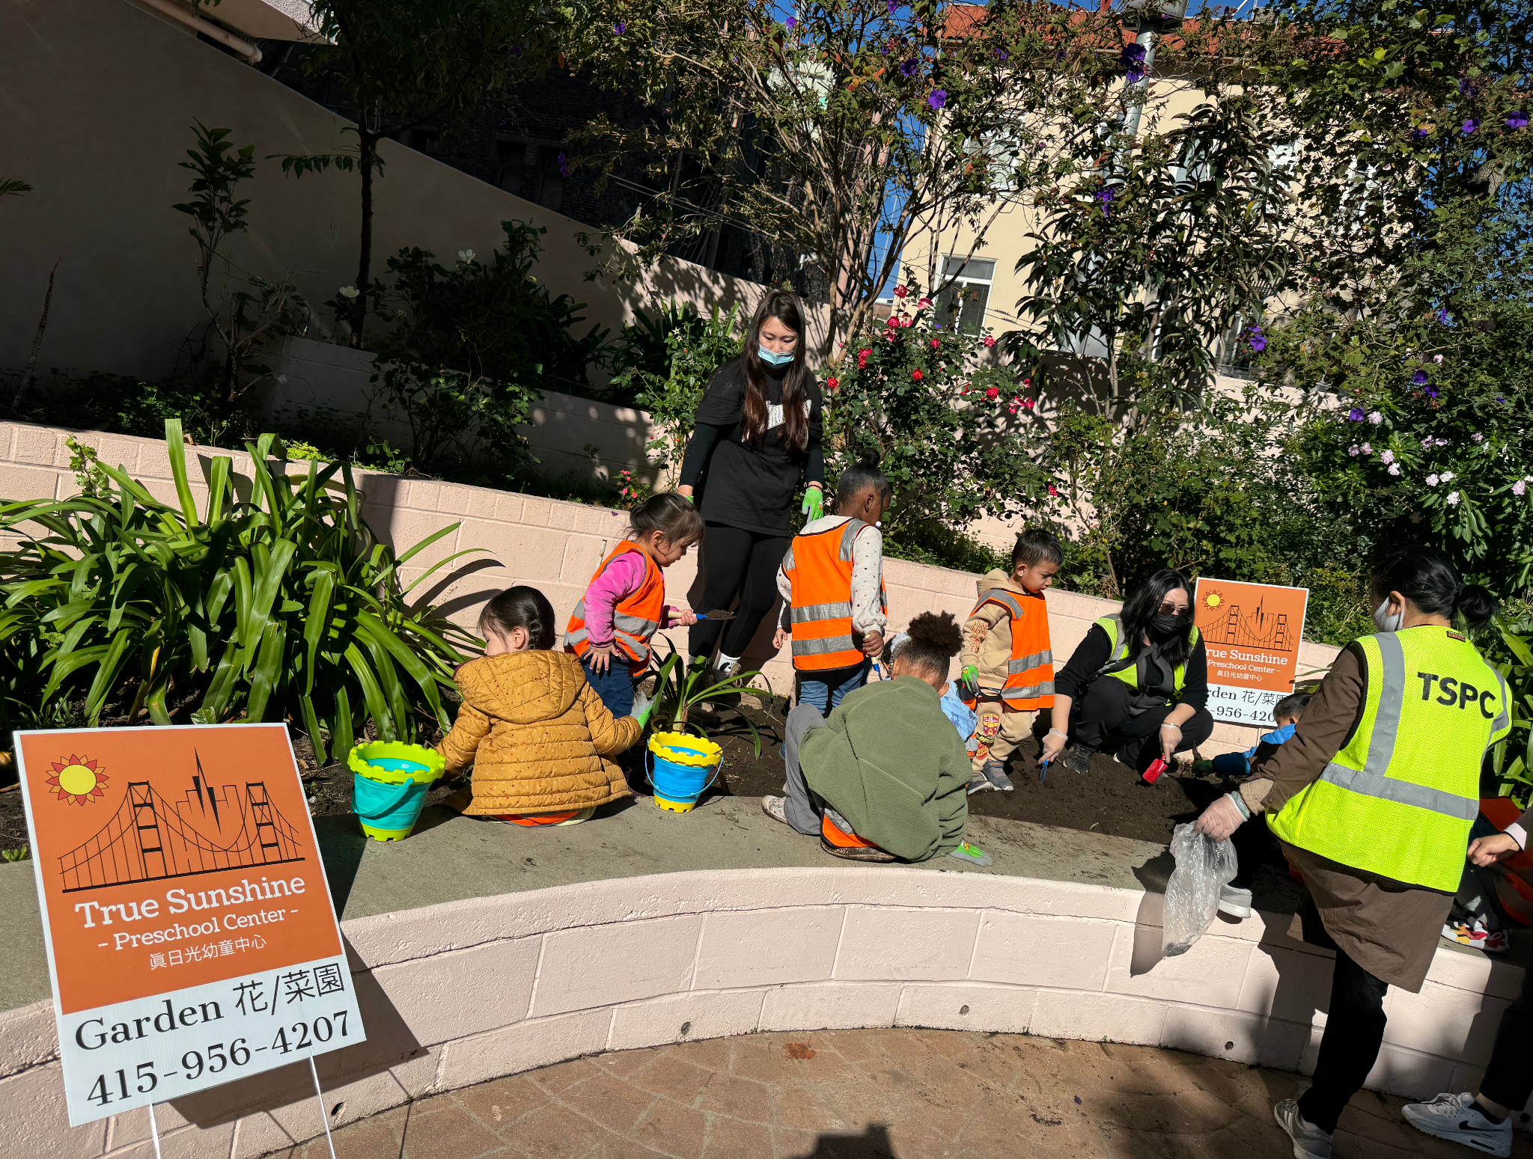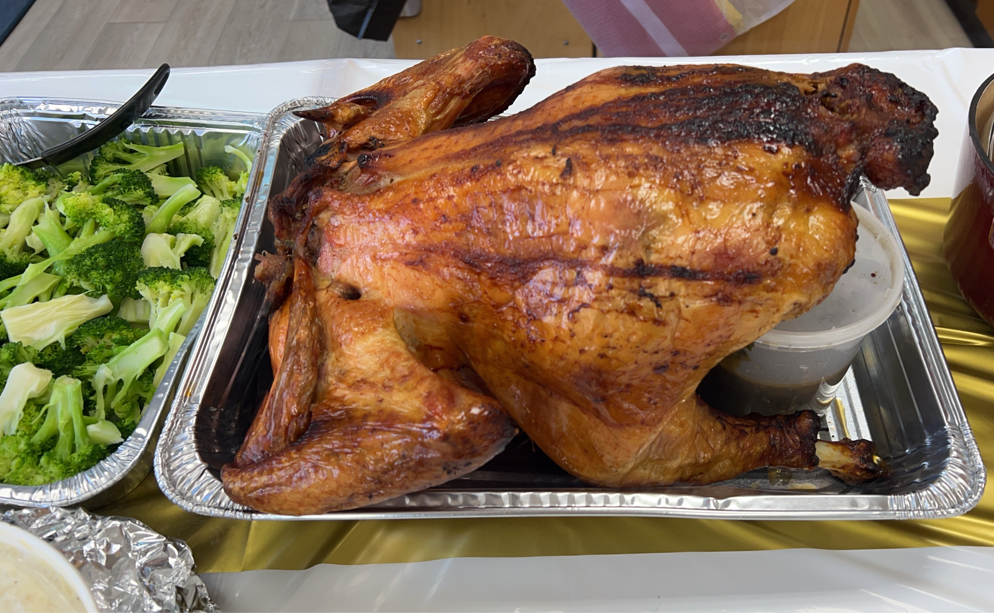
The Children Worked on the Garden Thanksgiving Cultural Potluck
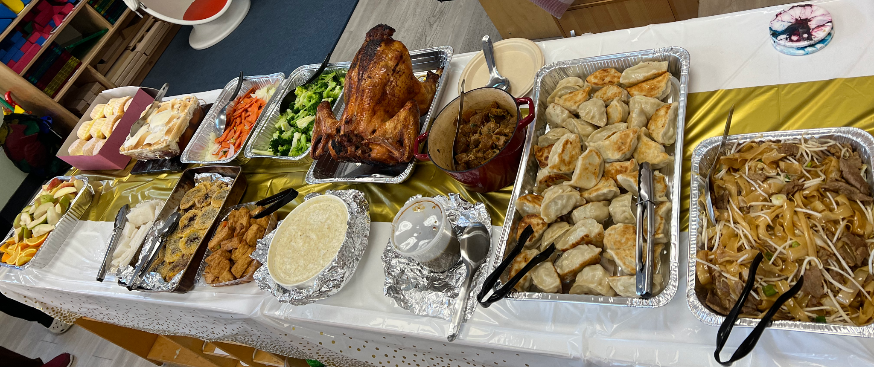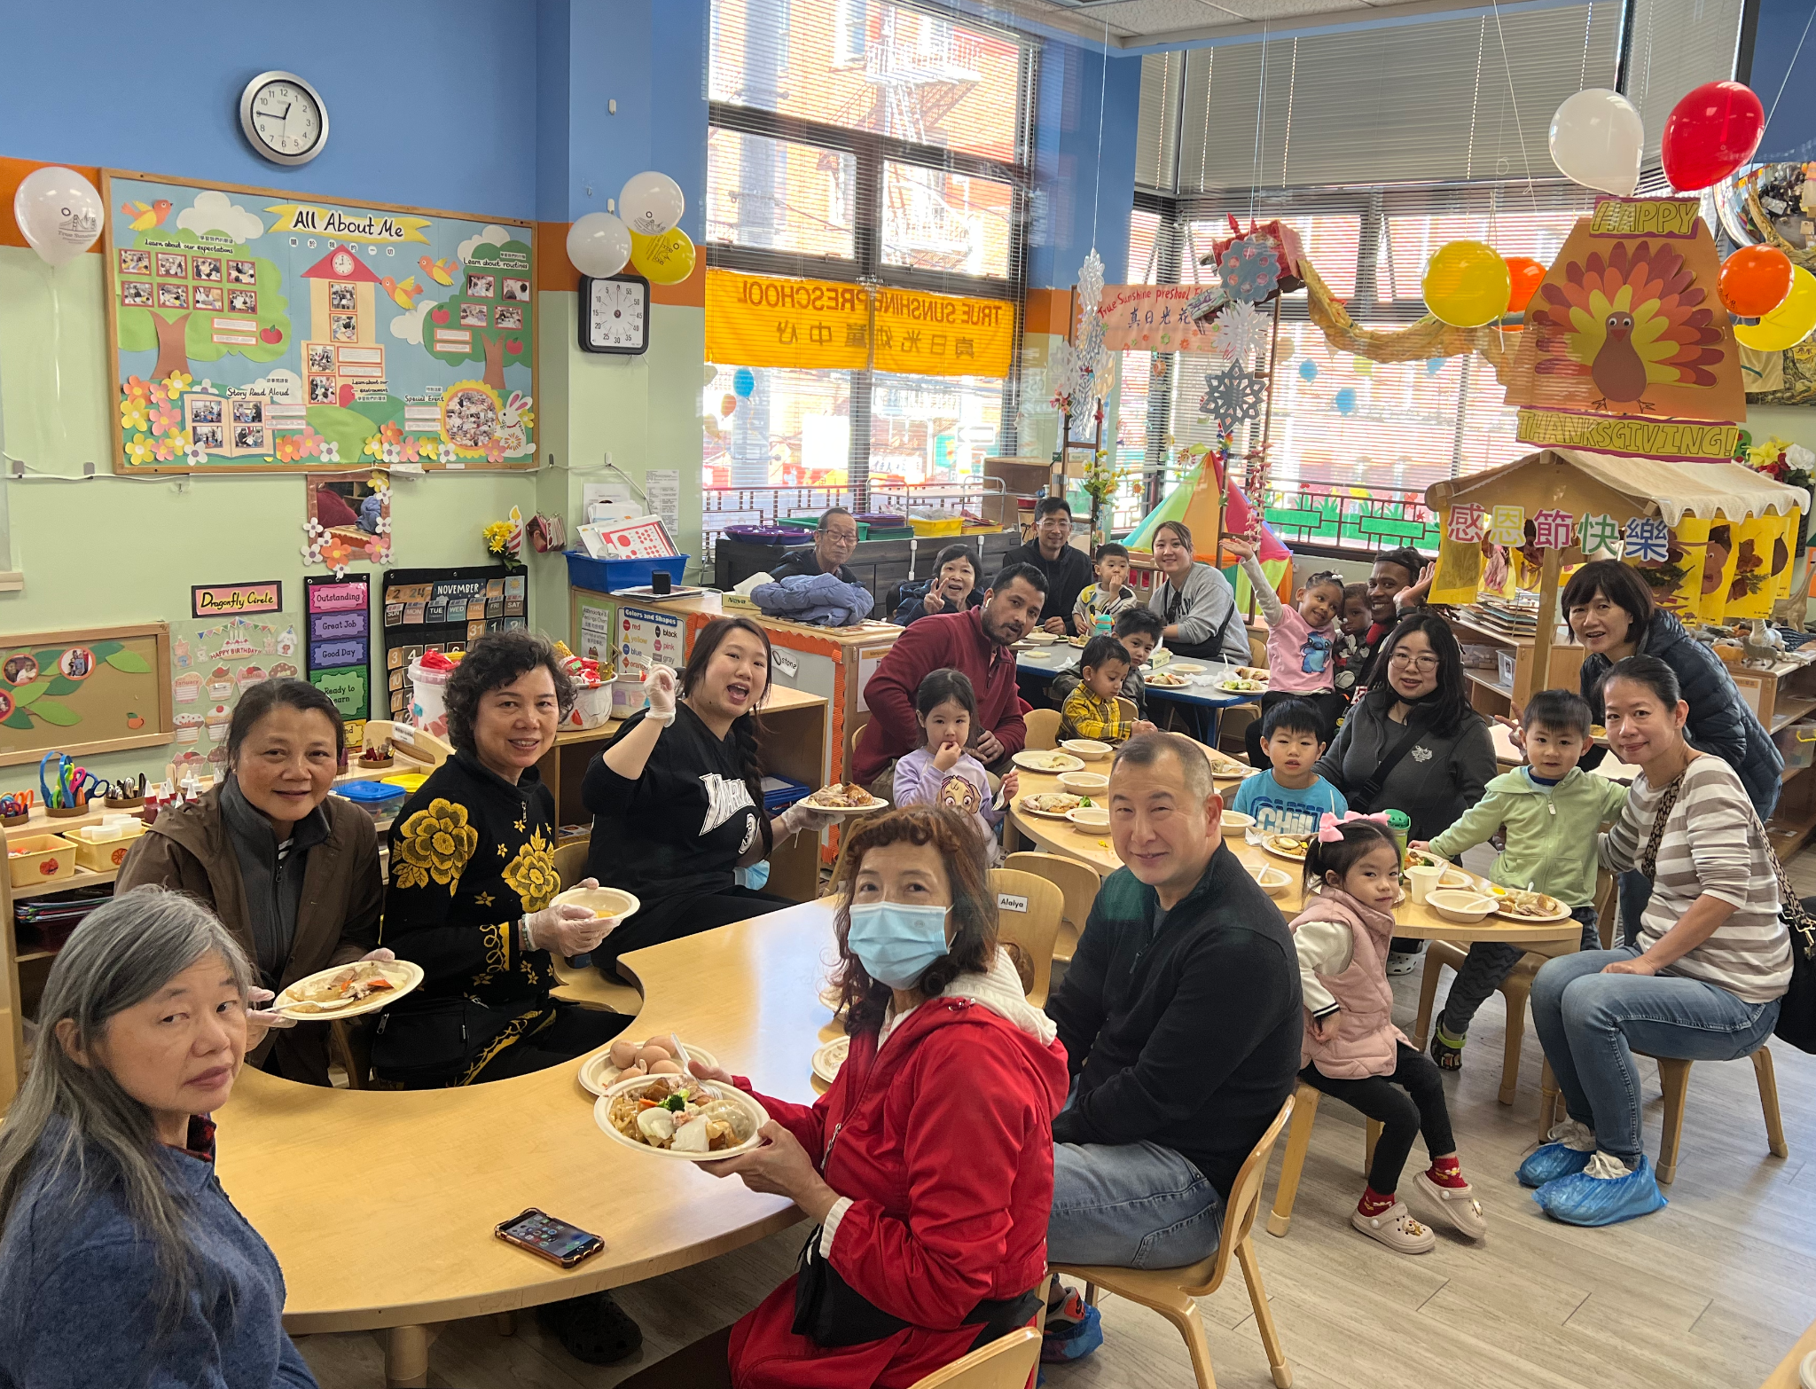
Thanksgiving Cultural Potluck
Dear Parents of the True Sunshine Community,

I hope everyone had a great Thanksgiving holiday.
Thank all of you who contributed and helped to make our Cultural Potluck event a success. We had a lot of food, and the children ate a lot. The “stone soup” was delicious. Thank you to all our children who worked hard to make the soup. I hope the children enjoyed the process of making it and understood the meaning behind it.

Our children enjoyed spending time in the garden in the courtyard at MeiLunYuen. They loosed the soil and dug the holes for their plants. It is nice to see children spend time in the garden (nature) as part of our curriculum.

December is the last month of the year. It is also a time when children reflect on what they have and how they can help and give to those in need within their abilities. To help the children understand the meaning of love and giving, teachers plan to take them to an animal shelter (if it can be arranged). Hopefully, children can find ways to help and care for the animals at the shelter.

The first Parent and Teacher Conference is on the week of 12/9. Please choose a good time to meet with your teachers when we have posted the sign-up sheet.

On 12/24, your child will start the day with a Pajama party. Please have your child come in their pajamas. They are going to have breakfast first, then have a lot of fun. At 12 pm, they will be doing an end-of-year performance. Santa will join us after the performance and give our children the gifts. The school will be over after the children have received their gifts. Parents can stay and take pictures with the Santa.

The school will be closed from 12/25-12/27 (Wednesday to Friday). The school resumes on 12/30 (Monday). No school on New Year’s Day, January 1st, 2025 (Wednesday).

To ensure the children’s vision, the nurse will come on 12/18, Wednesday, to do a vision check in the morning.
Reminders:
- Please inform the school by 9:30 a.m. that your child will be late or absent. No child will be admitted to school once the children are out to the park. No child will be onsite without the teacher’s supervision or can be dropped off at or picked up from the park.
- If your child is not feeling well (with any cold symptoms), please do not bring him/her back to school. Have your child stay at home until he/she is all better. If your child is home due to fever or diarrhea, please ensure he/she is fever and/or diarrhea-free for 24 hours before returning to school.
- Please follow us and like our Facebook page and Instagram.
The Important Dates:
- 12/9-12/13 (Monday to Friday) Parent and Teacher Conference Week.
- 12/18 （Wednesday）Vision Check
- 12/24/2024 (Tuesday) The End-of-Year performance. Starting at 12:00 pm. We have an early lunch starting at 11:30 am.
- 12/25-12/27/2024 (Wednesday-Friday), No School.
- 1/1/2025 (Wednesday) New Year's Day, No School.

Sincerely,
Diana
Executive Director

2024年12月學校通訊

孩子們在花園鬆土 感恩節文化聚餐
感恩節文化聚餐

親愛的家長，

我希望每個人都度過了一個愉快的感恩節假期。
感謝所有為我們的文化聚餐活動成功做出貢獻和幫助的家長。 我們吃了很多東西，孩子們也吃了很多。 「石頭湯」非常成功。 感謝所有盡心做湯的孩子。 希望孩子們享受製作的過程並理解背後的意義。

我們的孩子們很喜歡在美倫園庭院的花園裡的時光。 他們鬆土並為植物挖洞。 很高興看到孩子們在花園（大自然）中度過時光，作為我們課程的一部分。

十二月是一年中的最後一個月。 這也是孩子們反思自己擁有什麼以及如何在能力所及的範圍內幫助和給予有需要的人的時候。 為了幫助孩子們理解愛和給予的意義，老師們計劃帶他們去動物收容所（如果可以安排成功的話）。 希望孩子們能找到方法來關懷並幫助和照顧收容所的動物。

第一次家長教師會議將於 12 月 9 日這一週舉行。 當我們發布時間表後，請選擇與您的老師會面的好時間。

12 月 24 日，您的孩子將會穿著睡衣來學校參加睡衣派對並吃早餐。他們會用慶祝來度過一天。12點會進行年終表演。 表演結束後，聖誕老人會加入我們並給我們的孩子們發送禮物。 孩子們收到禮物後，學校就會放學了。 家長可以留下來與聖誕老人合照。

學校將於12/25-12/27（週三至週五）停課。 學校將於12月30日（星期一）恢復上課。 2025年1月1日（星期三）新年，不上課。

確保孩童的視力健康，十二月十八日早上護士回來幫孩子們做視力檢查。

溫馨的提醒：

- 請在早上 9:30 之前通知學校您的孩子將會遲到或缺席。 一旦孩子們出去了公園，就不會再讓孩子們入學。 沒有老師的監督， 孩子不行單獨待在教室裡，家長也不行自行到公園把孩子放下或從公園接孩子走。
- 如果您的孩子生病了（有任何感冒症狀），請不要帶您的孩子返回學校。 讓您的孩子待在家裡，直到他/她好起來。土國您的孩子是因為發燒或瀉肚子而回家，那您的孩子要24小時內沒發燒或瀉肚子後方可返回學校。 返回學校之前，需要獲得陰性的新冠病毒檢測結果。 請隨時告知我們測試結果
- 請關注並喜歡我們的Facebook頁面,和Instagram

重要的日子：

- 112/9-1/13（週一至週五）家長教師會議週。
- 2024年1月18日（星期三）視力檢查
- 2024年12月24日（星期二）年終演出。中午 12:00 開始。我們上午 11:30 開始吃早午餐。
- 12/25-12/27/2024（週三至週五），不上課。
- 2025 年 1 月 1 日（星期三）元旦，不上課。

校長，
Diana 謹上

