True Sunshine November 2025 Menu 
Monday | Tuesday | Wednesday | Thursday | Friday
03 | 04 | 05 | 06 | 07
A.M. Snack  Breakfast Cereal of the Day  Whole Fresh Fruit  Lunch  Natural Chicken Tenders  Steamed/Fresh Vegetables  Fresh Fruit  Milk  P.M. Snack  Chefables Very Own Cheese Sticks  Home Baked Crackers | A.M. Snack  Home Baked Cheddar Corn Bread Muffin  Whole Fresh Fruit  Lunch  Mongolian Beef & Brown Rice  Steamed/Fresh Vegetables  Fresh Fruit  Milk  P.M. Snack  Home Baked Delimanjoo  Whole Fresh Fruit | A.M. Snack  Home Baked Raspberry Banana Breakfast Bread  Whole Fresh Fruit  Lunch  Chicken Alfredo Pasta  Steamed/Fresh Vegetables  Fresh Fruit  Milk  P.M. Snack  Homemade Brazilian Cheese and Coconut Stick | A.M. Snack  Home Baked Orange Poppy Seed Breakfast Coquille  Whole Fresh Fruit  Lunch  Chefables Cheese Pizza PUFF  Steamed/Fresh Vegetables  Fresh Fruit  Milk  P.M. Snack  A2 Organic Vanilla Yogurt  Yummy Chefables Rolled Oats Cereal | A.M. Snack  Home Baked Cranberry Orange Squares  Whole Fresh Fruit  Lunch  Turkey Spaghetti Bolognese  Steamed/Fresh Vegetables  Fresh Fruit  Milk  P.M. Snack  Homemade Soft Pizza Pretzel Stick  Whole Fresh Fruit
10 | 11 | 12 | 13 | 14
A.M. Snack  Breakfast Cereal of the Day  Whole Fresh Fruit  Lunch  Natural Chicken Tenders  Steamed/Fresh Vegetables  Fresh Fruit  Milk  P.M. Snack  Chefables Very Own Cheese Sticks  Home Baked Crackers | Closed | A.M. Snack  Spiced Ginger Molasses Breakfast Bread  Whole Fresh Fruit  Lunch  Black Bean, Sour Cream, Pumpkin Seeds, Brown Rice and Mozzarella Cheese Burrito  Steamed/Fresh Vegetables  Fresh Fruit  Milk  P.M. Snack  Homemade Mini Empanadas | A.M. Snack  Home Baked Whole Grain Cinnamon Coconut Waffles  Whole Fresh Fruit  Lunch  Mac & Cheese  Steamed/Fresh Vegetables  Fresh Fruit  Milk  P.M. Snack  A2 Organic Vanilla Yogurt  Yummy Chefables Rolled Oats Cereal | A.M. Snack  Cinnamon Raisin Hodge Podge (Rice Porridge)  Whole Fresh Fruit  Lunch  Beef & Vegetable Stew  Home Baked Corn Bread Muffin  Fresh Fruit  Milk  P.M. Snack  Homemade "POP" Rice  Whole Fresh Fruit
17 | 18 | 19 | 20 | 21
A.M. Snack  Breakfast Cereal of the Day  Whole Fresh Fruit  Lunch  Natural Chicken Tenders  Steamed/Fresh Vegetables  Fresh Fruit  Milk  P.M. Snack  Chefables Very Own Cheese Sticks  Home Baked Crackers | A.M. Snack  Home Baked Sunflower Seed Chai Muffin  Whole Fresh Fruit  Lunch  Mac & Cheese  Steamed/Fresh Vegetables  Fresh Fruit  Milk  P.M. Snack  Homemade Mini Empanadas | A.M. Snack  Home Baked Banana Cacao Breakfast Bread  Whole Fresh Fruit  Lunch  Chicken Fajita Burrito  Steamed/Fresh Vegetables  Fresh Fruit  Milk  P.M. Snack  Homemade Brazilian Cheese and Coconut Stick | A.M. Snack  Home Baked Pumpkin Cinnamon Pancakes  Whole Fresh Fruit  Lunch  Mongolian Beef & Brown Rice  Steamed/Fresh Vegetables  Fresh Fruit  Milk  P.M. Snack  A2 Organic Vanilla Yogurt  Yummy Chefables Rolled Oats Cereal | A.M. Snack  Soft Cream Cheese Stuffed Cinnamon Raisin Bagel Bite  Whole Fresh Fruit  Lunch  Chicken, Butter Noodles & Parmesan Cheese  Steamed/Fresh Vegetables  Fresh Fruit  Milk  P.M. Snack  Homemade Soft Pizza Pretzel Stick  Whole Fresh Fruit
24 | 25 | 26 | 27 | 28
A.M. Snack  Breakfast Cereal of the Day  Whole Fresh Fruit  Lunch  Natural Chicken Tenders  Steamed/Fresh Vegetables  Fresh Fruit  Milk  P.M. Snack  Chefables Very Own Cheese Sticks  Home Baked Crackers | A.M. Snack  Home Baked Poblano Chile Corn Bread Muffin  Whole Fresh Fruit  Lunch  Turkey Spaghetti Bolognese  Steamed/Fresh Vegetables  Fresh Fruit  Milk  P.M. Snack  Home Baked Delimanjoo  Whole Fresh Fruit | A.M. Snack  Home Baked Pumpkin Sesame Seed Breakfast Bread  Whole Fresh Fruit  Lunch  Homemade Turkey Meatloaf  Brown Rice  Steamed/Fresh Vegetables  Fresh Fruit  Milk  P.M. Snack  Pumpkin Seed & Coconut Biscuit | Closed | Closed
 |  |  | Serving Sizes Overview  1-2 Year Olds  Breakfast  WGR Grain 1/2 sl or svg or 1/4 c  Fruit/Veg 1/4 c  Milk 4 oz  Lunch/Supper  Meat/Alt 1 oz  WGR Grain 1/2 sl or svg or 1/4 c  Veg 1/8 c  Fruit (or 2nd Veg) 1/8 c  Milk 4 oz  PM Snack (2 items only)  Veg 1/2 c  Fruit 1/2 c  Meat/Alt 1/2 oz, 1/4 c  Grain 1/2 sl or svg, or 1/4 c  Milk 4 oz | Serving Sizes Overview  3-5 Year Olds  Breakfast  WGR Grain 1/2 sl/svg, 1/3c or 1/4 c  Fruit/Veg 1/2 c  Milk 6 oz  Lunch/Supper  Meat/Alt 1-1/2 oz  WGR Grain 1/2 sl or svg, or 1/4 c  Veg 1/4 c  Fruit (or 2nd Veg) 1/4 c  Milk 6 oz  PM Snack (2 items only)  Veg 1/2 c  Fruit 1/2 c  Meat/Alt 1/2 oz, 1/4 c  WGR Grain 1/2 sl or svg or 1/4 c  Milk 4 oz
Notes
- One Grain serving per day must be WGR, M/MA may be substituted for a breakfast grain (3X/week max).
- Unflavored Milk served at ALL breakfast and lunch meals. Whole milk (Infant/Toddlers <2 yrs), lowfat (1%) milk (preschool >2 yrs). All Milk served is rBST-free.
- Chefables reserves the right to substitute stated menu items if it becomes unavailable in the market or due to unforeseen circumstances.
Just some of the vegetables this month:
Artichoke arugula Asian green avocado beets bok choy broccoli rabe Brussels sprouts cabbage carrots cauliflower celery chard collard greens cucumber kale leeks lettuce mushroom okra onion parsnip peas peppers potato radishes rhubarb rutabaga scallions spinach winter squash sunchokes sweet tomatillo tomatoes turnips
Just some of the fruits this month:
Apples Asian pear cactus dates grapes guava kiwi kumquats lemons limes mandarins oranges persimmons plums pomegranates pomelo quince strawberries
= New menu offering | = Whole Grain Rich | = Vegetarian Menu Option |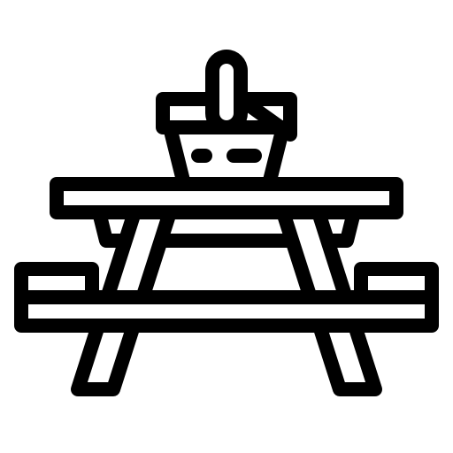 = Field Trip Menu Option |

