Return-to-Learn – School policy template
The Brain Injury Association of New Hampshire (BIANH) is pleased to provide this School Policy Template to assist New Hampshire school districts in creating effective Return-to-Learn policies for students recovering from a concussion.
This template is designed to promote a consistent, student-centered approach across districts while helping schools meet the requirements of RSA 200:63 (effective September 27, 2020) and align with the New Hampshire Department of Education (NHED) Technical Advisory (issued in May 2025). Our shared goal is to ensure that every student has a safe and supported transition back to the classroom.
New Hampshire school districts are encouraged to use this document, either wholly or in selected sections, to support the development or revision of local Return-to-Learn policies. Districts may also cite this document via the BIANH website. This template includes a placeholder (“[District]”) that may be replaced with the district’s official name. No additional permissions are required for NH school districts.
Table 1: Return-to-Learn policy summary table
Who? | Policy applies to students in the district who have experienced a concussion, Caregivers of these students, and District staff who support these students (e.g., Administrators, Teachers, School Nurse, Athletic Trainers, Other Staff).
What? | Policy describes the District’s protocols for the process of Return-to-Learn after a concussion.
Why? | Policy promotes use of best practices for safe, timely recovery and full return to the academic environment after concussion.
When? | Policy applies from the time of concussion until the student’s full recovery, typically within 1–4 weeks.

Contents
Return-to-Learn – School policy template 1
Introduction – Return-to-Learn Policy 3
Definitions 3
Identification and assessment of concussions 4
Roles and communication after a concussion incident 4
Concussion Management Team 4
Return-to-Learn Plan 7
Black Stage 8
Red Stage 8
Orange Stage 8
Yellow Stage 9
Green Stage 9
Documentation 9
Policy and procedure evaluation and adjustment 10
Training and awareness 10
Appendix A: Return-To-Learn Protocol 11
Appendix B: Sample RTL letter for parents/guardians 12

Introduction – Return-to-Learn Policy
[District] is committed to protecting the safety and well-being of all students during school hours and at school-sponsored events. We recognize that concussions occur and, after an initial rest period of approximately 48 hours, school is often the best environment to support recovery. This policy reflects [District]’s commitment to follow best practices recommended by the Brain Injury Association of New Hampshire (BIANH) and to comply with RSA 200:63 (effective September 2020) and the New Hampshire Department of Education (NHED) Technical Advisory (May 2025).
Applicability: This Policy applies to students in the [District] who have experienced a concussion, Caregivers of these students, and [District] staff who support these students (e.g., Administrators, Teachers, School Nurse, Athletic Trainers, Other Staff).
Timing: This policy applies to the short-term recovery phase following a concussion from the time of injury until the student has resumed their pre-concussion level of functioning at school (typically within 1–4 weeks).

Definitions
[District] defines the following key terms. (Note that additional definitions are provided in the NHED Technical Advisory (May 2025))
- Caregiver(s): The parent(s) or legal guardian(s) for a student.
- Concussion: A concussion is a type of traumatic brain injury. Per the CDC, it results from a bump, blow, or jolt to the head—or a force to the body—that causes rapid movement of the head and brain. This motion can make the brain move or twist inside the skull, causing a temporary disruption to the functioning of the brain, potentially impacting the function of the individual. Individuals are typically expected to return to a pre-concussion level of functioning in one to four weeks.
- Return-to-Learn (RTL): The process and strategies involved in reintegrating students into academic activities and the learning environment following a concussion injury.
- Academic Adjustments: The nonformalized educational adjustments made in the regular educational/academic/learning environments. These adjustments are typically short-term and do not require significant changes to the curriculum.
- Healthcare Provider: A person who is licensed, certified, or otherwise statutorily authorized by the state to provide medical treatment and is trained in the evaluation and management of concussions (See, NH RSA 200:52, I).

Identification and assessment of concussions
The Return-to-Learn process begins after a Healthcare Provider diagnoses a concussion. It often takes a team to detect and properly identify a concussion and [District] staff will work closely with students, Caregivers, and Healthcare Providers to identify potential concussion incidents and to seek formal diagnosis from a Healthcare Provider.
Note: [District] recognizes that some families face financial / health insurance barriers to accessing a Healthcare Provider. Families are encouraged to seek information and support resources from the NH Insurance Department with the following web address: https://www.insurance.nh.gov/consumers/health-insurance/new-hampshires-federally-facilitated-health-insurance-marketplace

Roles and communication after a concussion incident
Immediately After-Incident: It is the responsibility of the student to inform their parent/ legal guardian of any incidents that may result in a concussion -and- It is the responsibility of [District] personnel (e.g., Teacher, School Nurse, Coach, Athletic Trainer, other Staff) to inform a student’s Caregiver of any incidents that may result in a concussion whether witnessed directly or reported by another person.
Diagnosis: It is the responsibility of the Caregiver to seek an assessment of the student by a Healthcare Provider after an incident. It is the responsibility of the Healthcare Provider to assess the student and to make a diagnosis where appropriate.
After Diagnosis: It is the responsibility of the Caregiver to inform the [District] of the outcome for a suspected concussion incident. It is the responsibility of the Healthcare Provider to communicate the diagnosis and any treatment guidance to the [District] following a Concussion diagnosis.
A sample letter for Parents/Guardians can be found in Appendix B.

Concussion Management Team
The Concussion Management Team (CMT) comprises the school professionals who interact frequently with the student as well as the student’s Healthcare Provider and Family. Depending on the student’s age, grade level, and individual needs, and [District]’s resources, the CMT may include the roles detailed below.
One of these team members will serve in the role of Concussion Management Team Leader (CMT Leader). The CMT Leader is responsible for coordinating daily communication among team members, developing the student’s Return-to-Learn Plan, gathering input to determine student progress through the Return-to-Learn stages, ensuring that [District]’s concussion policy is followed, and following their recovery process to completion.
When [District] is notified of a student’s concussion diagnosis, a School Administrator will connect the student to their school’s Concussion Management Team and CMT Leader.
Based on [District] resources – the following people may be involved in the CMT:
- Caregiver
  - Caregivers give support and guidance from home, encouraging positive health behaviors that facilitate recovery outside of the school setting.
  - Caregivers provide insight regarding symptoms, behaviors, and challenges as recovery progresses.
  - Caregivers play a key role in encouraging students to return to school after the initial brief rest period (24-48 hours) to ensure optimal recovery.
- School Nurse
  - As the medically trained professional in the school, the school nurse provides the health-related care and support students may need during the school day.
  - Often, nurses can assess symptom levels like pain, tolerance for bright lighting and sound, and dizziness related to movement.
  - School nurses regularly serve as keepers of Return-to-Learn processes in schools.
- School Counselor
  - School Counselors are often engaged in supporting Return-to-Learn.
  - School Counselors are trained in supporting students when it comes to coping with stressors or challenges, and encouraging positive behaviors.
- Teacher
  - Teachers have regular contact with students, and are well-positioned to monitor and reflect upon student response to classroom and schoolwork activity.
  - Teachers are responsible for being responsive to a student’s day-to-day return-to-learn stage and for adjusting workloads and assignment types appropriately.
  - Teachers know classrooms best, so they are in the strongest position to make the necessary adjustments to tasks that meet student’s where they are in their recovery process.
  - Teachers will regularly report back to the CMT Leader regarding observed and self-reported symptoms and status.
- Primary Care Physician (PCP) including Urgent Care
  - PCPs are responsible for handling the medical needs of the student.
  - PCPs are often involved in the initial acute care immediately after a concussion, and will generally follow a student through to full recovery, often providing final clearance for return to sports.
  - In situations and regions where PCP access is limited, Healthcare Providers in Urgent Care settings may fill part of the PCP role on the CMT.
- Neuropsychologist
  - Neuropsychologists are licensed Healthcare Providers focused on the relationship between the brain and human behavior, with particular expertise in brain injury care and management.
  - Due to the cognitive and behavioral changes following concussion, neuropsychologists are valuable CMT members to advise on matters related to return to activity, especially those activities related to thinking skills and behavioral health.
  - Neuropsychologists are uniquely trained and qualified to manage the multimodal/multidisciplinary approach required to manage recovery after concussion.
- Athletic Trainer (ATC)
  - Athletic trainers are often on-scene for an injury, or just afterward, if a concussion happens during sports practice or a game. They will often provide initial assessment and care.
  - ATCs will primarily be involved in a student athlete's return-to-play (RTP). RTP is different from the Return-to-Learn process, but as a complete cognitive recovery is required for a complete return-to-play, ATCs are key players in the interaction between these two processes.
- Others who interact with student frequently
  - [District] may have other supporting roles in the school that may aid an individual as they Return-to-Learn after concussion.
  - The CMT is intentionally flexible and [District] will engage a team that builds on the strengths of the school.

Return-to-Learn Plan
The Return-to-Learn Plan provides a step-by-step approach to help the Concussion Management Team (CMT) guide a student’s safe and gradual return to full learning. Its primary focus is on supporting the student’s participation and well-being at school, not on medical treatment. If a student shows concerning medical symptoms, staff will immediately involve the school nurse and follow emergency protocols to ensure the student’s safety.
[District] personnel will support students in working through the following color-coded stages recommended by the Brain Injury Association of New Hampshire following concussion in collaboration with the student’s Caregivers and Healthcare Provider(s). Stages begin with a brief period of rest at home, followed by an intentional shift to full days at school with a balance of rest and gradually-increasing cognitive exertion. There is no partial school attendance or half-days within this recommended protocol.
For students who are participating in a sport, Return-to-Learn stages happen in parallel with Return-to-Play. Importantly, completion of Return-to-Learn is required prior to sports competition. (Please see [District]’s Return-to-Play policy.)
Figure 1: Return-to-Learn stages
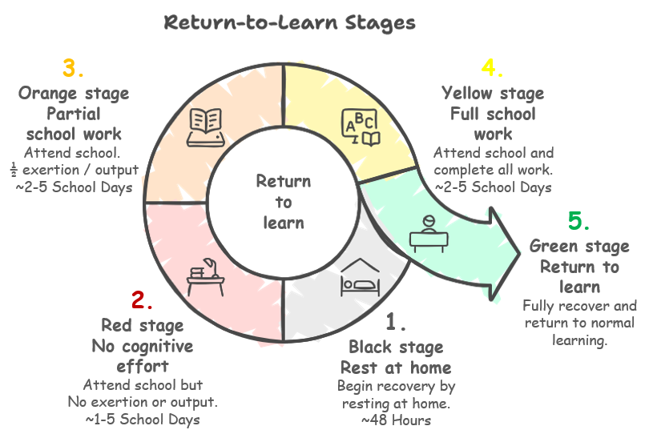

With guidance from the RTL Plan, the CMT will communicate daily to determine a student’s stage for that day, which academic adjustments are to be used, how a student is managing symptoms, and when to progress to the next stage.

Black Stage
The black stage of concussion recovery typically represents the 48 hours immediately after the injury occurs.
- Expected Duration: 24-48 hours
- Workload Expectation: no work
- Classroom Adjustments: no adjustments as the student is not in the classroom
- Readiness to Move to Next Stage: the student can engage in their typical morning routine without support, get ready for school, and do so without worsening of symptoms

Red Stage
The red stage of concussion recovery represents the time period when the student first returns to school.
- Expected Duration: 1-5 days
- Workload Expectation: The student should be present and listening, but there should be no cognitive exertion or effort in this stage. Students may participate and engage to their comfort level, but should not be expected to do so.
- Classroom Adjustments: No cognitive exertion or coursework output. Participation and engagement are allowed to tolerance.
- Readiness to Move to Next Stage: In addition to successfully continuing to get ready and get to school without worsening symptoms, if the student can sit through one complete day of class without worsening symptoms, they might be ready to move to the next stage.
Note: if the student reaches 5 days in the Red Stage, the CMT Leader should immediately seek consultation from a Neuropsychologist.

Orange Stage
The orange stage of concussion recovery represents the time period when the student begins to do schoolwork again.
- Expected Duration: 2-5 school days
- Workload Expectation: 50% of classwork, 50% of homework, No tests, No large assignments
- Classroom Adjustments: Academic adjustments for assignments
- Readiness to Move to Next Stage: In addition to successfully continuing to wake up, get ready, and get to school without worsening symptoms, if the student can complete half of their work for two full days without worsening symptoms, they might be ready to move to the next stage.

Yellow Stage
The yellow stage of concussion recovery represents the time period when the student begins to complete their full schoolwork load again.
- Expected Duration: 2-5 school days
- Workload Expectation: All classwork, All homework, Tests and large assignments
- Classroom Adjustments: Academic adjustments for tests and large assignments.
- Readiness to Move to Next Stage: In addition to successfully continuing to wake up, get ready, and get to school without worsening symptoms, if the student can complete their work for two full days without worsening symptoms, they might be ready to move to the next stage.

Green Stage
The green stage of concussion recovery represents the time period when the student is considered fully capable of returning to learn.
- Expected Duration: There is no limit, if there is no further injury
- Workload Expectation: All work, without modifications or accommodations
- Classroom Adjustments: None should be needed at this point
Note: If symptoms persist beyond 4 weeks, the Concussion Management Team will re-evaluate the plan, with input from the Neuropsychologist. In some cases, this may include the need for additional assessment by other Healthcare Providers or specialists.

Documentation
The Concussion Management Team leader will maintain a record of student Return-to-Learn progress after concussion. Key indicators such as time to recovery and time in each stage may be used to improve Return-to-Learn protocols.

Policy and procedure evaluation and adjustment
[District] will conduct an annual review of policies and procedures related to student concussions to ensure alignment of best practices.
[District] will draw upon updated information from the Brain Injury Association of New Hampshire (BIANH) and from the New Hampshire Department of Education (NHED) when making such updates.

Training and awareness
[District] is committed to ensuring staff are prepared to support students returning to learning after a concussion. The [District] provides annual training, as well as refresher sessions and a toolkit whenever a new concussion diagnosis is reported. These trainings are offered in collaboration with the BIANH and NHED.

Appendix A: Return-To-Learn Protocol
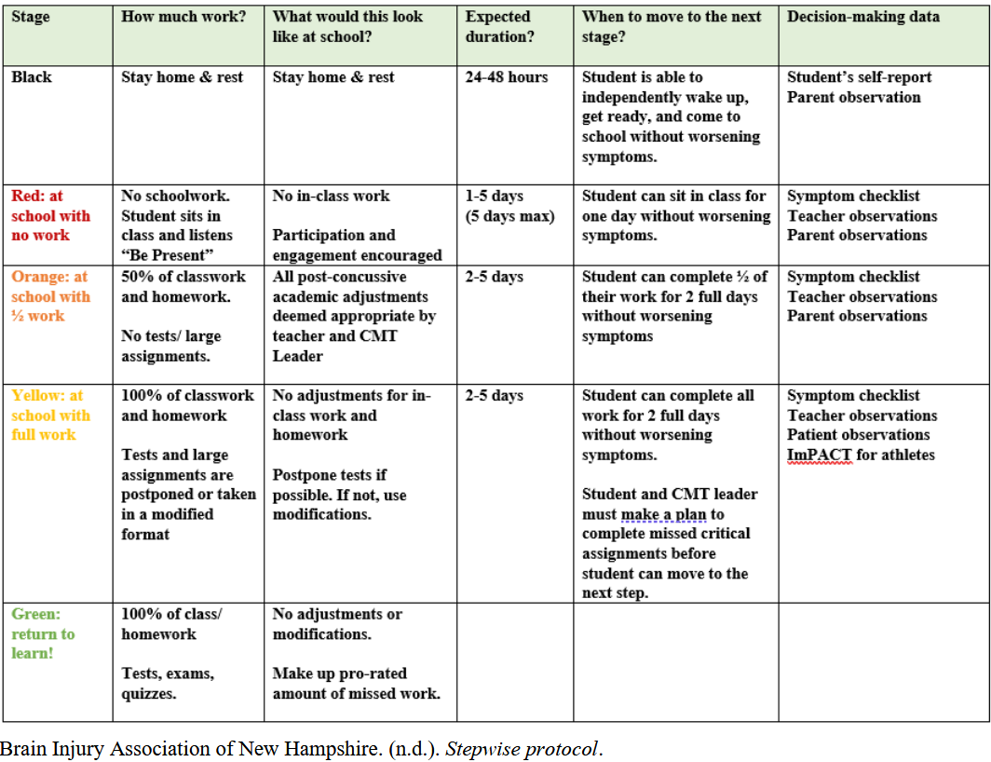

Appendix B: Sample RTL letter for parents/guardians
<<Date>>
<<School District Address Block>>
Re: Return-to-Learn after Concussion

To Whom It May Concern,

I am writing to inform you that my child (child’s name) ________________________________ was involved in an injury on (Date and approximate Time)_____________________________. They were diagnosed with a concussion by (child’s Healthcare Provider) _____________________________________ on (Date) _______________________.

My Healthcare Provider will send a separate letter noting the diagnosis, symptoms, and recommendations for accommodations in school.

I have noticed the following changes in my child since the injury: (describe changes noticed in personality, behavior, memory, abilities to complete tasks, attention, etc.).
- __________________________________________________________
- __________________________________________________________
- __________________________________________________________
- __________________________________________________________
- __________________________________________________________
- __________________________________________________________

I do not yet know how this injury will affect my child in school but given the differences I have noticed, they may experience difficulties with the following: (List difficulties you believe your child may experience, such as attention, memory, light sensitivity, behavior)
- __________________________________________________________
- __________________________________________________________
- __________________________________________________________
- __________________________________________________________
- __________________________________________________________
- __________________________________________________________

Sincerely,
(Caregiver signature, mobile phone number, and email)

