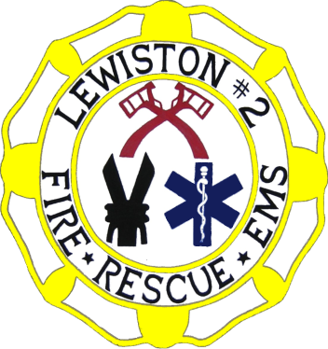
Lewiston Fire Company No. 2 Inc.
1705 Saunders Settlement Road
Niagara Falls, New York 14304
716-297-0050

Application for Membership

Date: _____________

Active Firefighter (18 and older): ______ Active Member: ______

Minor Member (16-17 years old): _____ Junior Firefighter (14-15 years old): ______

FOR OFFICE USE ONLY
First Reading to Fire Company Membership: Date: ____/____/______

Membership Interview: Date____/____/______

Fire Company Membership Vote: Yes _____ No _____ Date: ____/____/______

Submitted to Town of Lewiston Board on: Date: ____/____/______

IN CASE OF EMERGENCY NOTIFY:

Name: ____________________________________ Relationship: ______________________

Phone: ____________________

Name: ____________________________________ Relationship: ______________________

Phone: ____________________

- _______________________________________________________________________________
(Last Name) (First Name) (M.I.)

- _______________________________________________________________________________
(Address) (Apt. /Suite No.)

_______________________________________________________________________________
(City Town Village) (State) (Zip Code)

3. Phone: (_____) ____________________ (_____) ____________________
(Home) (Cell)

4. Email: ______________________________

5. How long have you resided at the above address? Years: _____ Months: _____

6. How long have you resided in New York State? Years: _____ Months: _____

7. Are you 18 years of age or older? Yes ___ No ___ If “No”, State your age: _____
If under 18-Date of Birth _____/_____/______

8. Are you currently employed? Yes ___ No ___ if “Yes” give employer information below. May we contact your employer as a reference? Yes___ No ___

Name of Company _______________________________________________________________

Address ______________________________________ Telephone (_____) _________________

9. Do you have a valid New York State Drivers License? Yes ___ No ___ ID# ________________

10. Previous emergency services experience: (include only fire, rescue, police, and emergency medical agencies).

Name of Agency ___________________________________________Years of service________

Address _______________________________________________________________________

_______________________________________________________________________

Contact Person ________________________ Telephone (_____) _____________
(If more space is needed, please identify on attached sheet)

- Please list two personal references, other than members of this organization, who have known you for at least 3 years.

A. Name ______________________________________ Telephone (_____) ________________

Address ____________________________________________________________________

B. Name ______________________________________ Telephone (_____) ________________

Address ____________________________________________________________________

- OSHA regulations require that you pass a physical examination before becoming an interior structural firefighter. The department’s designated physician will provide you with a free medical examination. The only thing the Fire Company receives is a statement, from our Medical Provider listing whether you passed the examination.
Will you be willing to undergo an examination? Yes ___ No ___

- The applicant is aware and agrees by their signature below, that the arson and sex offender criminal background check will be disclosed to the Executive Board of the Lewiston Fire Company No. 2 Inc.

- I certify that, if accepted, I will comply with the constitution and by-laws of the Lewiston Fire Company No. 2 Inc.

APPLICANT SIGNATURE __________________________________________ DATE _________

A $2 Application Fee and $3 Dues is required at interview

Sponsor 1 Name: ____________________________________________

Sponsor Signature: ___________________________________________

Sponsor 2 Name: ____________________________________________

Sponsor Signature: ___________________________________________

PRIVACY NOTIFICATION

Section 94 of the Public Officers Law (Personal Privacy Protection Law) requires that you be notified of the following facts when information which will be maintained in a record system is collected from you.
The authority to request and confirm personal information about you is found in Article 6 of the executive Law.
The information obtained will:
- be used to determine your qualifications for the position for which you are applying;
- be released to the fire chief and Executive Board; and
- be maintained in your personnel file (if you become a fire company member) or in our resume file for six months (if you are not a fire company member).
- Failure to provide the information or authorization will result in your application not being considered for membership.

