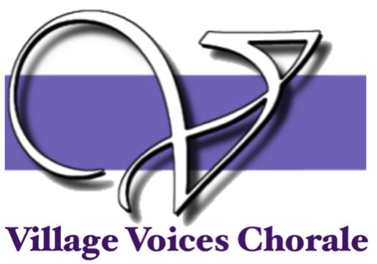

BOARD MEETING Minutes
Monday, September 13 2020 7:00pm
Hosted on Zoom by Bonnie Hicks
Attended: John Thompson, Bonnie Hicks, Hannah Best, Nicole Singer, Tim Bonds, Marti Smith, Gloria Hilliard Absent: Charlene Stitzer, Katie Phillipson

Meeting began at 7:05
- Approval of August Minutes
There was a request that we receive the minutes within the week after our meeting so we don’t forget what we need to do.
Hannah Best motioned to accepted corrected August minutes.2nd. passed
- Treasurer's Report (Marti Smith)

A. Treasurer’s Report
1. Nothing has changed since last month
2. Marti contracted with our accountant, Janice to do our tax returns for this year. They are due
of November 15 and she is confident they will be turned in on time.
3. Bonnie received a postcard from the Secretary to State letting us know we needed to file a SI-100 Form. When we changed our name with the state we filled this form. Marti will check to make sure our check was cashed and that they have the form.
John Thompson motioned to accept the Treasurer’s Report. 2nd. passed

- Board Reports
  - President (Bonnie Hicks)
1. most of my discussion will happen in Old Business
  - Membership (Tim Bonds)
  - Ways and Means (Nicole Singer)
1. Nicole reminded us that we talked about getting former scholarship winners to record a statement on how the scholarship they received help them.
  - Director Report (Gloria Hilliard)
  - Concert Master (John Thompson)
  - Publicity (Hannah Best)
1. Hannah wanted some clarification on the goals of the choir to help her know how to proceed with what to email and post on Facebook. Is our goal to stay in touch with patrons or with members. It was suggested that the 1st priority should be our members, and 2nd to let patrons know we are still an active group.
2. Gloria will send Hannah some videos of performances from VVC members.
  - Graphics & Programs (Katie Phillipson)
  - Secretary (Charlene Stitzer)

- Old Business
  - Virtual Meetings with members
1. Tim and Bonnie have met with the Soprano and Alto sections over zoom and it has gone well. They are meeting with the Bass and Tenor sections tomorrow night. Everyone seems to be doing well and really appreciated the zoom meeting. Many people do not feel like they will be ready to come back by January. At our next meeting we might want to discuss alternatives to how we can meet.

- New Business

Next Meeting: Monday, October 12 7pm Hosted by Bonnie on Zoom

