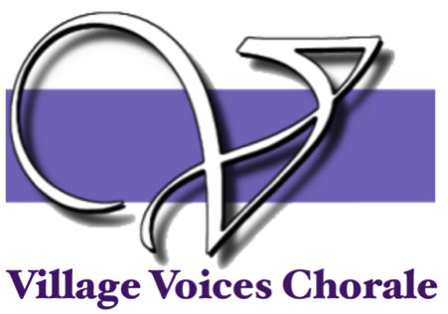
BOARD MEETING Agenda
Monday, August 16 2021 7:00pm
Hosted on Zoom by Bonnie Hicks
In Attendance: Bonnie Hicks, Nicole Singer, John Thompson, Tim Bonds, Katie Philipson, Sarah Harris, Gloria Hilliard Absent: Wynona Krieger

- Approval of July Minutes
Minutes aren’t available, we will approve next meeting
- Treasurer's Report (Marti Smith)
A. Treasurer’s Report
1. Nothing has changed in our finances from last month’s report
2. Marti is still waiting to hear from the lawyer about our contracts for Gloria and Chris.

- Board Reports
  - President (Bonnie Hicks)
1. Update of Positions- Sarah Harris has agreed to be our Publicity Chairperson
2. Contract with Church- Gloria has asked that they make some corrections before we sign it.
3. First Rehearsal Help- Katie and Tim will check vaccination cards and have members sign a form from the church about the church not being liable for any COVID cases that occur at rehearsal. Marti will collect dues and Mike Becker will pass out music.
4. Those that can help set up we will meet at the church around 6:45p.m.

  - Membership (Tim Bonds)
1. We currently have 44 members on our roster.
  - Ways and Means (Nicole Singer)
1. There is nothing new to report
  - Director Report (Gloria Hilliard)
1. Gloria is excited about the music that we picked so long ago and she thinks it will be an exciting concert.
2. She will call the church office to get the facility contract so we can sign it at rehearsal
  - Concert Master (John Thompson)
1. Theater update- We have not heard from the BAPAC but when we get the contracts John will let us know
  - Publicity
1. Nextdoor- Gloria suggested we use Nextdoor a little bit more than we have in the past.
2. Bonnie is going to make Sarah Harris an Admin for our Facebook page.
  - Graphics & Programs (Katie Phillipson)
1. Since we are not sure about where our concert will be held yet Katie will make the posters and flyers but hold off until we have everything finalized
2. Bonnie suggested utilizing QR Codes more
3. Katie suggested allowing people coming to the concert a way to dedicate a song to singers or other loved ones. She will think about it some more.
  - Secretary (Winona Krieger)

- Old Business

- New Business

Next Meeting: Monday, September 13 7:00p.m. Zoom

