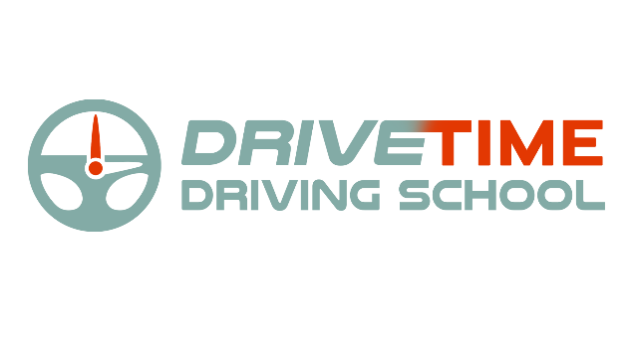

5 Stanley Drive

Robbinsville, NJ 08691

Tel: (609) 301-0721

Service Agreement

drivetimenj@gmail.com www.drivetimenj.com

Date: / /

We hereby agree to provide behind the wheel instruction in relation to the operation of a motor vehicle to:

First Name: MI: Last Name: Street Address: City: State: Zip: DOB: / /

Student Cell: High School Attending:

SEX: ☐ Male ☐ Female Email for scheduling Road Test:___________________________________________

Parent Information: Name:_____________________________________ Parent Phone:_______________________

# 6 Hours behind the wheel Cost: *$475.00.* PLUS $ 10.00 NJMVC cost for permit….if you want/need

# red reflectorized decals for license plates, they are an additional $4/pair which should be included in check to NJMVC

# *(If paying by check, it should be separate from the check to NJMVC)*

# Services include: 6 hours of instruction broken up into 3 two-hour lessons or 2 three-hour lessons.

# Vision screening performed at the MVC office in Lawrence(Bakers Basin),

# Pickup and validation of permit. Scheduling of Road Test

# Additional services and fees:

☐ **$ 175.00** 2 hour lesson ☐ **$ 95.00** 1 hour lesson

☐ **$200.00** 1 Hour Refresher & Road Test(including use of car)

☐ **$ 50.00**  Knowledge Test at NJMVC

☐ **$120.00** Road Test Car Rental *(use of the car only, $150 for Delanco)*

# CANCELLATION POLICY:

**1 Full Business Day** advanced notice is required for canceling an appointment or there will be a **$95 Cancellation Fee.**

# ACCEPTANCE:

This constitutes the entire agreement between the school, the student and parent or guardian and no verbal agreements will be recognized. The student may rescind the agreement within 72 hours of the first (1st) lesson and upon such rescission shall receive a refund for any lesson or service not conducted or provided.

I have read, understand and comply with every provision of this agreement and by my signature, hereby certify that I accept and agree to abide by them.

Signature or Parent/Guardian Signature:

**Please return this Agreement and Permit Application(green).**

***with:* Payment to DriveTime Driving School(checks won’t be cashed until lessons begin), check made out to NJMVC, *Original* Birth Certificate OR Passport AND High School New Jersey Web Knowledge Test Receipt**

***NOTE: Checks returned for any reason will be assessed a $45.00 service fee.***

DriveTime Driving School is licensed by the State of New Jersey. License# 000354