TOURNAMENT DATES
February 5TH through February 19, 2023
Scores Bowled In Your League Will Be Used For The Tournament

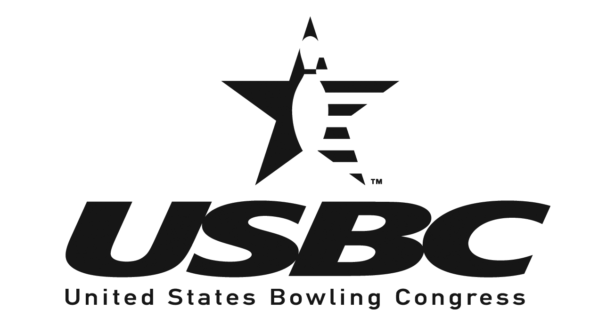
PRIZE FUND $22.00
EXPENSE FEE $ 3.00
ENTRY FEE $25.00
MULTIPLE ENTRIES ALLOWED (RULE 6)

ALL PRIZE FEES RETURNED 100%  HANDICAP BASED ON 90% OF 210 (RULE 7)
Return this page to : Patty Wunder 662 Monroe St Grovetown, Ga 30813
Please complete an entry form for each league with the dates of participation.

Once entry has been approved, you will receive a recap sheet for each entry with instructions.

Name _________________________________
Address _______________________________
City ___________________________________
State _____________________ Zip _________
E-mail _________________________________
Phone _________________________________
Highest Average _________________________
League Name ___________________________
Date(s) of Above League ___________________

league_________________________

TOURNAMENT RULES
1. Eligibility: USBC and AUSBCA Rules will govern this tournament. Competition is restricted to members of the Augusta USBC Association who have bowled at least 21 games in a certified league within the AUSBCA jurisdiction.
2. Closing Date: Entries must be postmarked no later than January 30, 2023.
3. Fees and Prizes: Entry fee will be $25.00 per event Singles: ($22.00 Prize Fund, and $3.00 Expense Fee). Prize ratio shall be at least one (1) for every eight (8) entries per event. THERE WILL BE A $30.00 SERVICE CHARGE ON ALL RETURNED CHECKS. After an entry has been received by the Tournament management, fees will not be refunded.
4. Entering Averages: Bowlers are responsible for verifying their own averages. If the submitted average is lower than the actual average and results in a higher handicap, the bowler will be disqualified, whether submitted by the bowler, the team captain or someone else. If the submitted average is higher than the actual average, prize winnings will be based on the submitted average. Bowlers must use their highest of the following:
A: 2021-2022 Augusta USBC Association Yearbook average or
B: 2022 summer league.
C: current average of at least 21 games or more in an Augusta USBC Association certified league as of January 1, 2023.
All other entrants shall bowl scratch.
5. Re-rating: USBC Rule 319c, Average Adjustment & Re-rating and 319d, Reporting of Winnings and Scores will apply to this tournament. USBC Rule 319a2, the Ten Pin Rule, WILL apply to this tournament.
6. Multiple Participation (USBC Rule 319, Multiple Participation): Multiple participation will be allowed during league. Must have an entry form for each time you want to bowl.
a. Singles Event - The same individual may not place more than once.
7. Handicap: Handicap shall be based on 90% of the difference between the entering average and 210. Handicap will be applied on an individual basis on each 3 games.
8. Scheduling: Participation will be during your league competition. (No prebowl scores will be allowed)
9. Lost Scores: Any lost scores shall be governed by USBC Rule 327c.
10. Protests: Any protests or appeal involving eligibility or playing rules must be filed with the tournament management, the local association or USBC before tournament prizes are paid. Protests/Appeals must be submitted in writing.
11. Tournament Management reserves the right to refuse entry to those who do not meet the membership requirements and will decide all questions and disputes arising in the tournament. Their decisions will be final, subject to appeal to USBC.
NOTE: Premature termination of the tournament brought on by war, national emergency, or other emergency causes related thereto or therefrom fire, strike, lockouts, labor difficulties or other reasons beyond the control of the management shall cause the foregoing prize schedule to be prorated in accordance with the number of entrants having bowled in each respective event – up to and including termination.

